

**INDIVIDUAL ASSIGNMENT**

**CT108-3-1-PYP**

**STUDENT NAME:** SOO JIUN GUAN

**TP. NO:** TP068687

**INTAKE CODE:** APD1F2206CS

**MODULE CODE:** CT108-3-1-PYP

**MODULE NAME:** PYTHON PROGRAMMING

**LECTURER NAME:** VIKNESH RAMAMOORTHY

**HAND-IN DATE:** 9th OCTOBER 2022

**Table of Contents**

1.0 Introduction 3

2.0 Assumptions 4

3.0 Design of the Program 5

3.1 Pseudocode 5

3.2 Flowchart 26

4.0 Program Source Code and Explanations 76

5.0 Sample Input/Output and Explanations 85

5.1 Main Menu 85

5.2 Exit 85

5.3 Admin 86

5.4 Customer 97

6.0 Conclusion 106

7.0 References 107

# **1.0 Introduction**

Due to rise of the electronic commerce and people’s busy schedules, online shopping is commonly seen nowadays while the mode of traditionally door-to-door shopping to buy daily supplies and food materials has downfallen. Online shopping not only provides customers with a lot of conveniences when buying, but also gives many benefits to merchants.

When offering an online shopping platform to consumers, a good groceries management system is necessary. For merchants, it is effective and faster to look over orders of customers and manage information about groceries by using this system. Owing to the variety of groceries, merchants are difficult to remember what they have, so groceries management system is important to be created. Furthermore, there are many customers consuming in physical stores every day, which will cause merchants are hard to count their whole day’s sales, but groceries management system can easily do it. It is worth mentioning that this system can reduce personnel costs because merchants don’t need to hire too many employees and then train them to serve the customers. By combining offline and online stores, it also made a considerable profit for merchants.

In addition, the pandemic rages out of control now, and it leads people to don’t want to buy groceries and household items outdoors, but online shopping can solve this problem very well. A good groceries management used in online shopping platform can empower customers to navigate and search all the grocery listings, as well as find out more about the products that are sold by merchants. Moreover, it provides an extra channel between merchants and customers. Customers can place an order anytime or anywhere without going to the physical store and merchants can process their orders immediately even though they are not face-to-face. Customers only need to pay for it after selecting their needed things, then they can wait at home to receive the goods.

A good groceries management system can ensure the operation of store become more efficient and provide customers with a better buying experience. Therefore, FRESHO Sdn Bhd has hired me to develop a Groceries Management System (GMS) to be used by them for the purpose of managing groceries functionalities and customers’ transactions.

# **2.0 Assumptions**

There are some assumptions when I develop Groceries Management System for FRESHO:

* I assume that FRESHO has three kinds of classifications for groceries, which are dry, wet and stationery.
* I assume that FRESHO has two kinds of payment methods, which are online banking and cash.
* I assume that FRESHO always fill up its stock so it can take a lot of orders.
* I assume that all admins upload the prices of groceries by Malaysian Ringgit (MYR).
* I assume that all customers use Malaysian Ringgit (MYR) to pay their orders.
* I assume that all customers use local Malaysian phone numbers which start by +60.

# **3.0 Design of the Program**

## **3.1 Pseudocode**

**menu function**

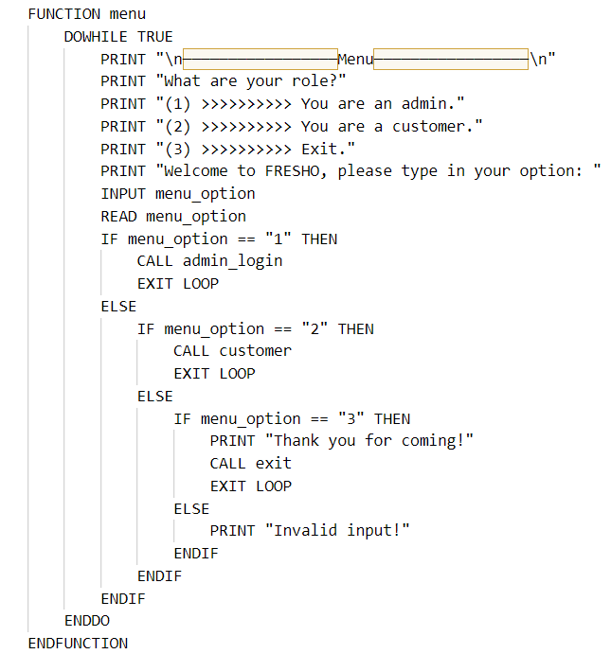

**admin_login function**

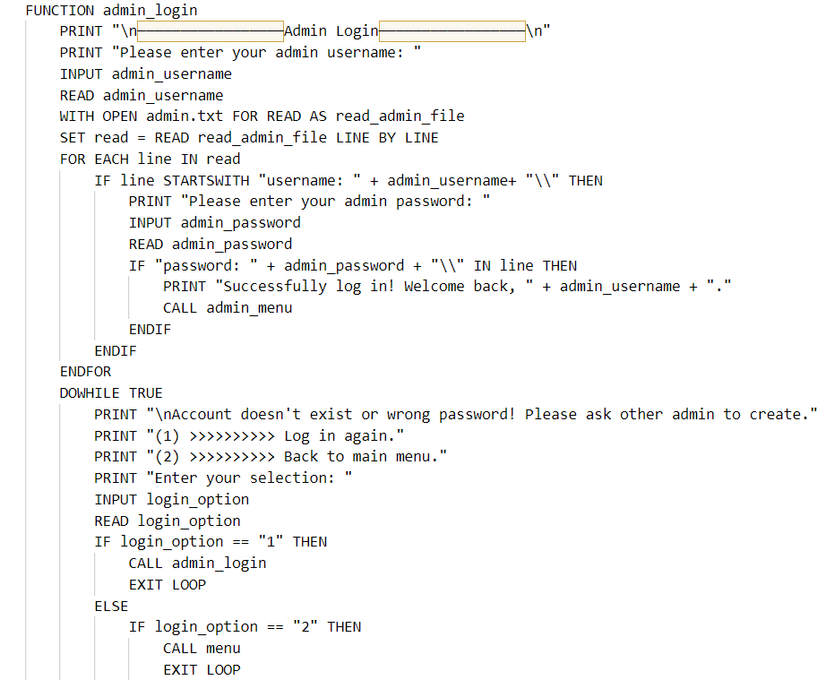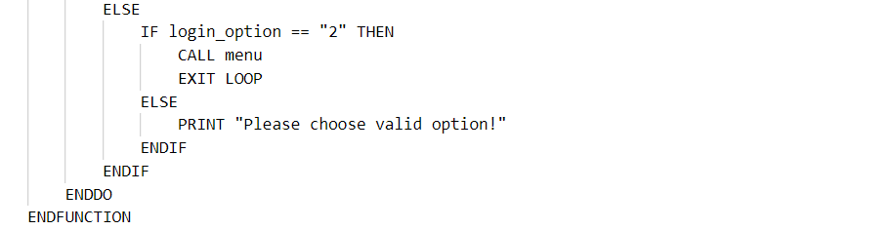

**admin_menu function**

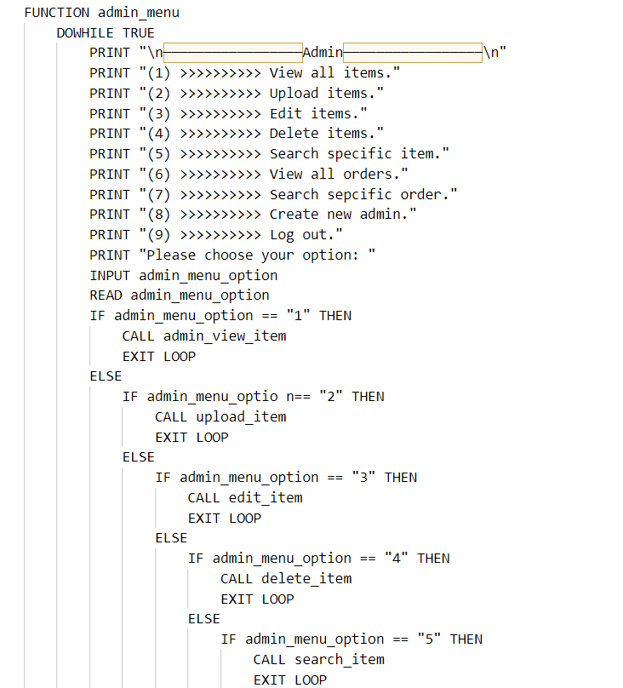

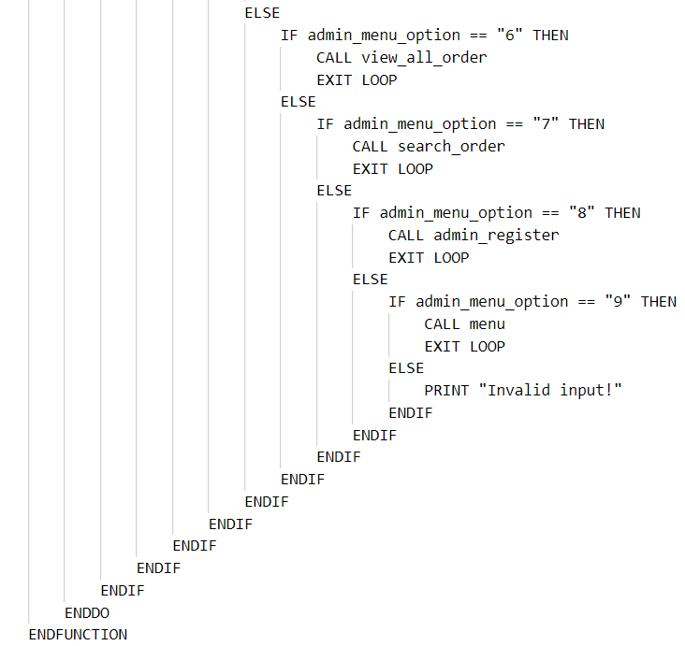

**admin_view_item function**

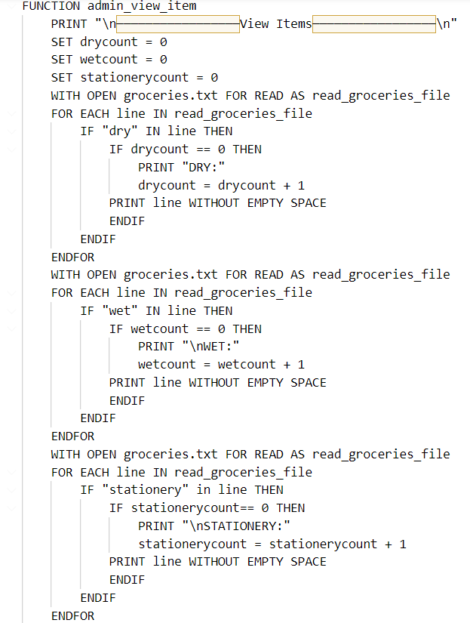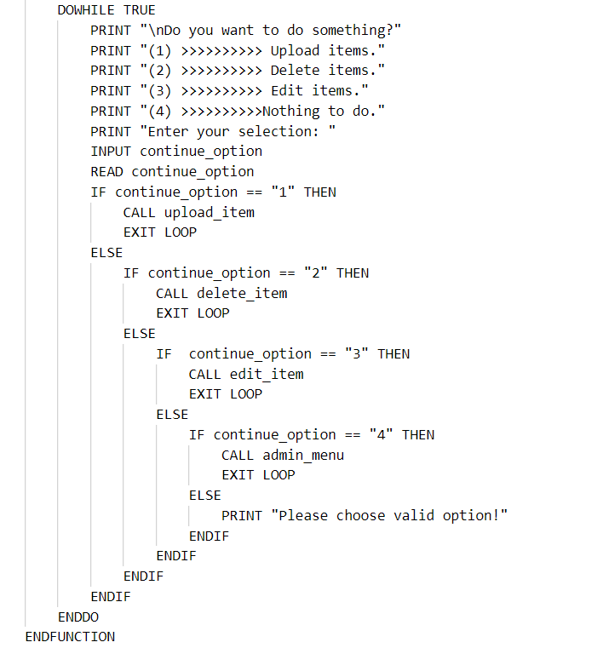

**upload_item function**

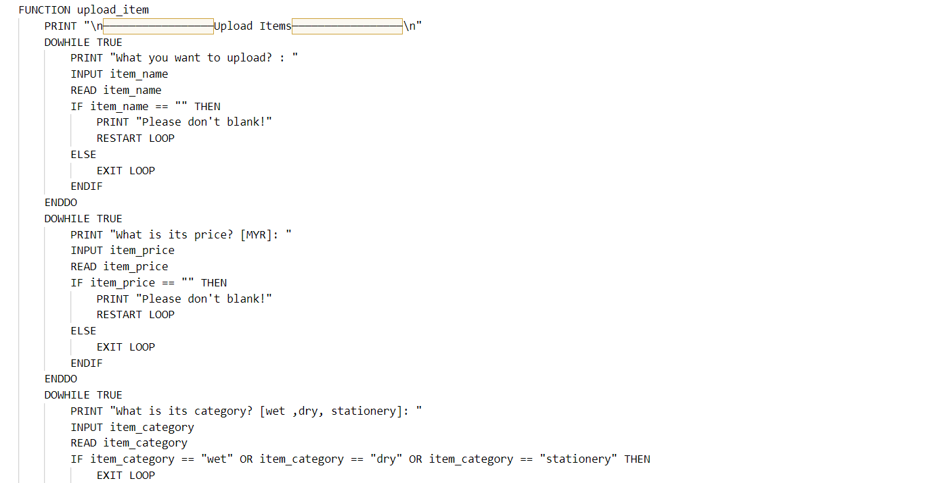 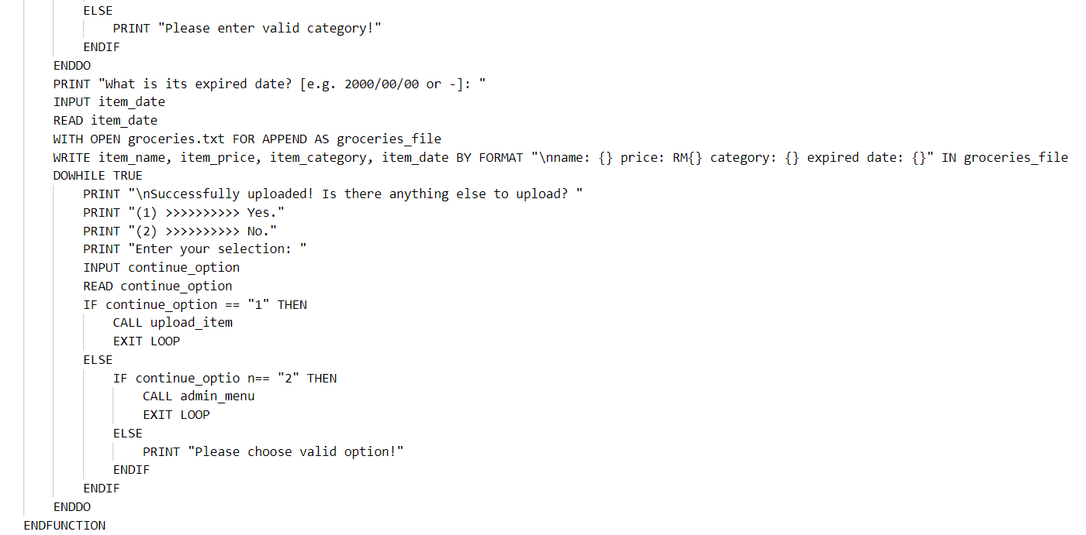

**edit_item function**

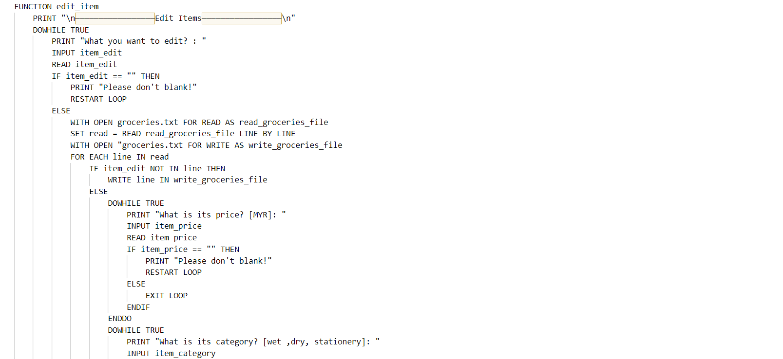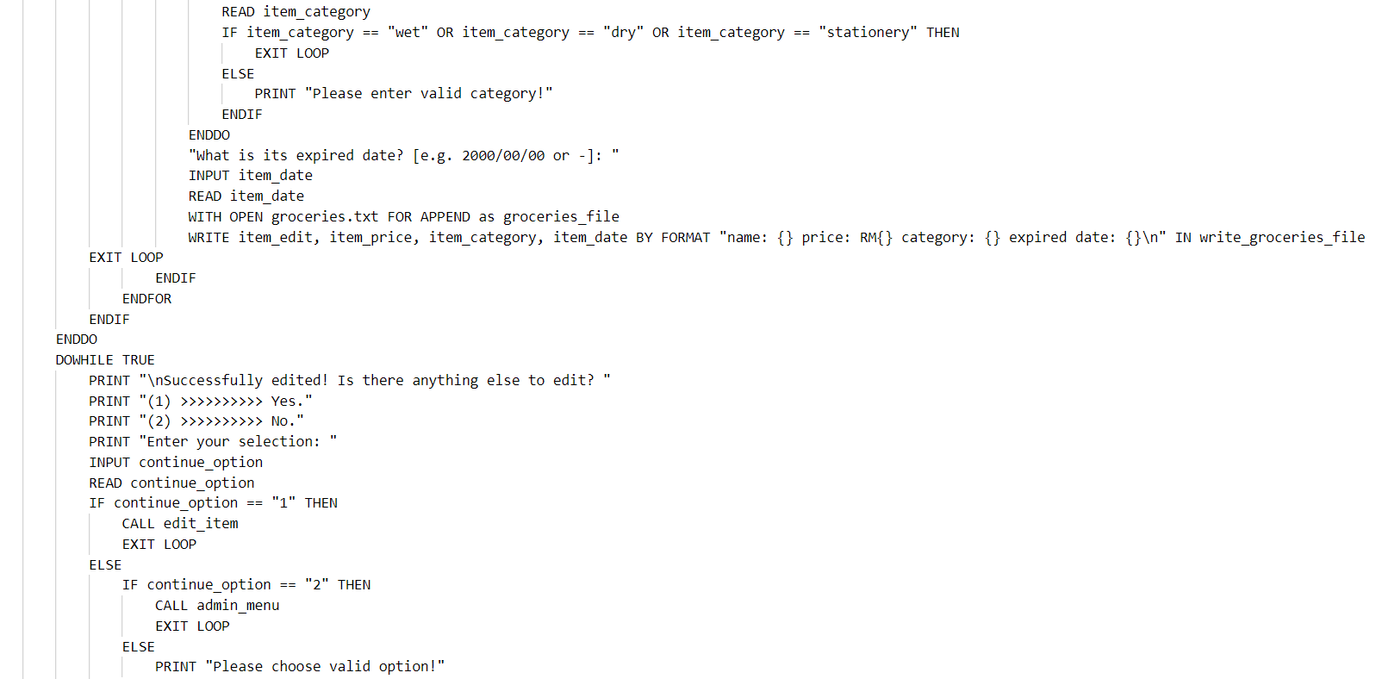 

**delete_item function**

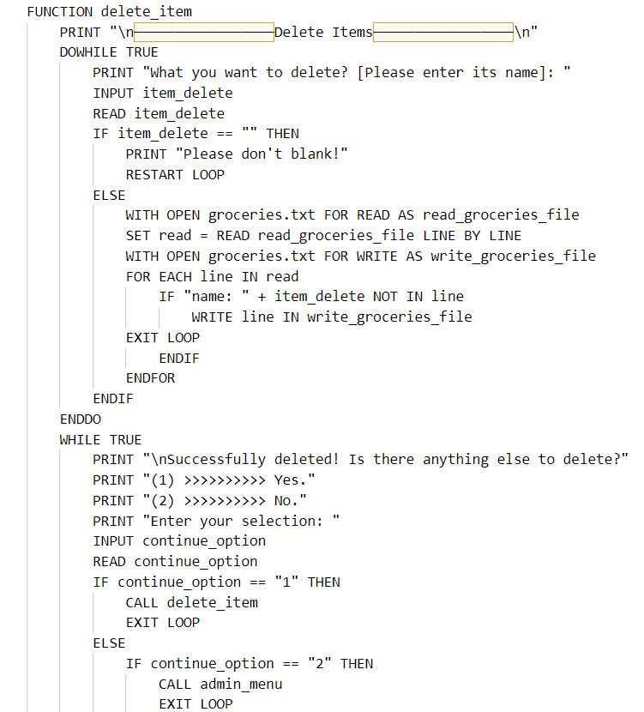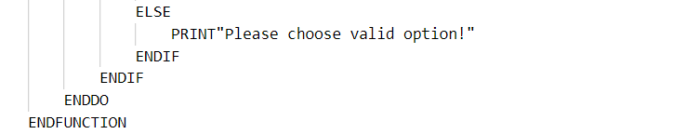

**search_item function**

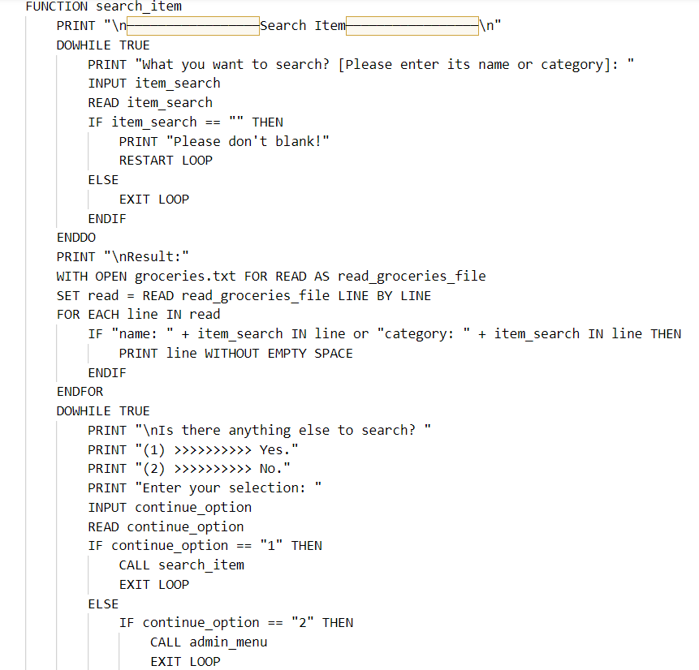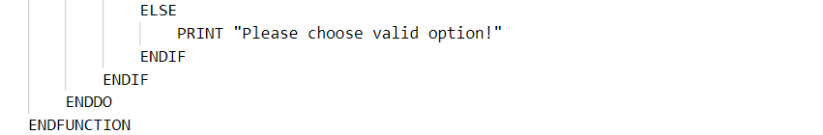

**view_all_order function**

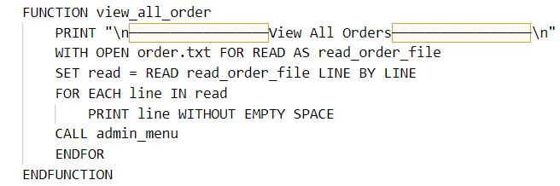

**search_order function**

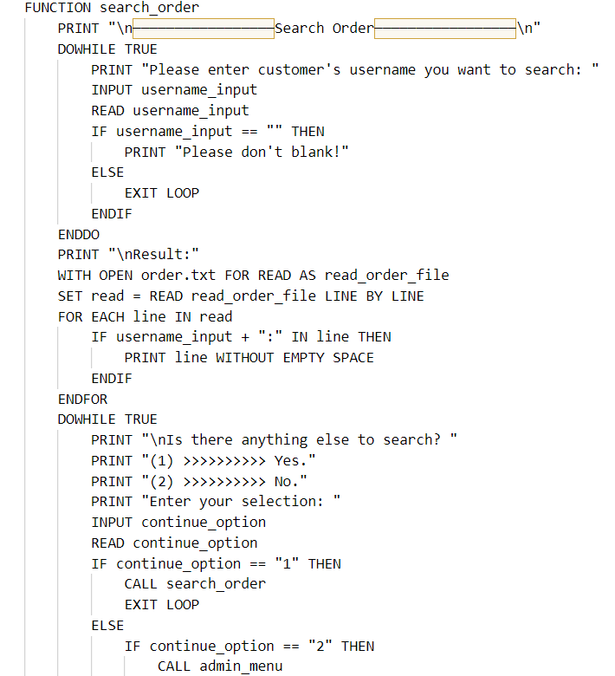

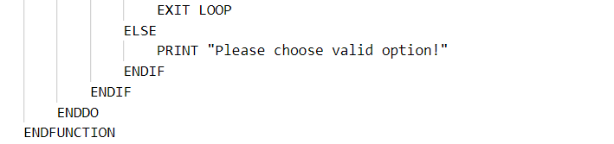

**admin_register function**

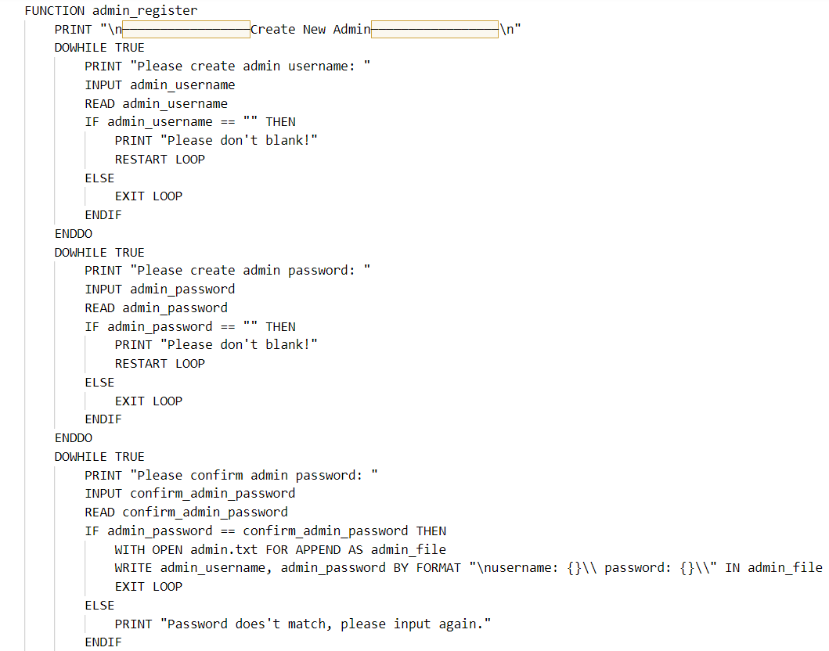 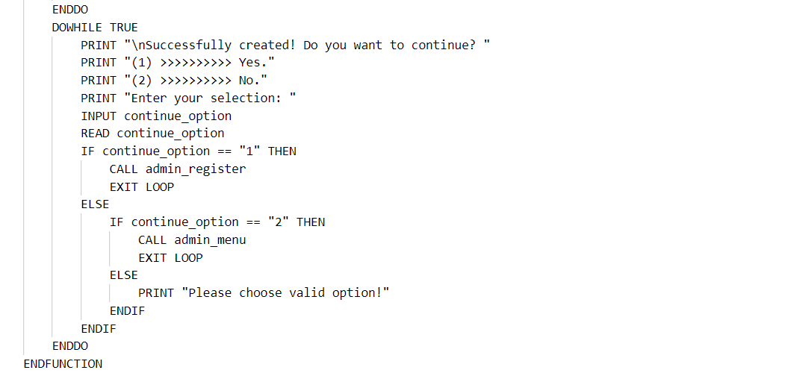

**customer function**

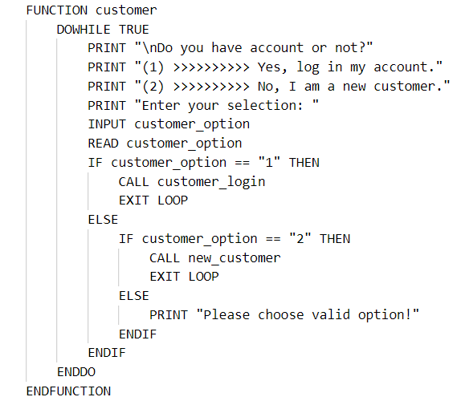

**new_customer function**

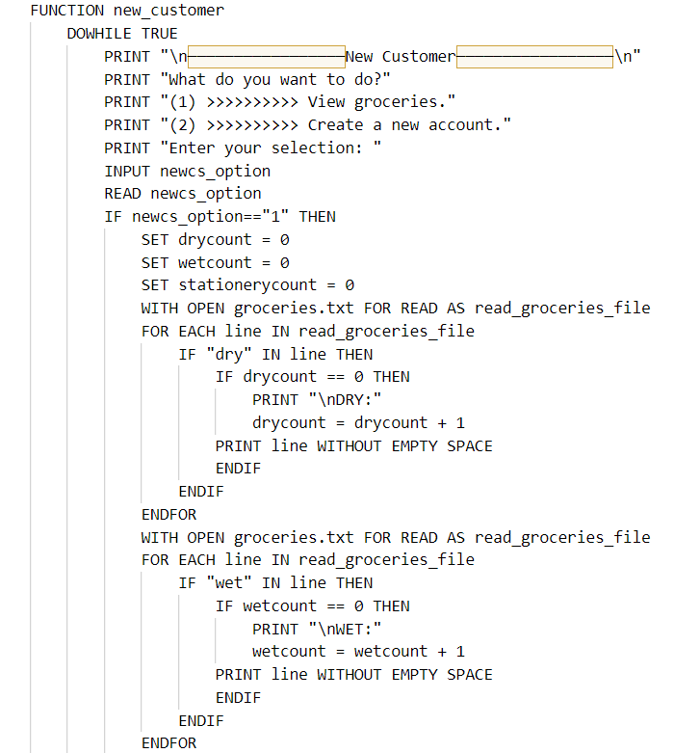 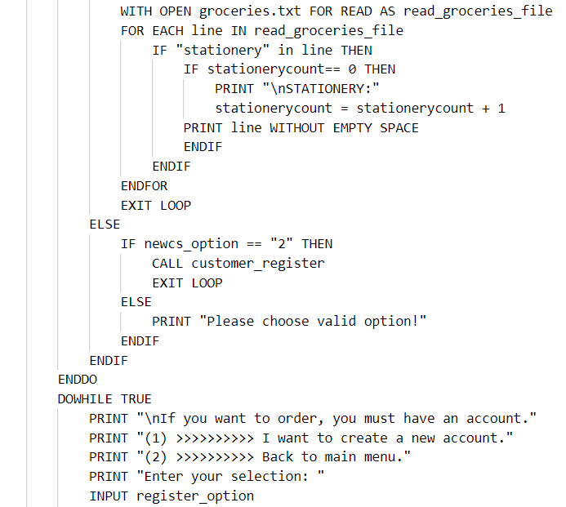 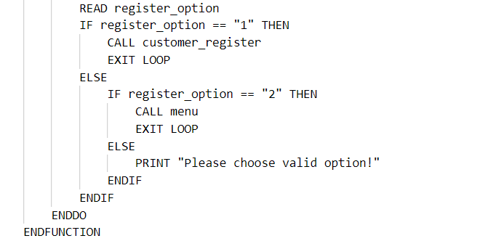

**customer_register function**

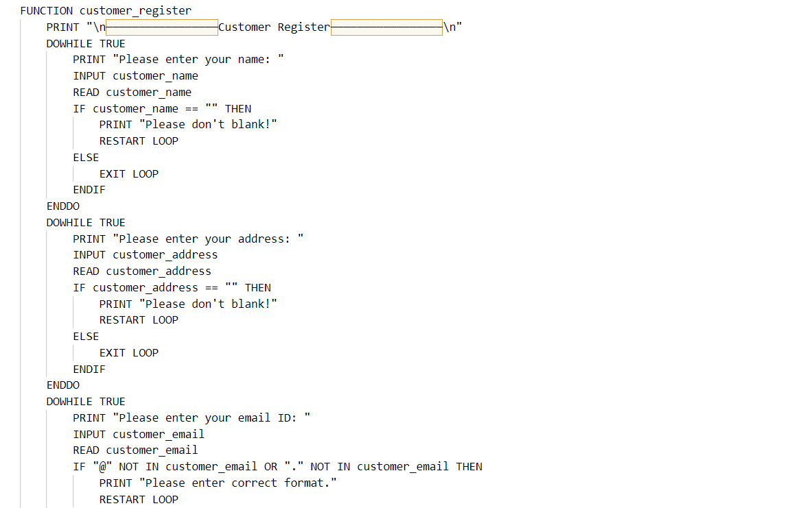

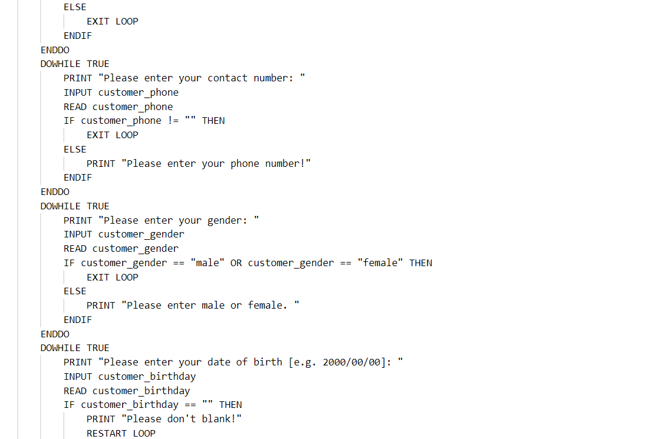 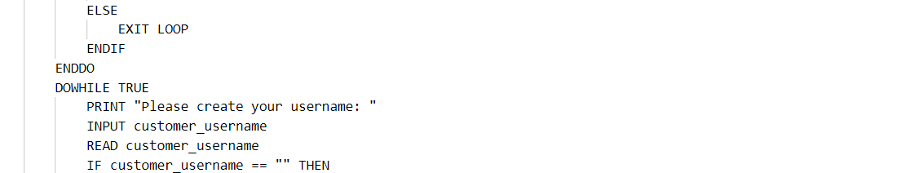



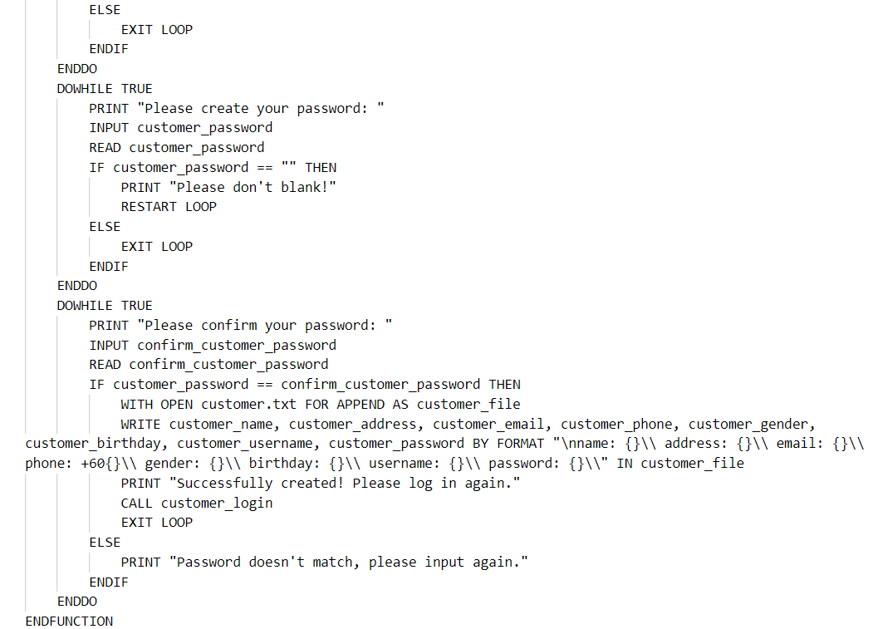

**customer_login function**

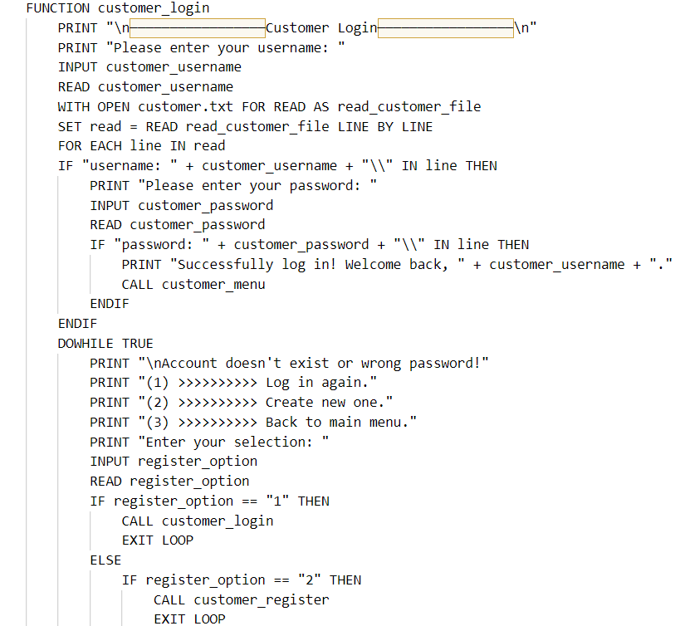

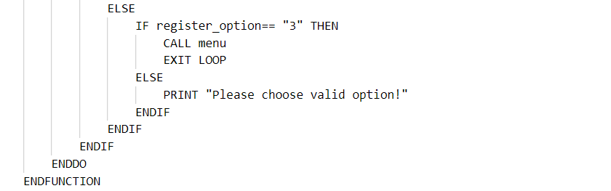

**customer_menu function**

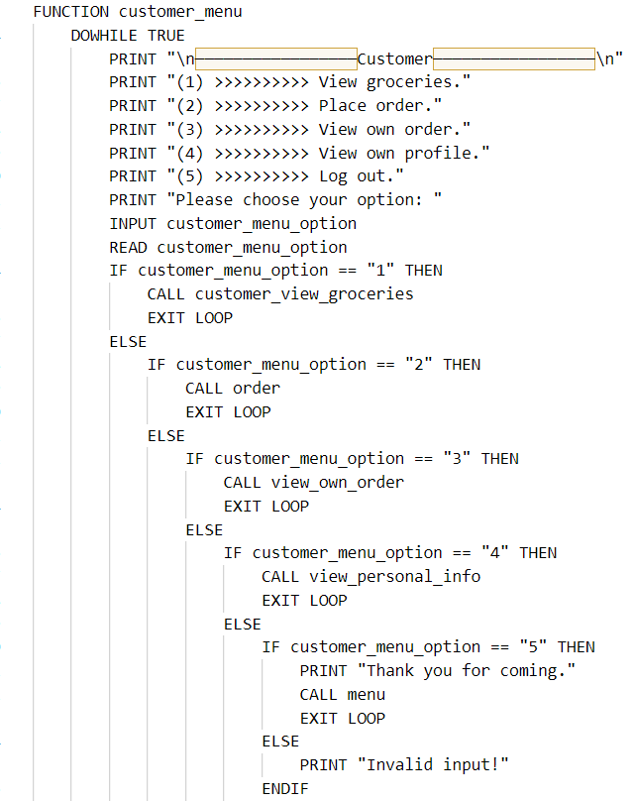

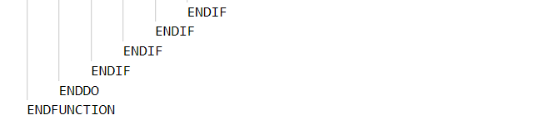

**customer_view_groceries function**

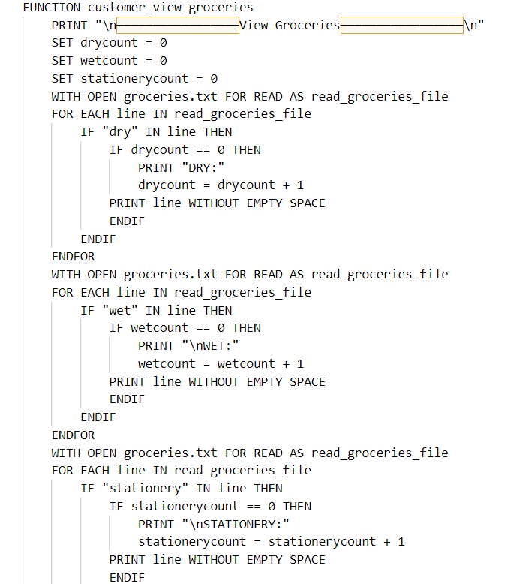

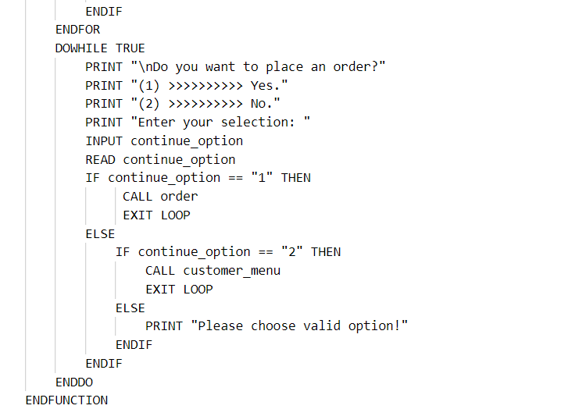

**order function**

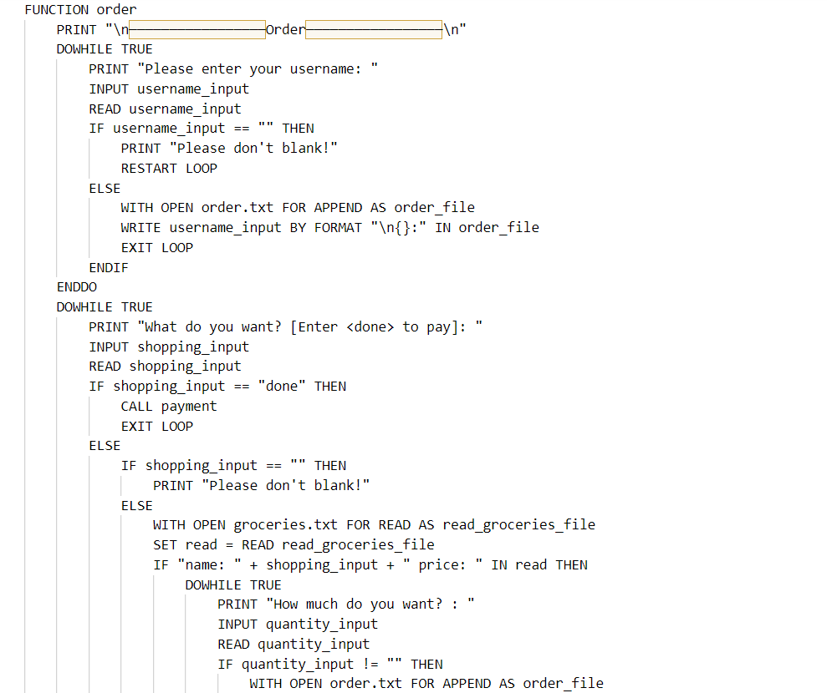 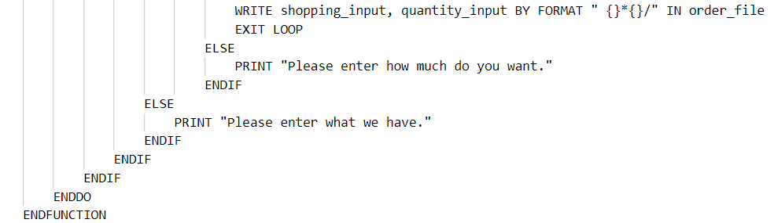

**payment function**

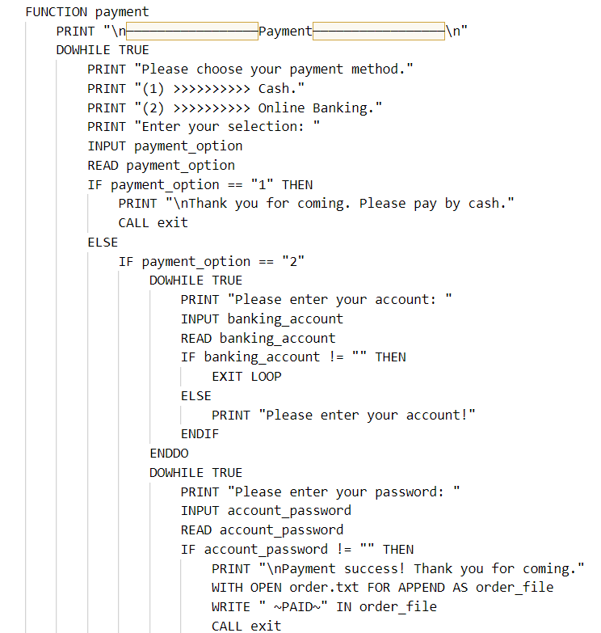

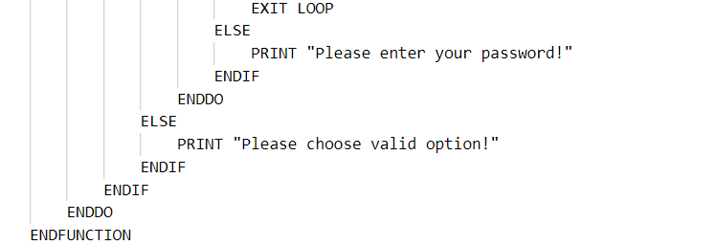

**view_own_order function**

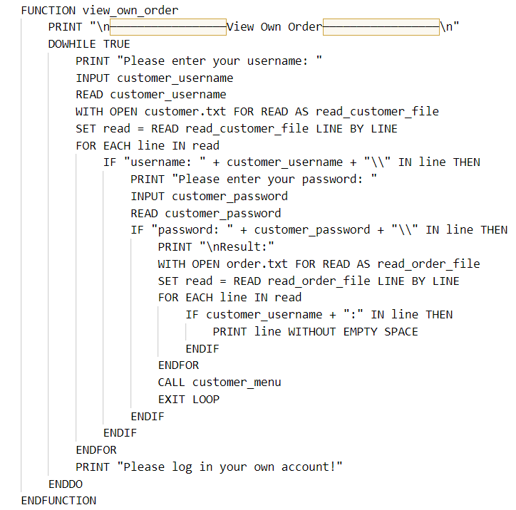

**view_personal_info function**

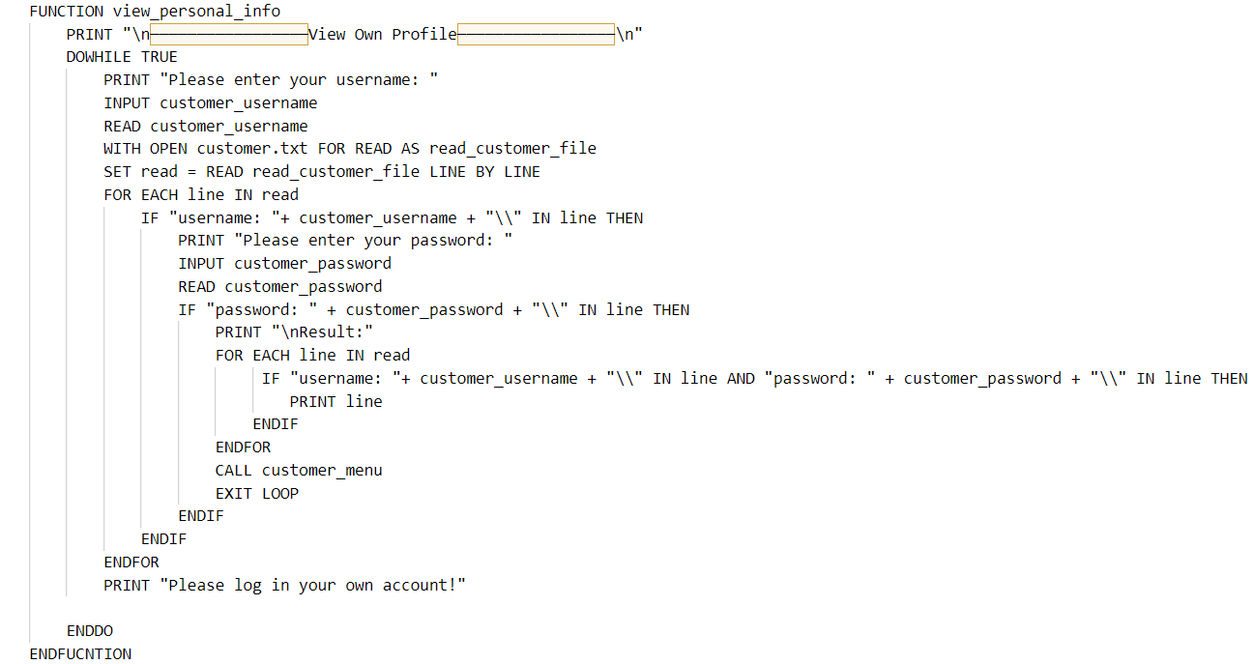

**call overall program**

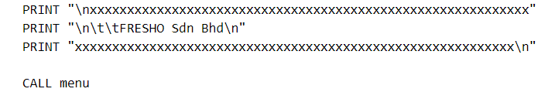

## **3.2 Flowchart**

**menu function**

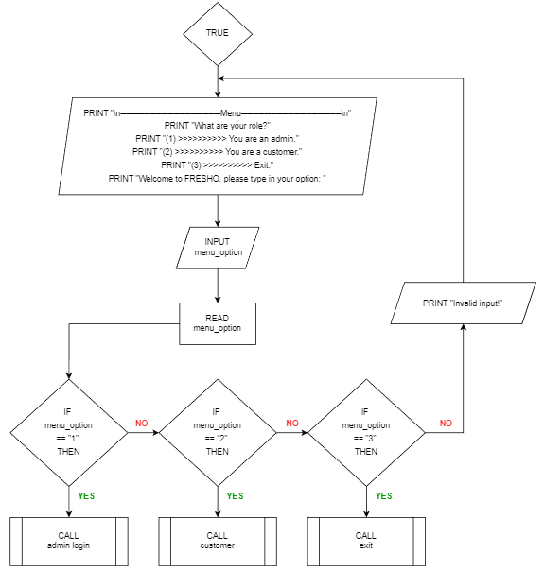

**admin_login function**

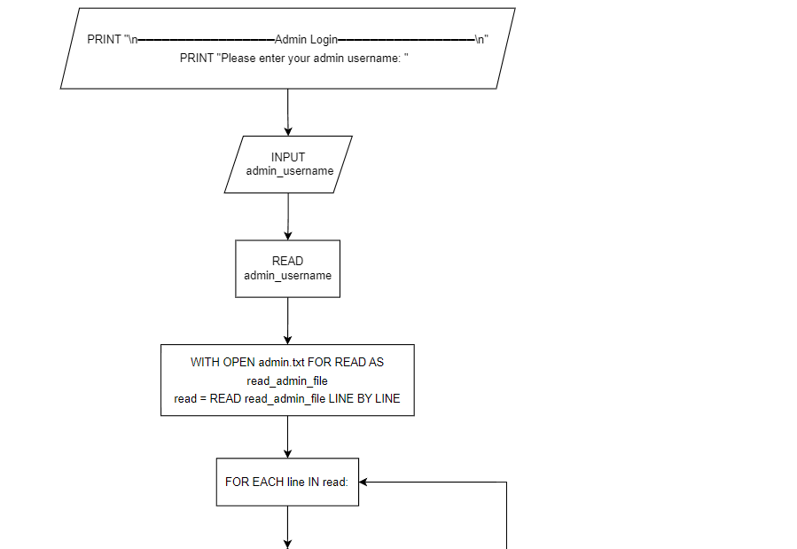 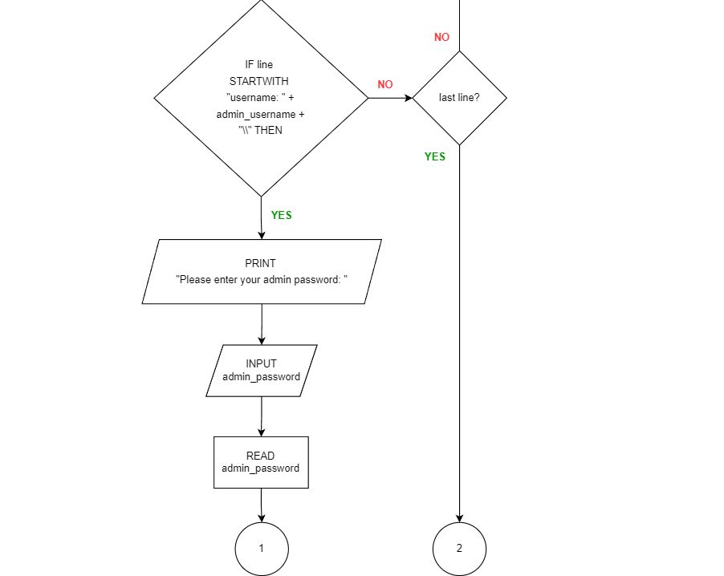

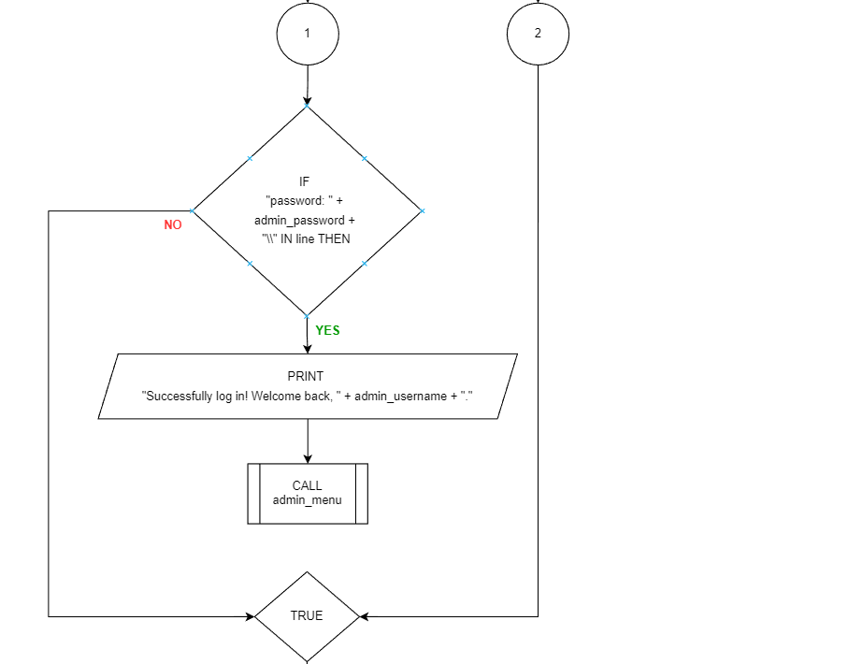 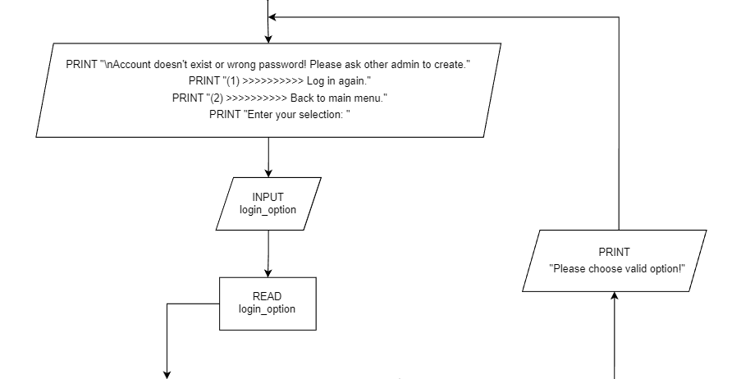 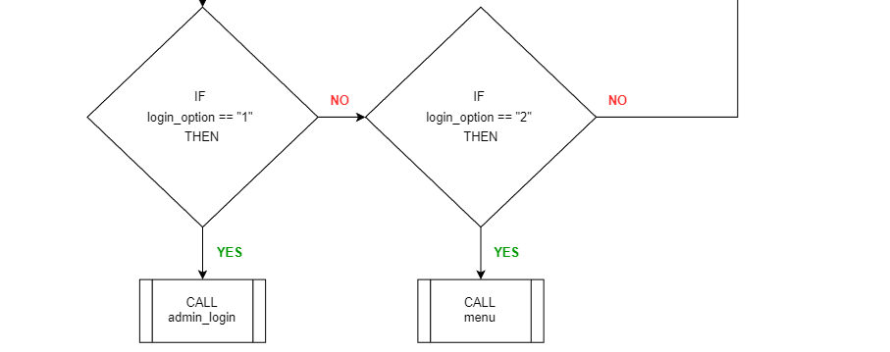

**admin_menu function**

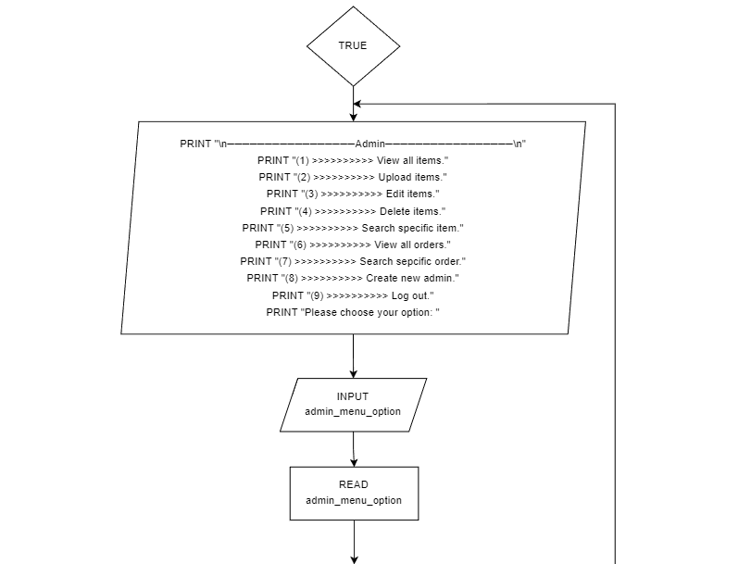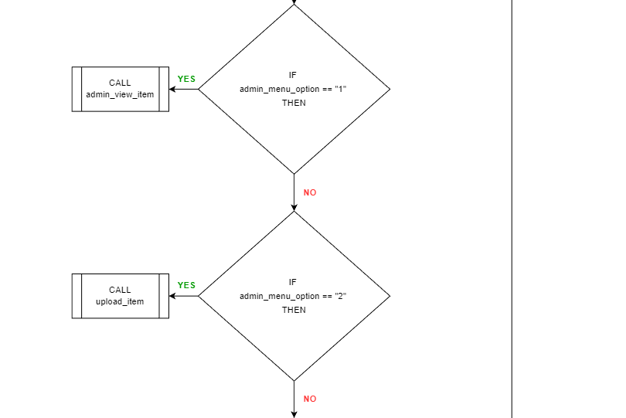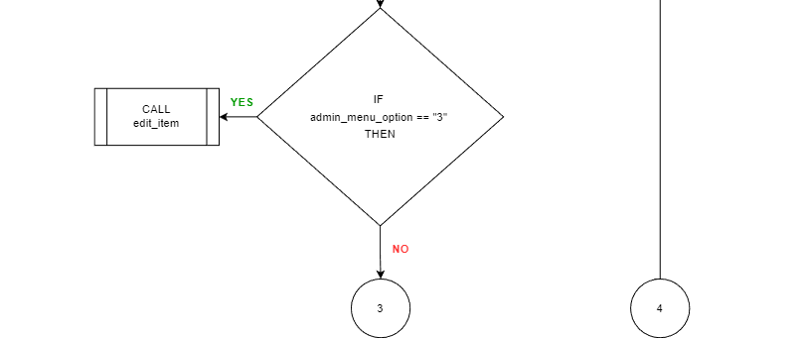

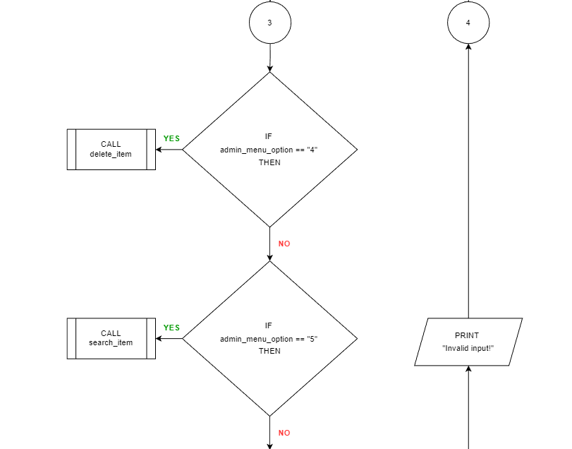 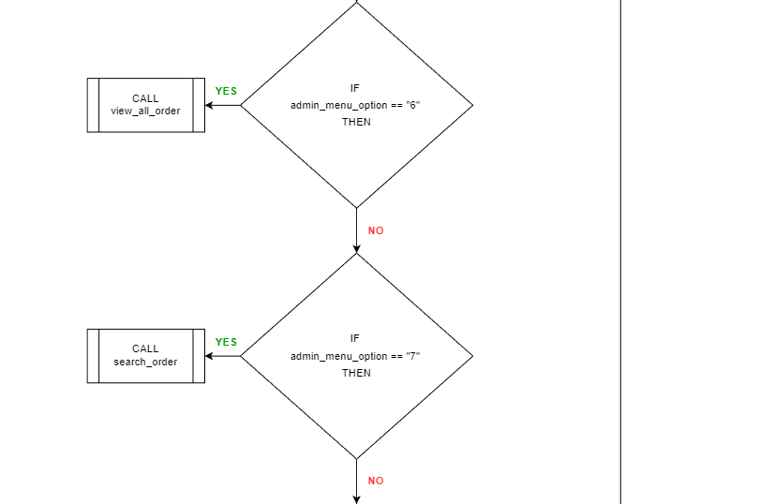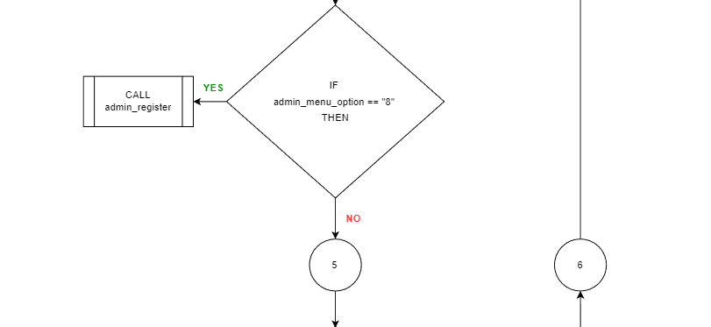

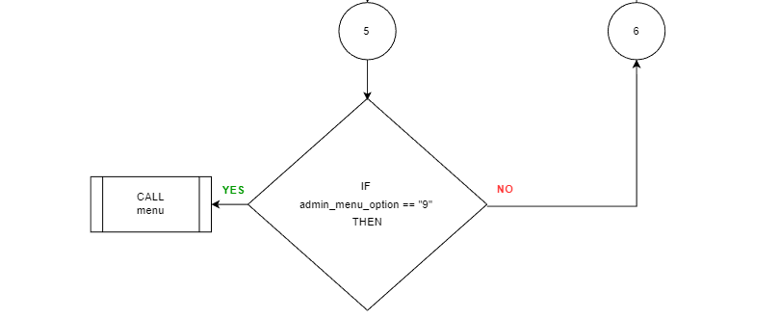

**admin_view_item function**

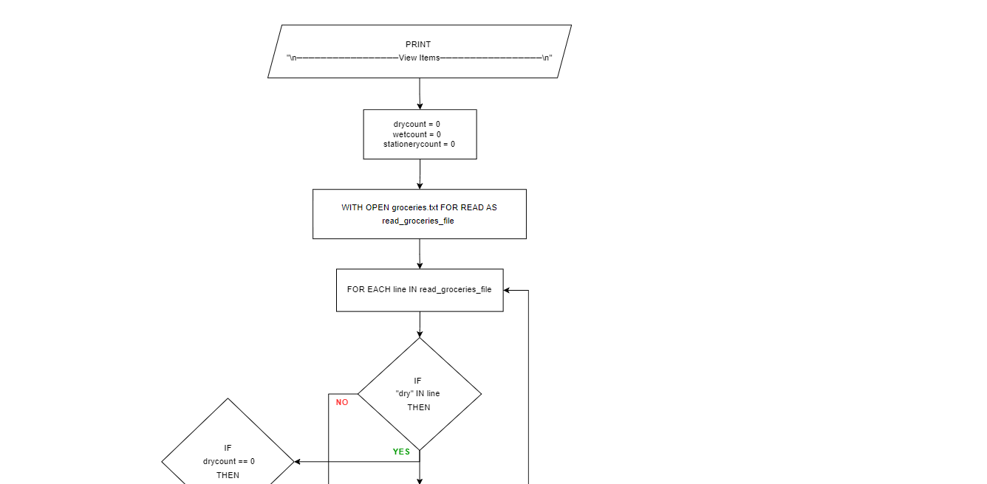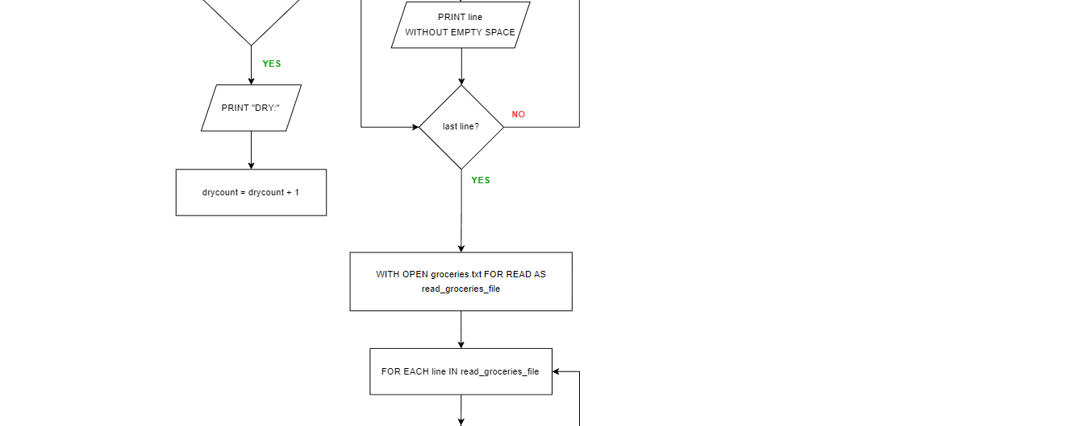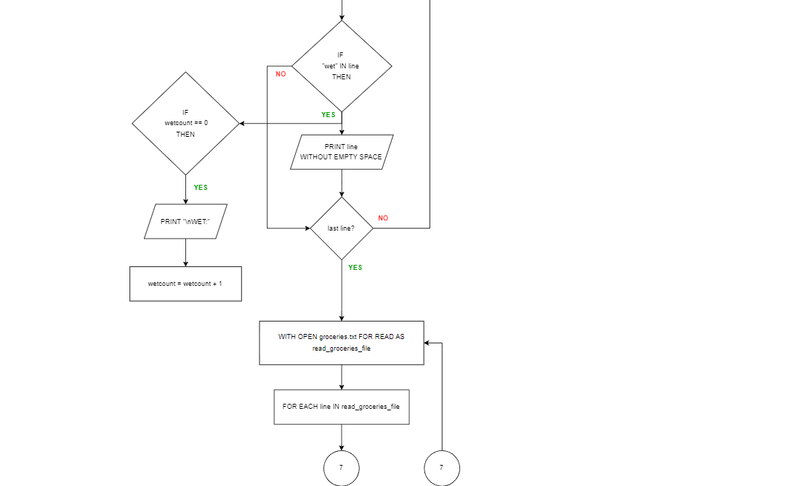



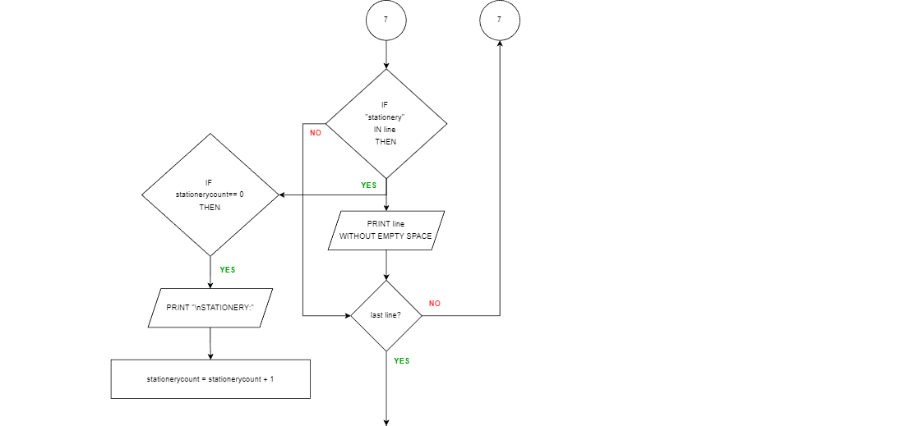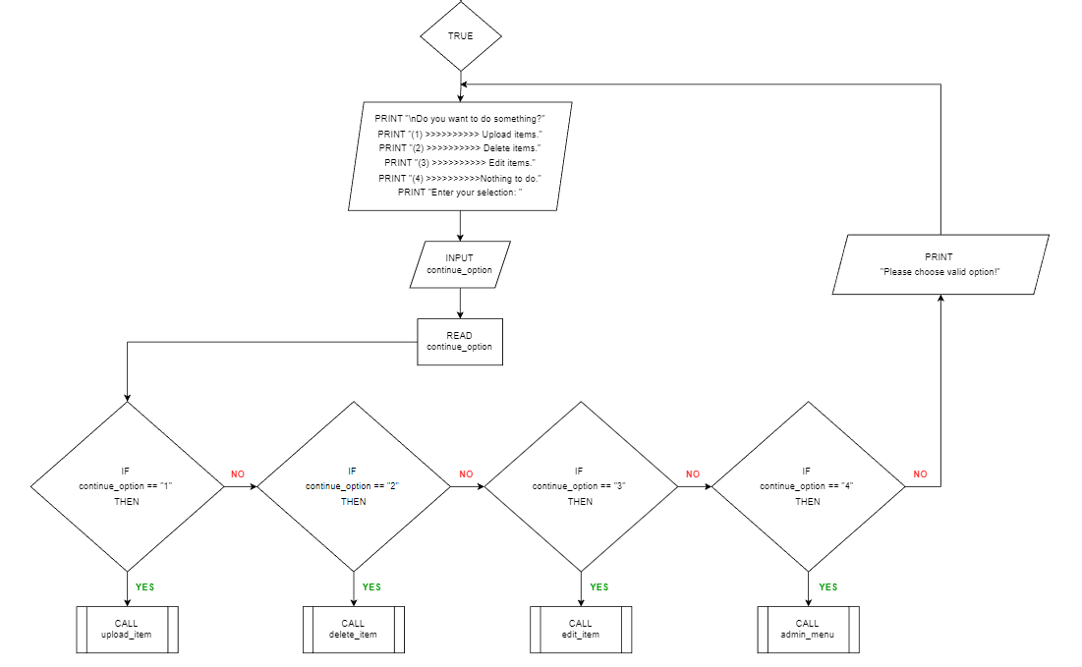

**upload_item function**

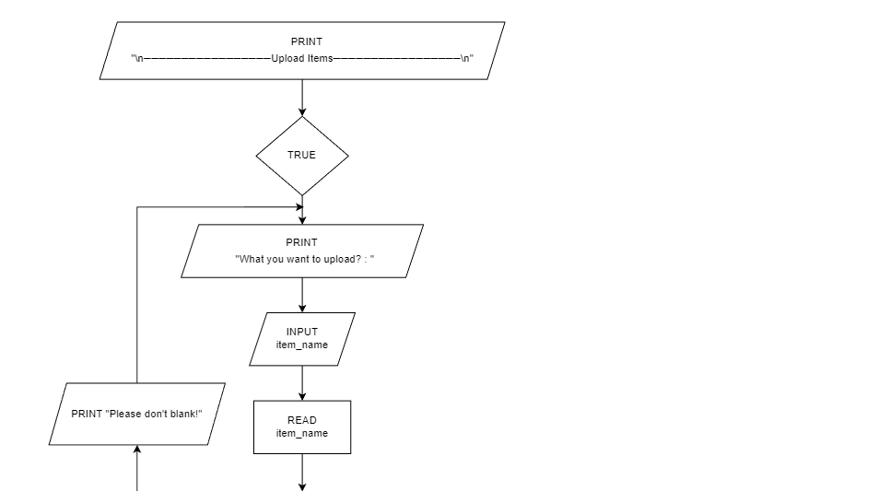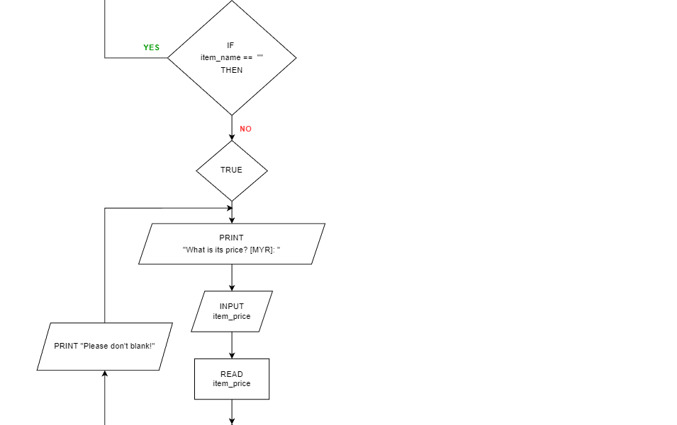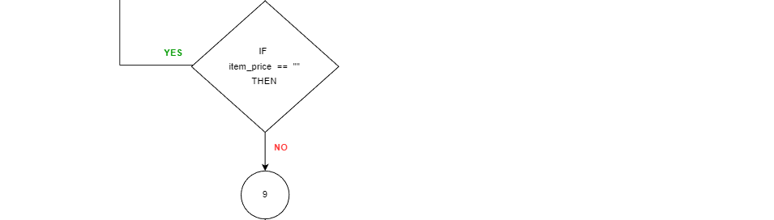

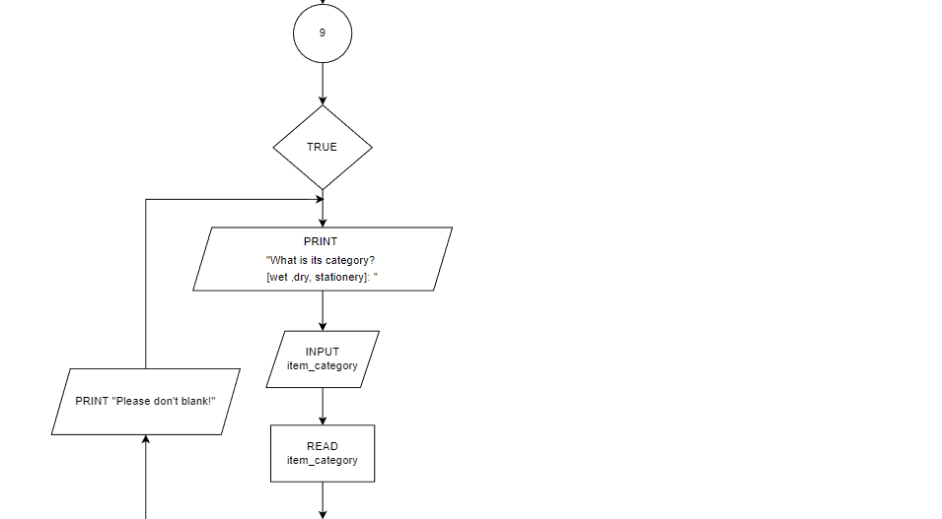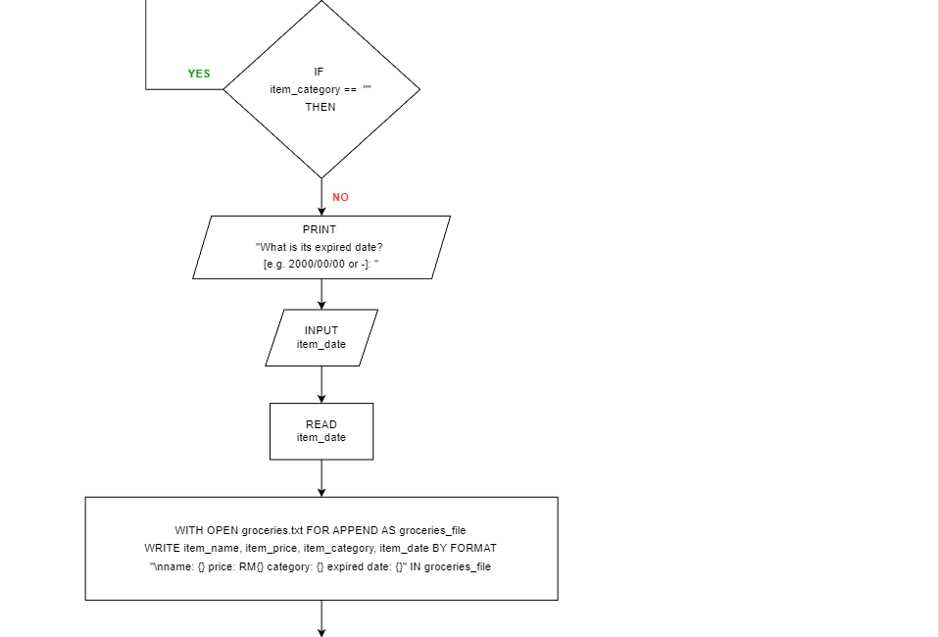

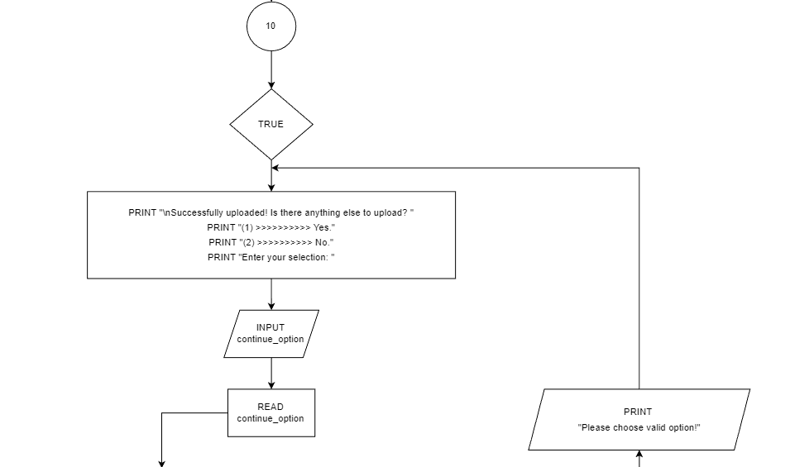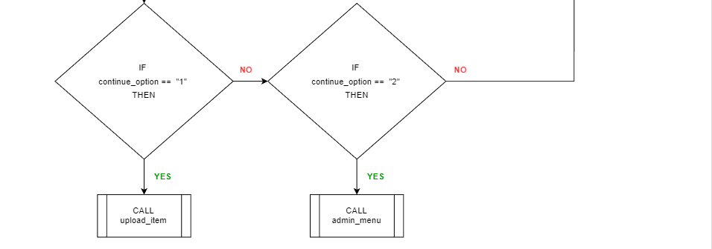

**edit_item function**

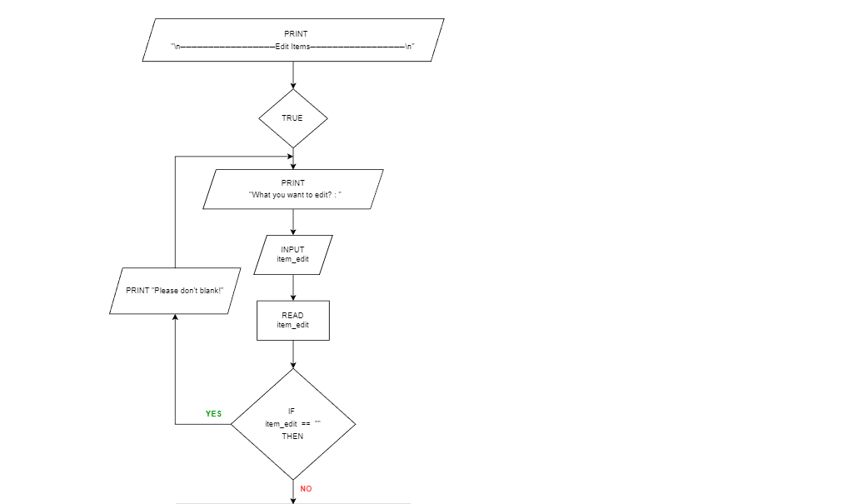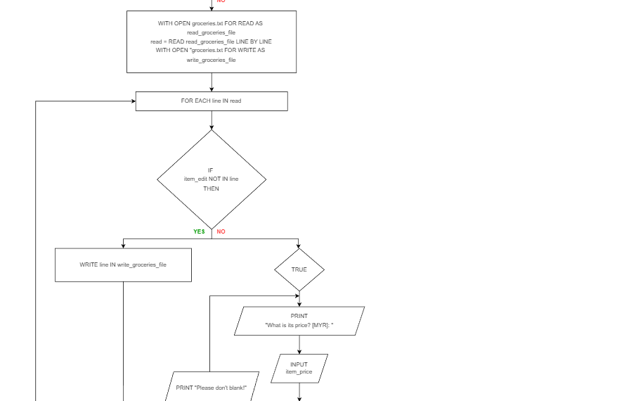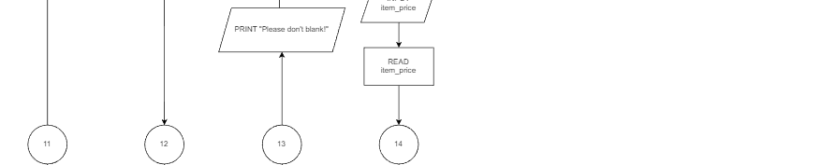

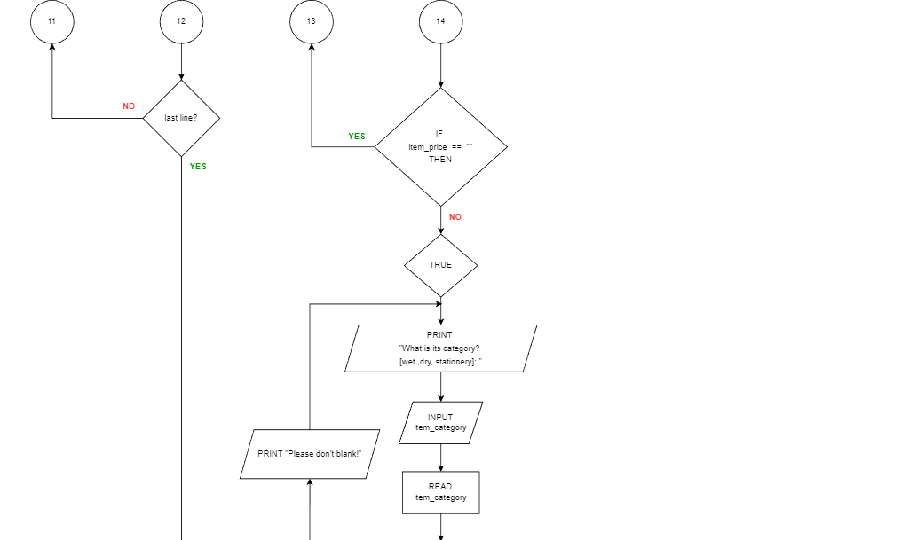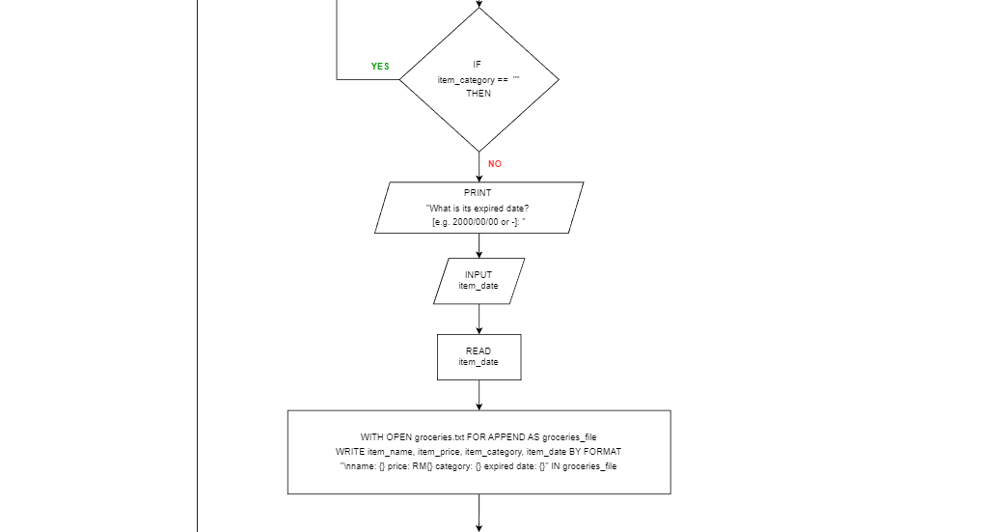

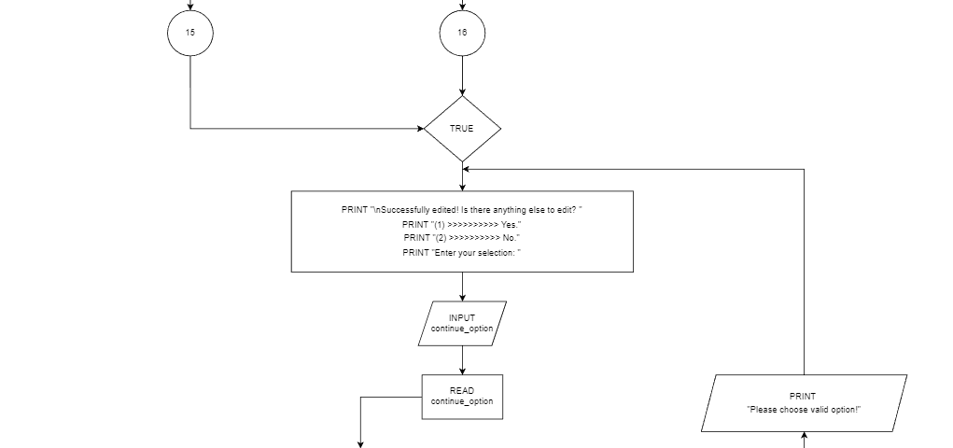

**delete_item function**

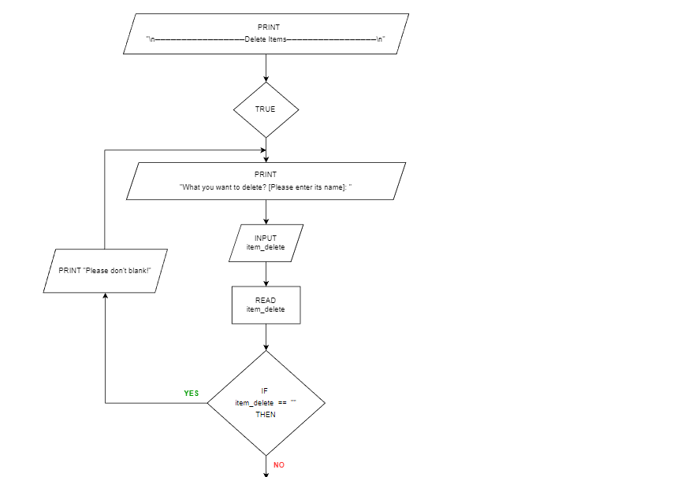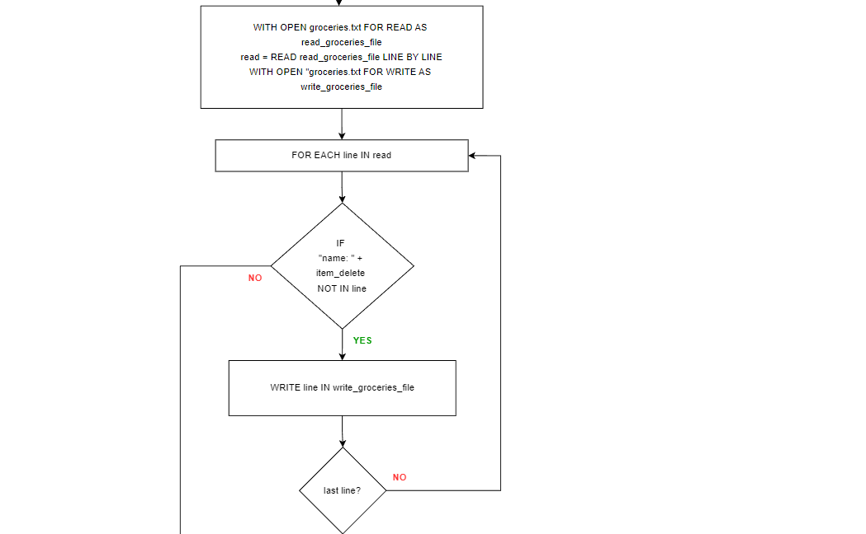

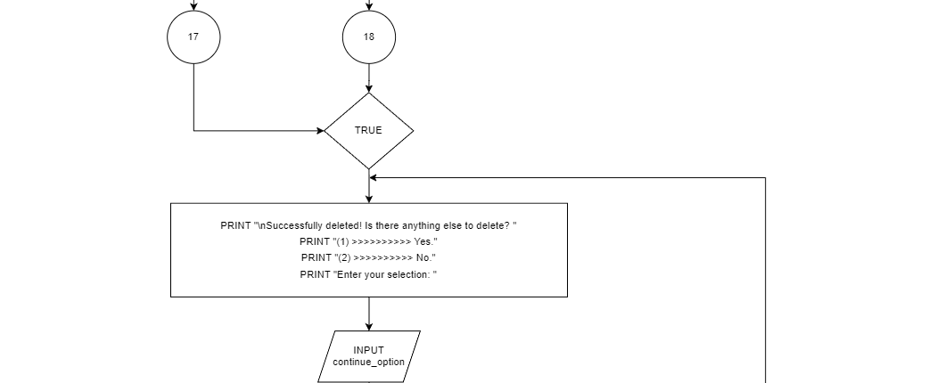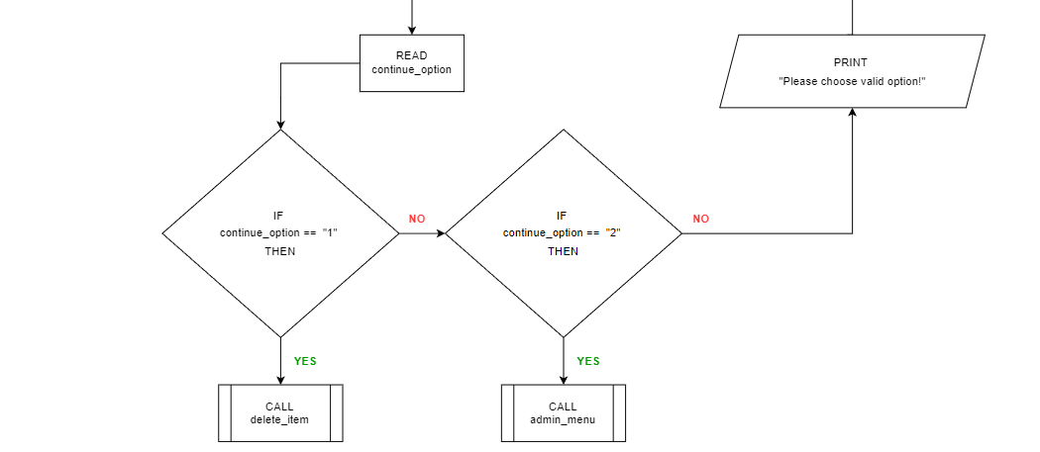

**search_item function**

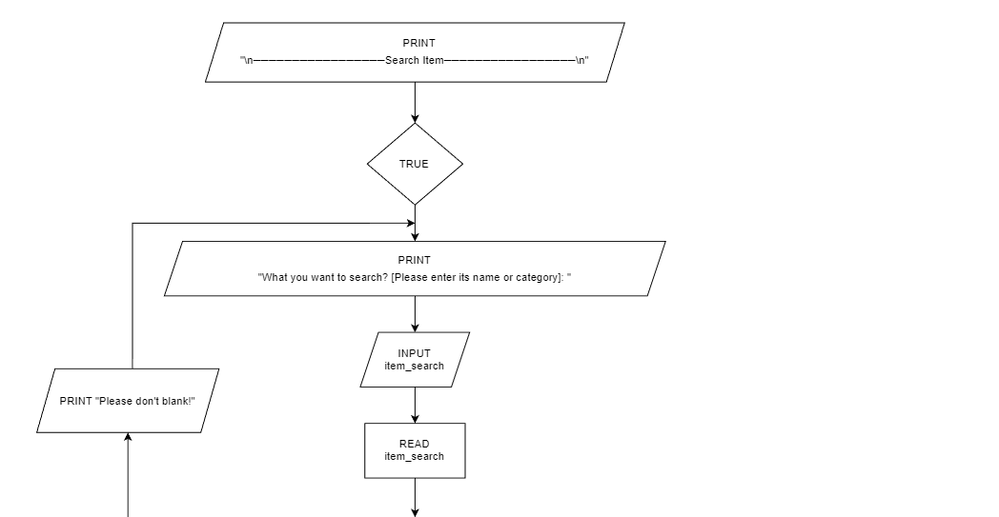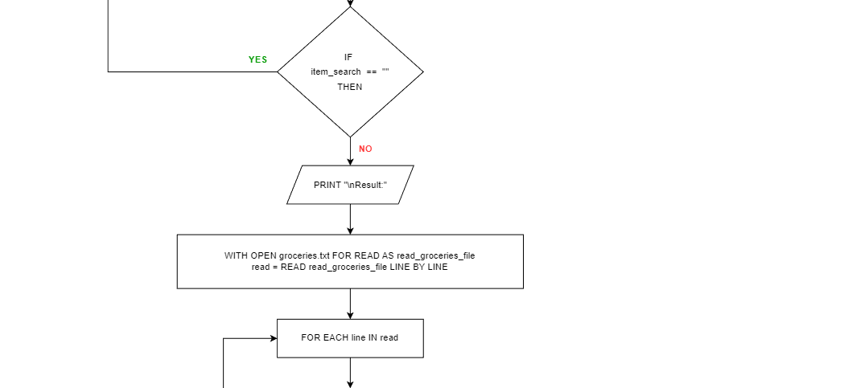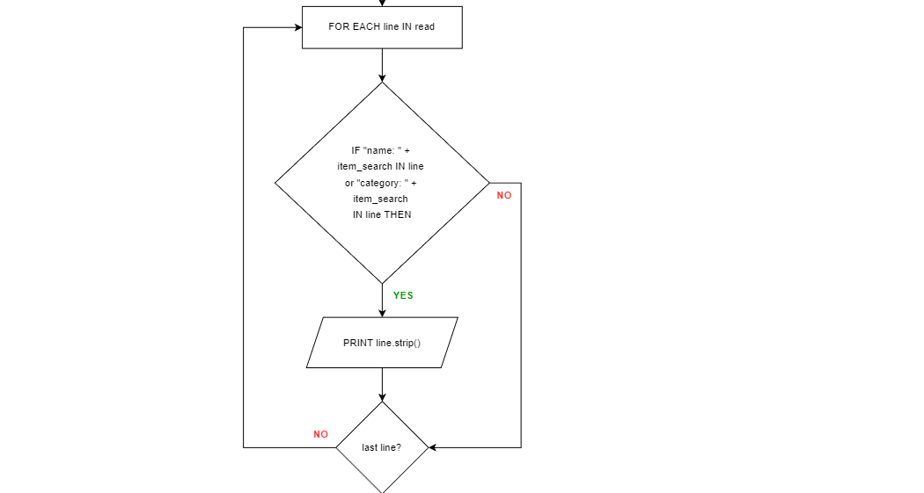

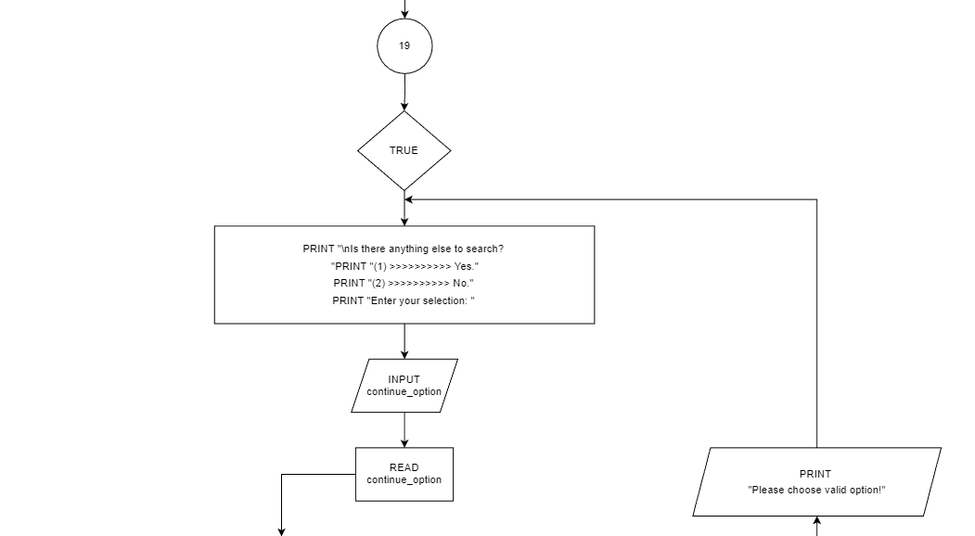

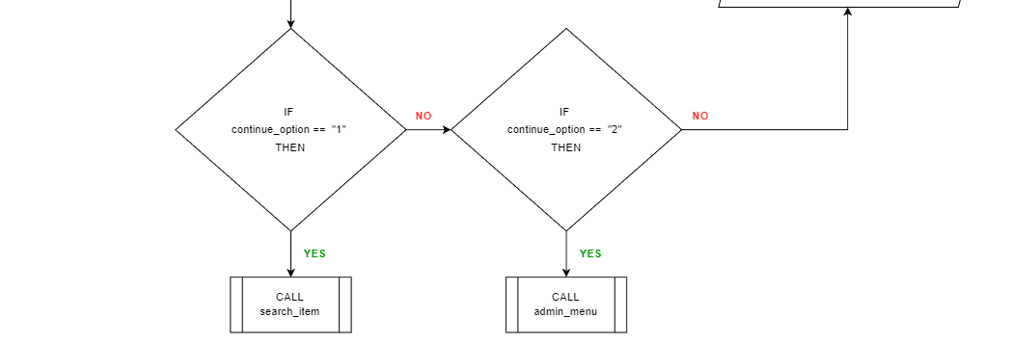

**view_all_order function**

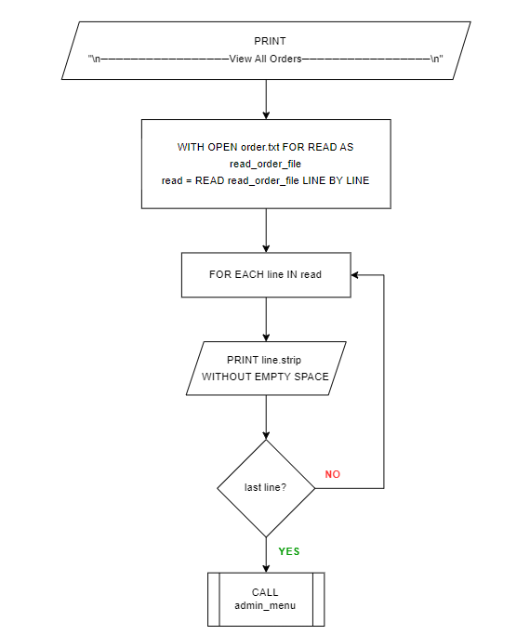

**search_order function**

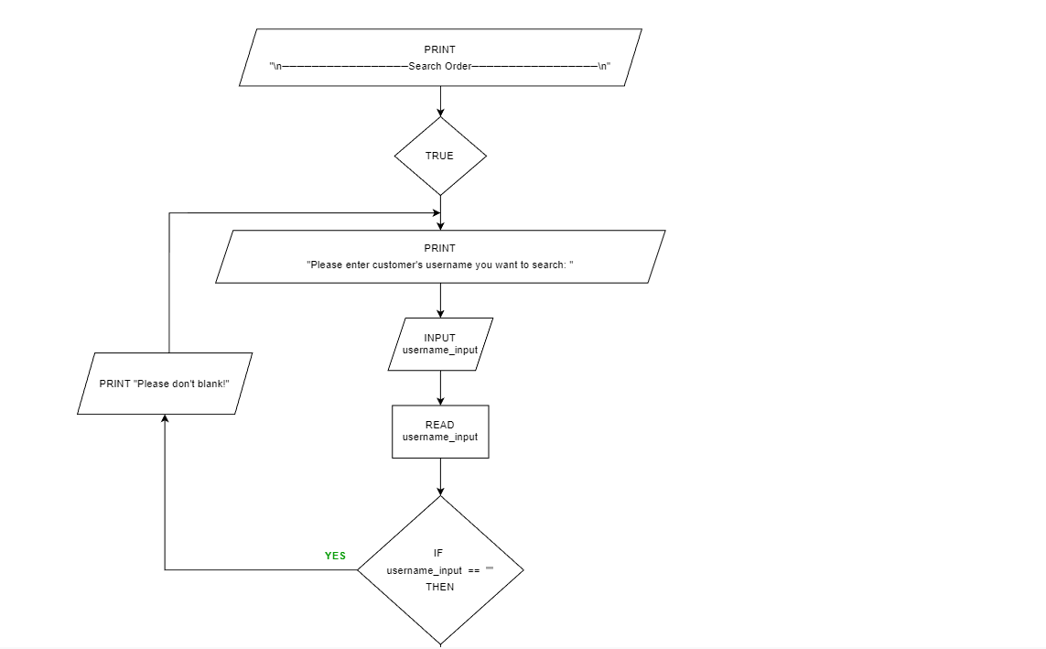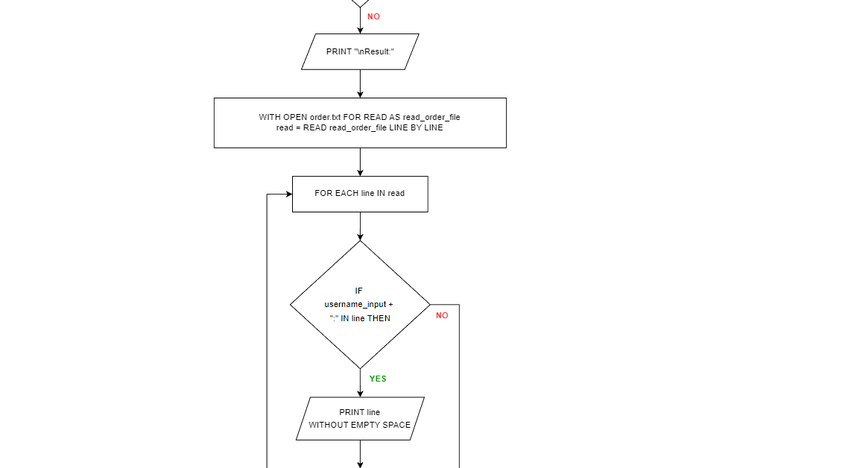

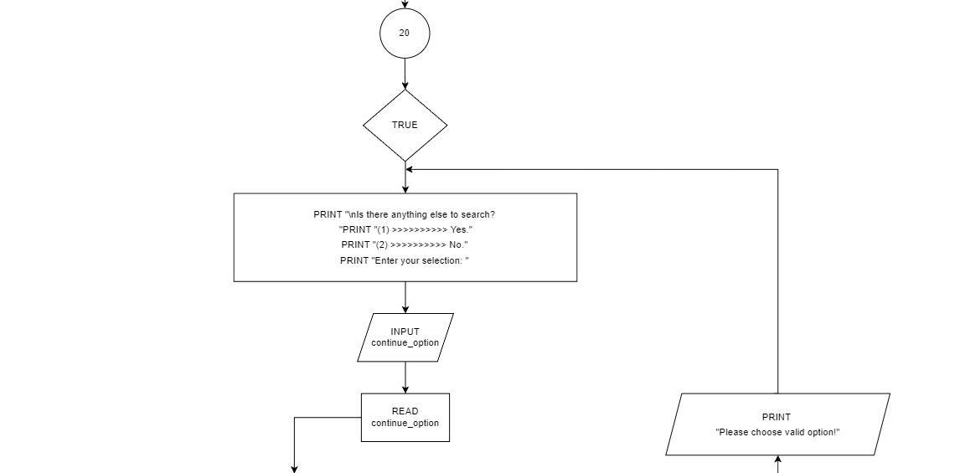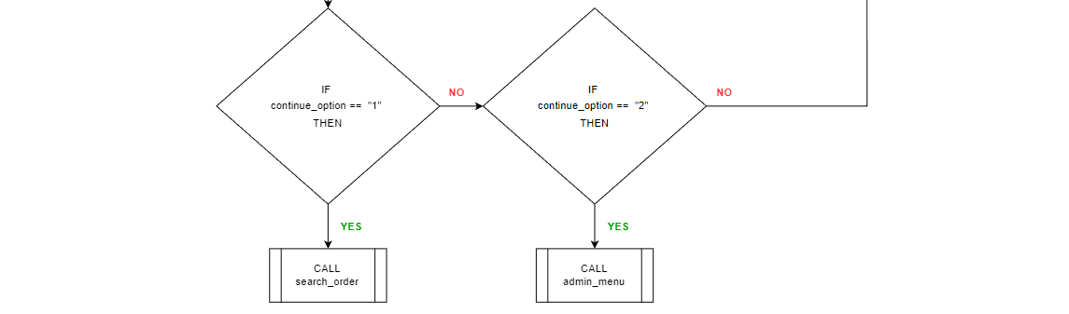

**admin_register function**

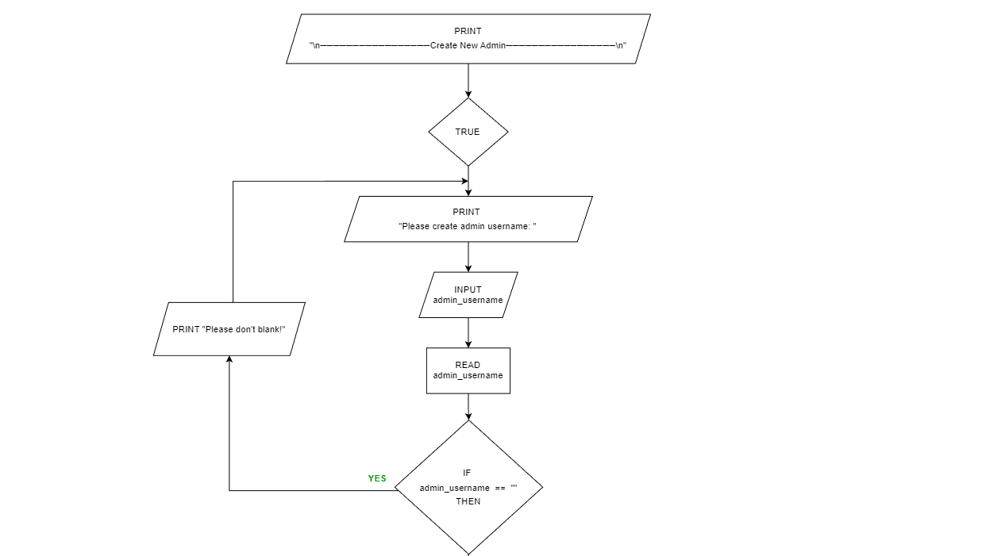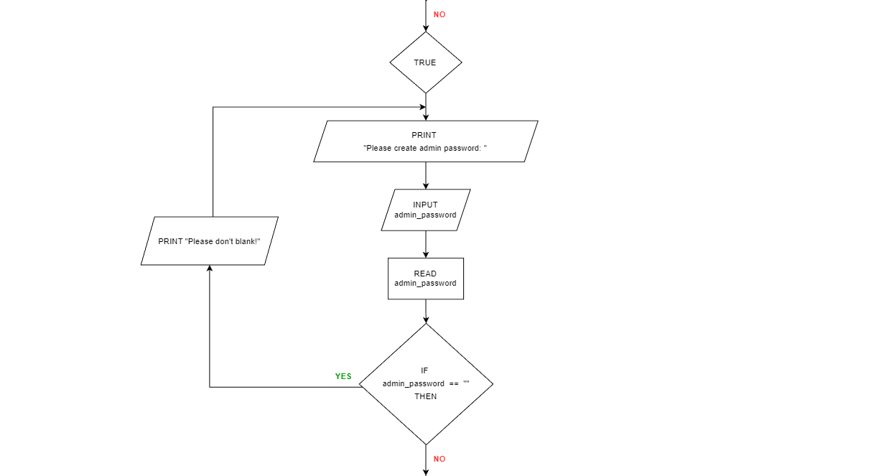

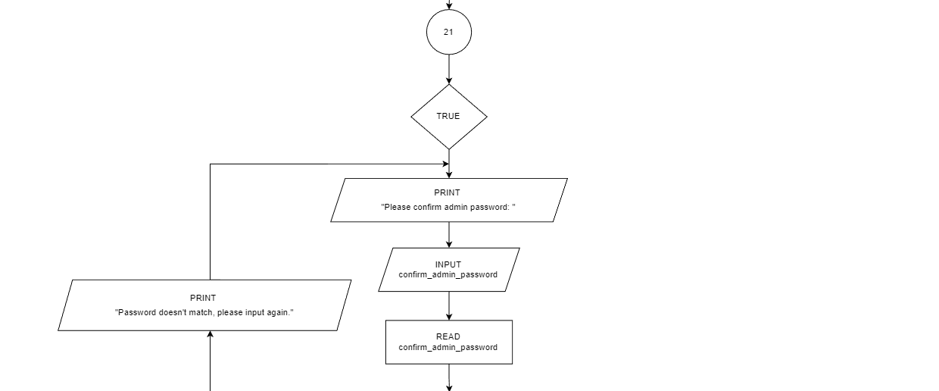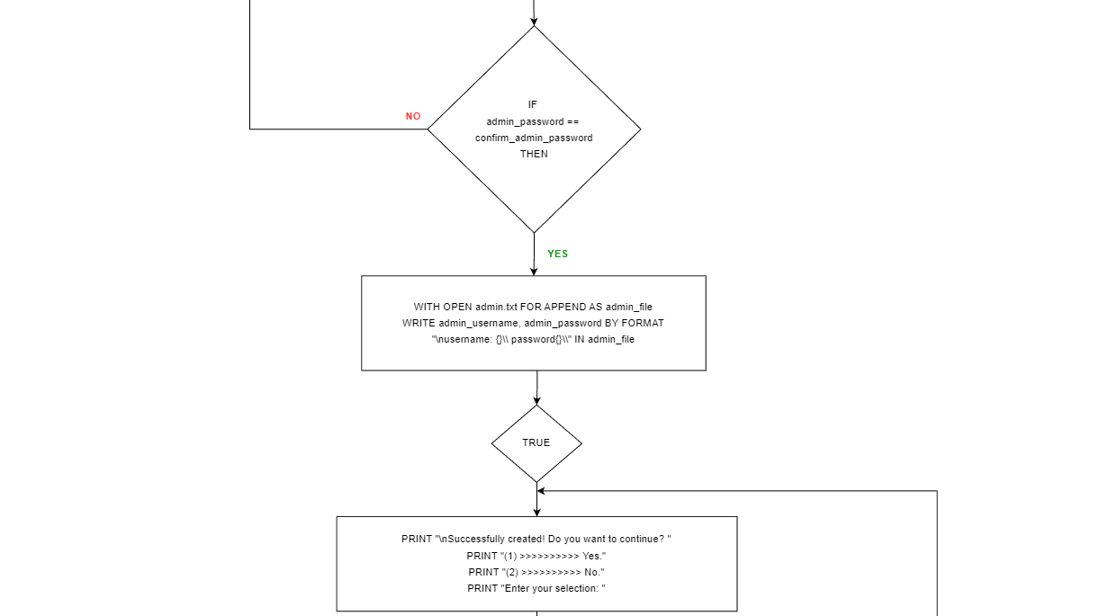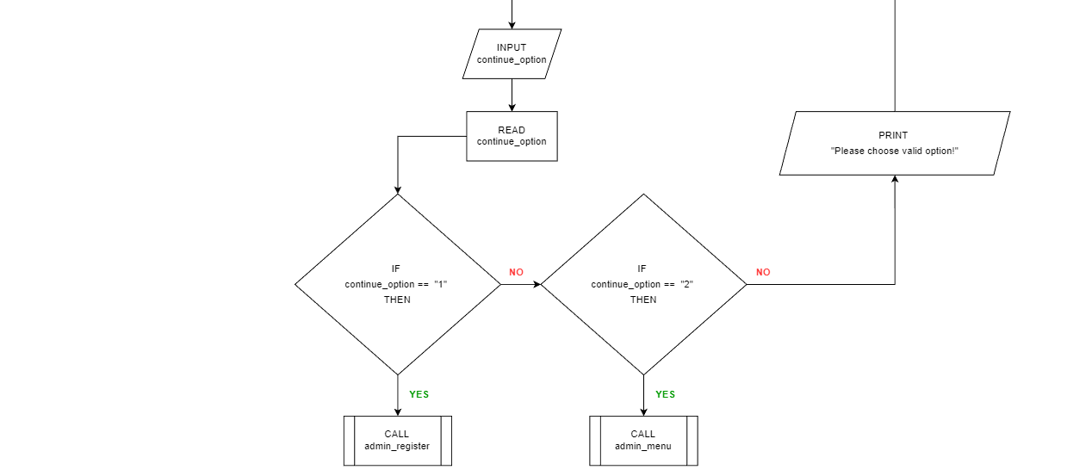

**customer function**

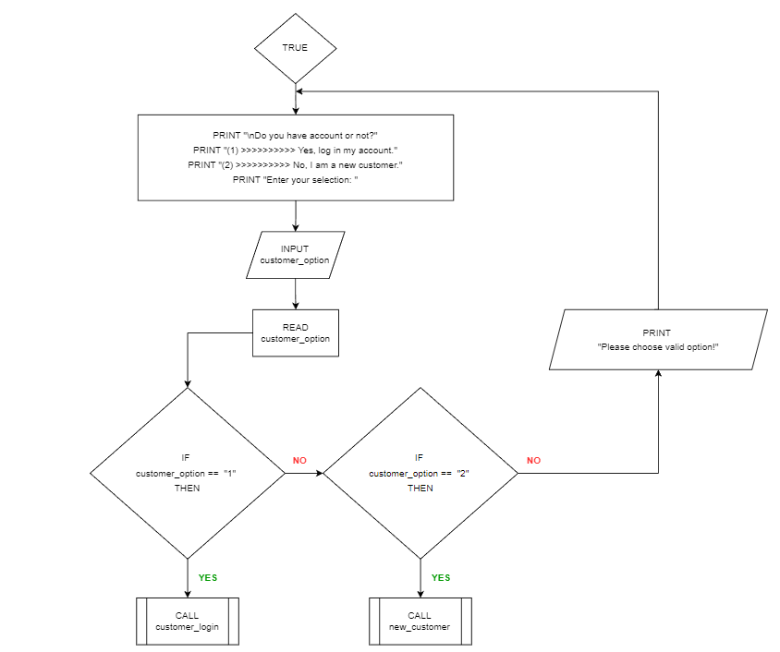

**new_customer function**

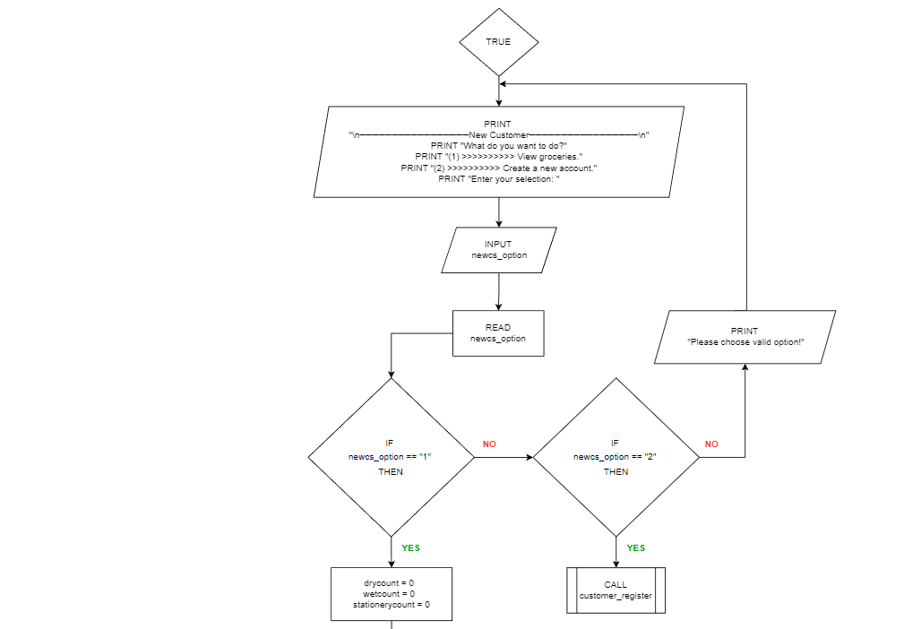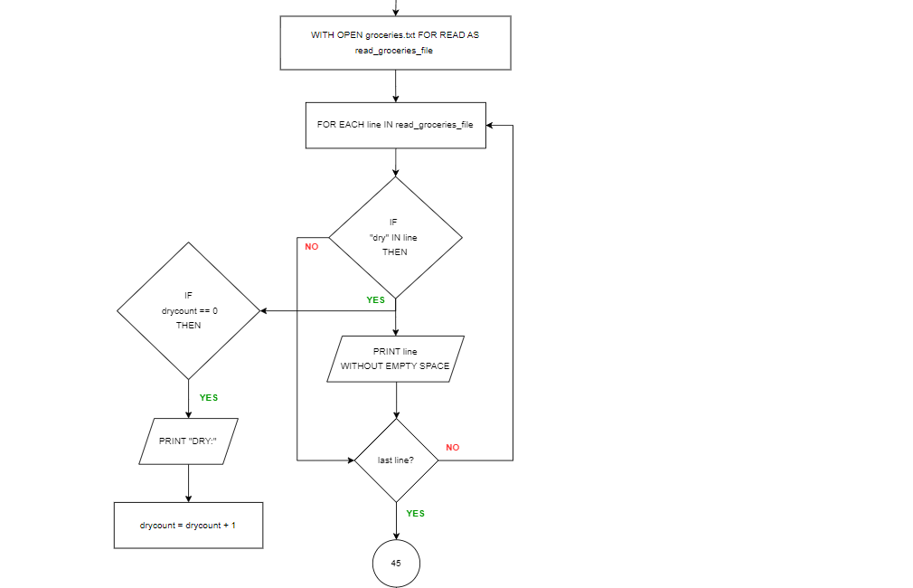

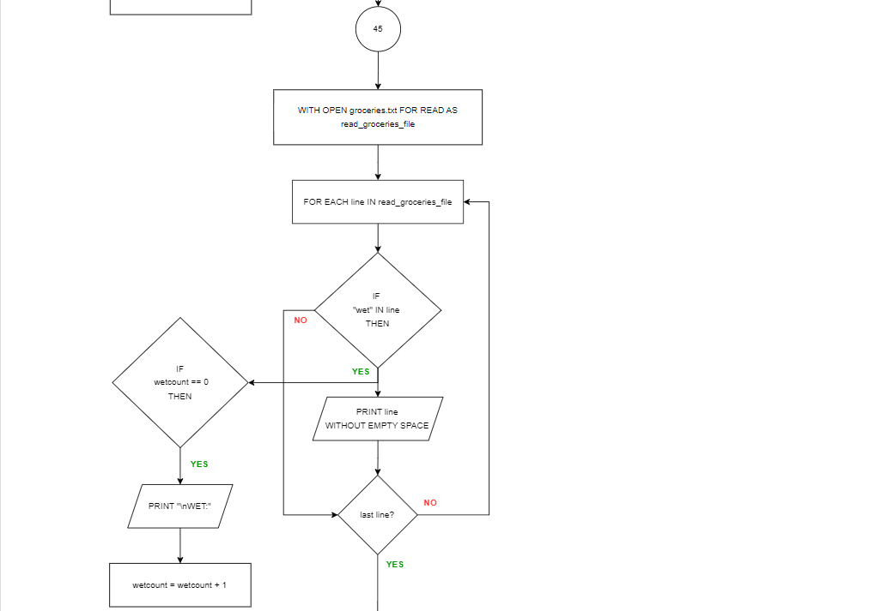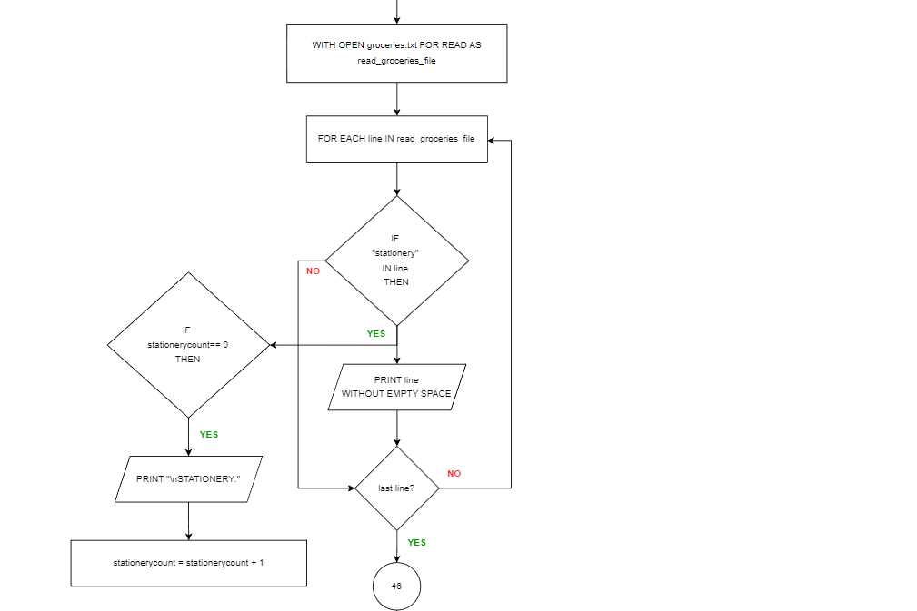

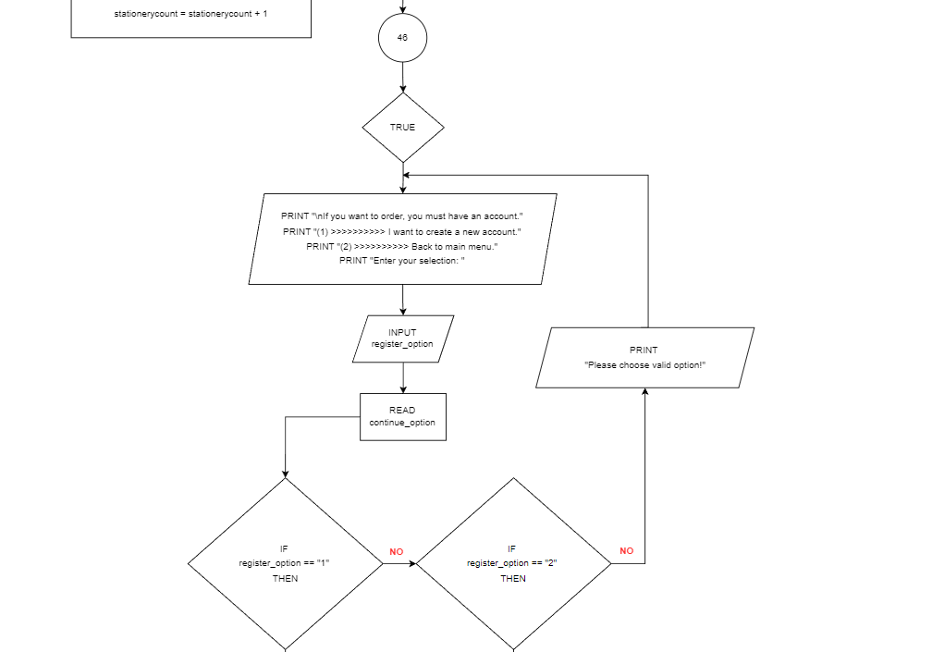

**customer_register function**

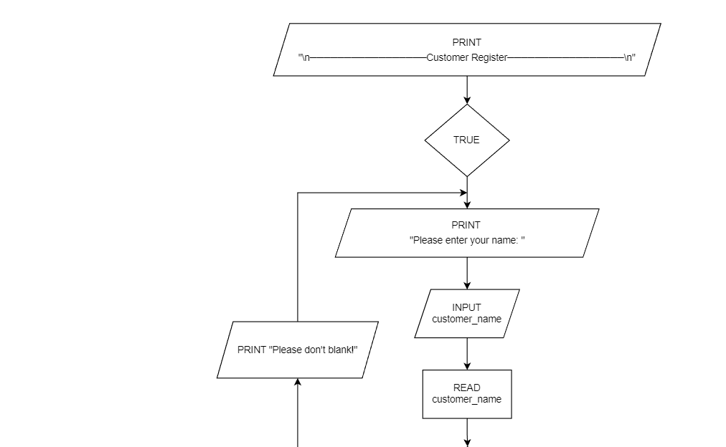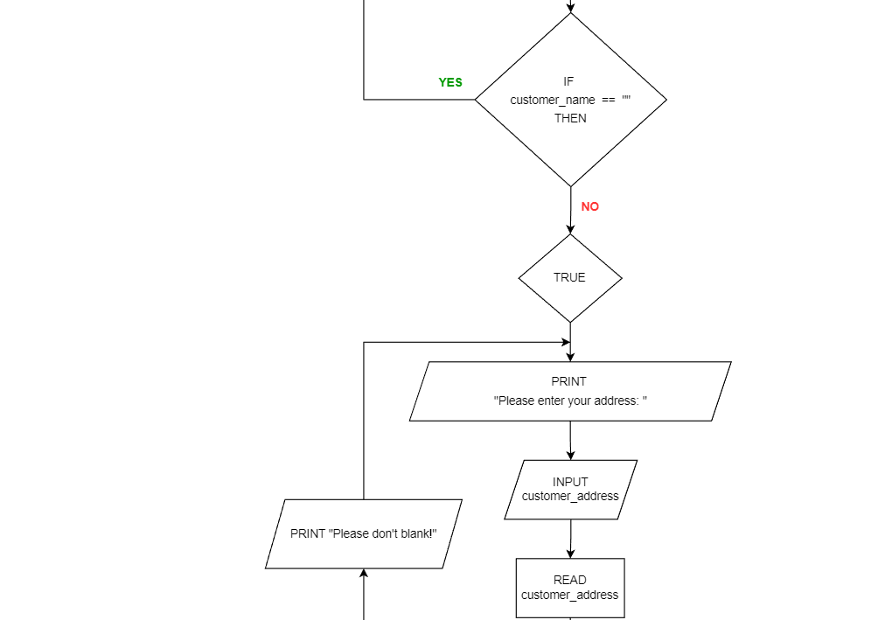



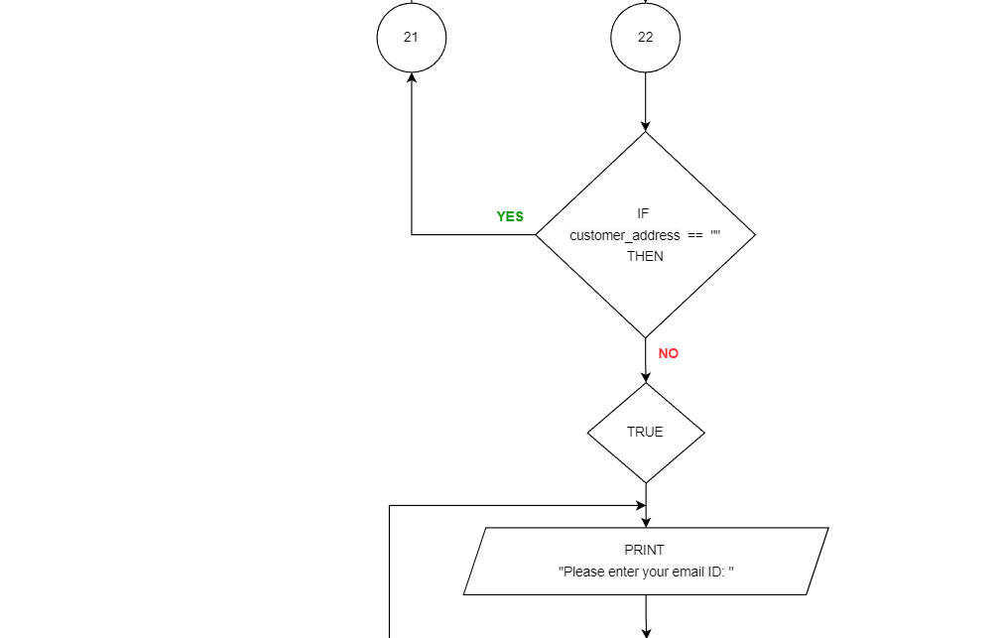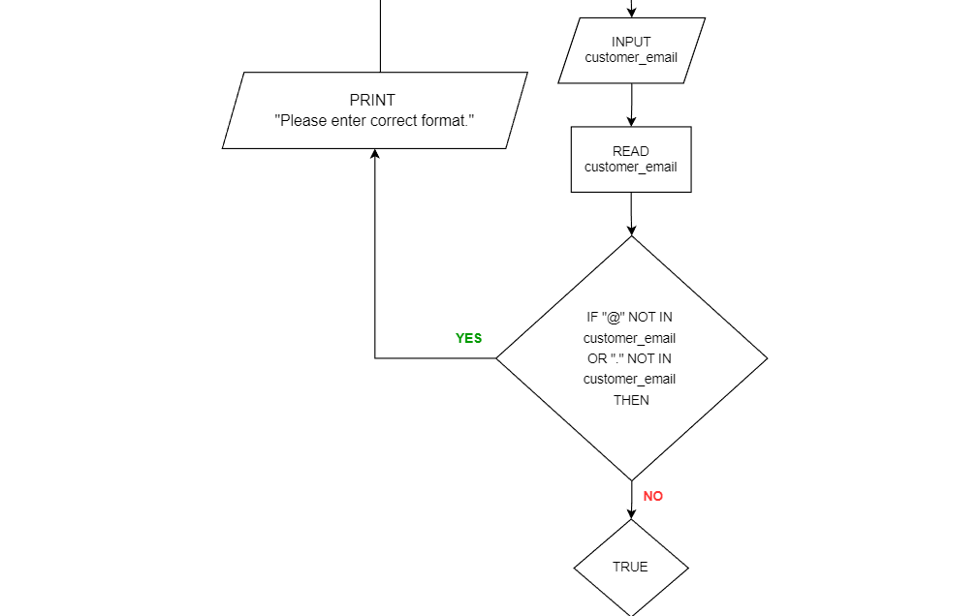

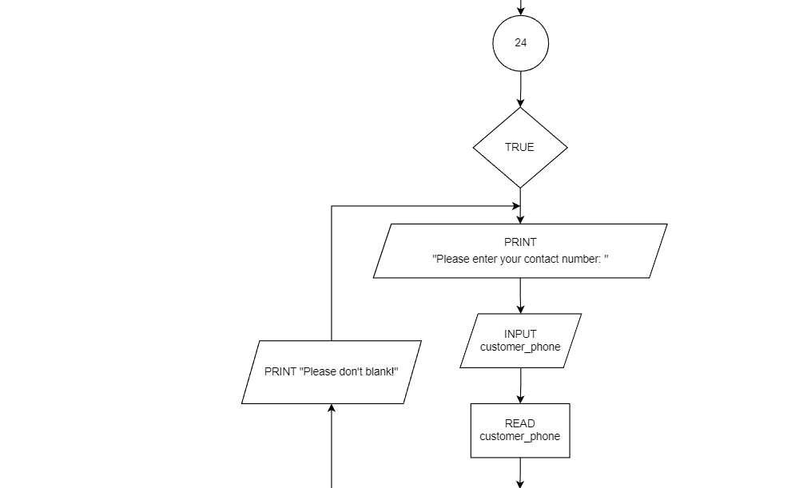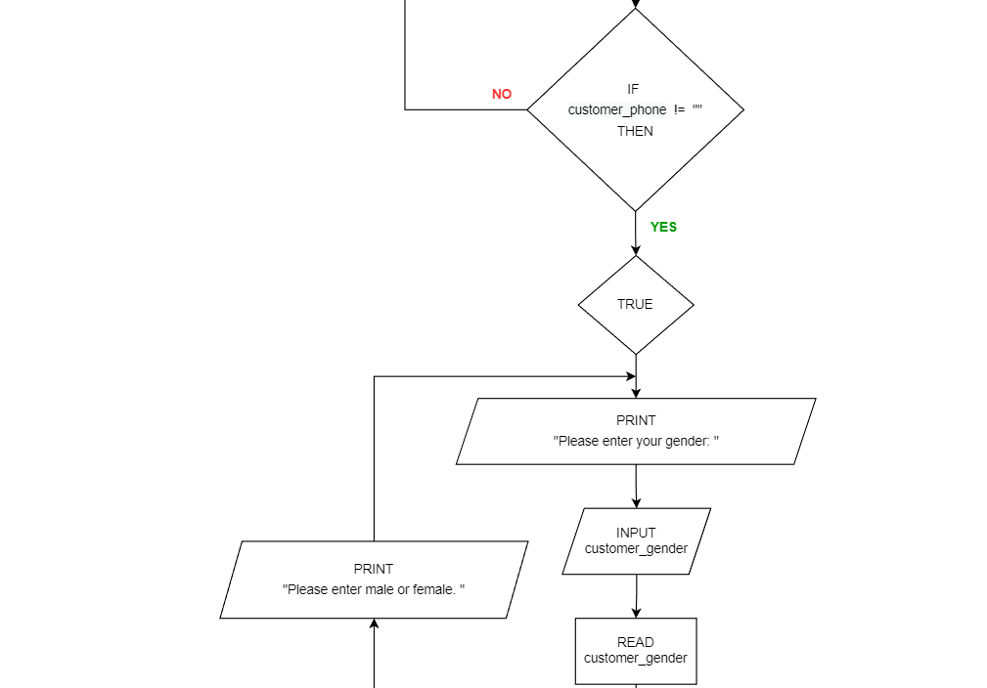

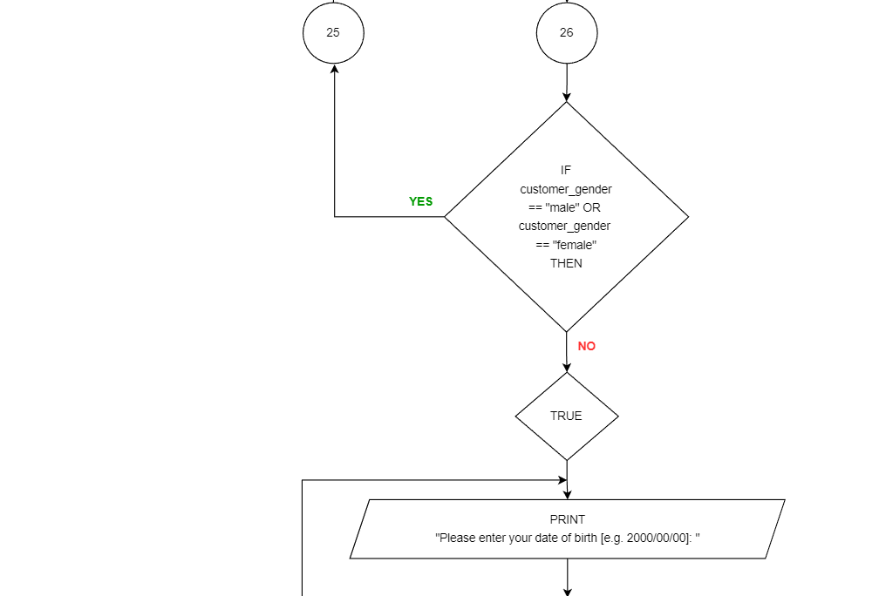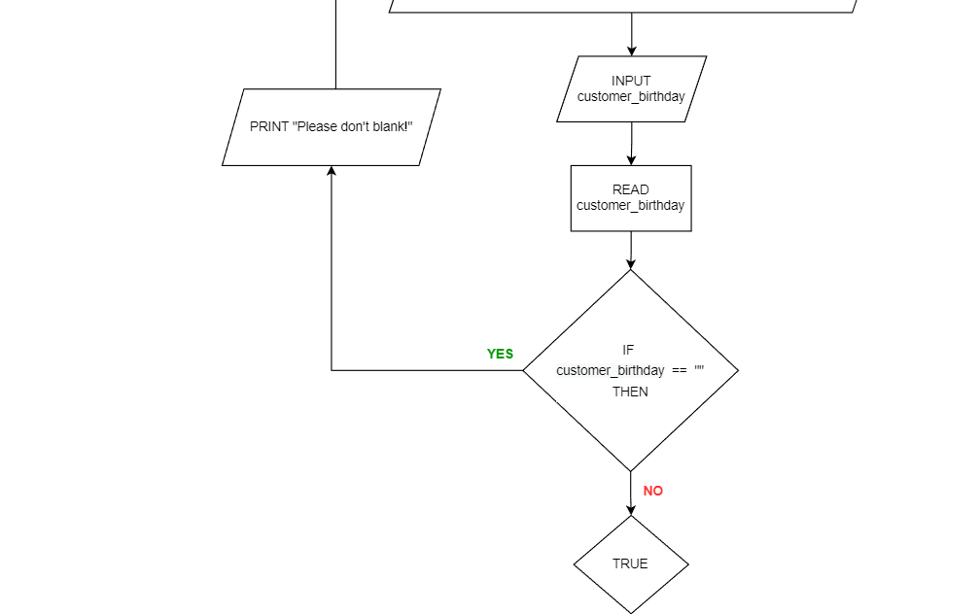

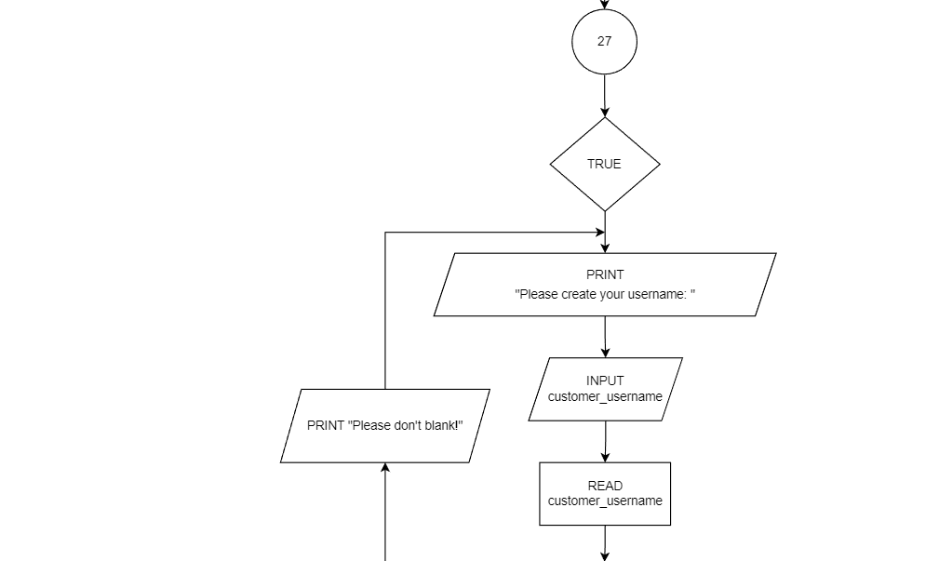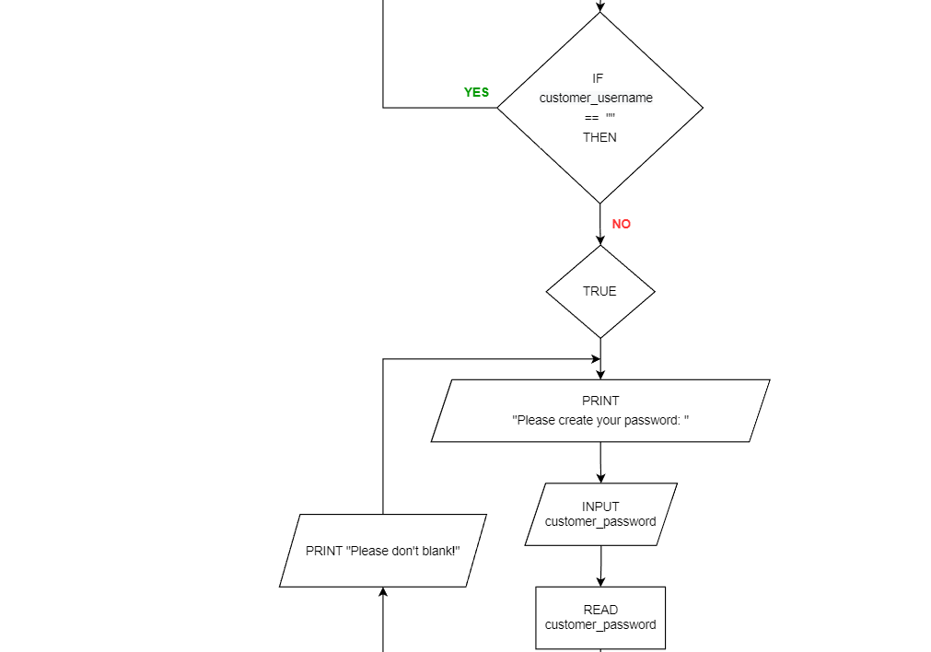

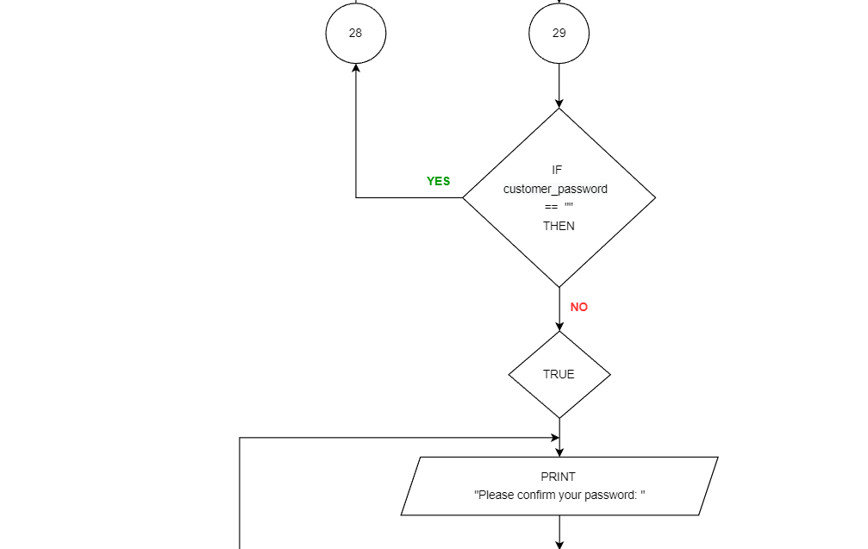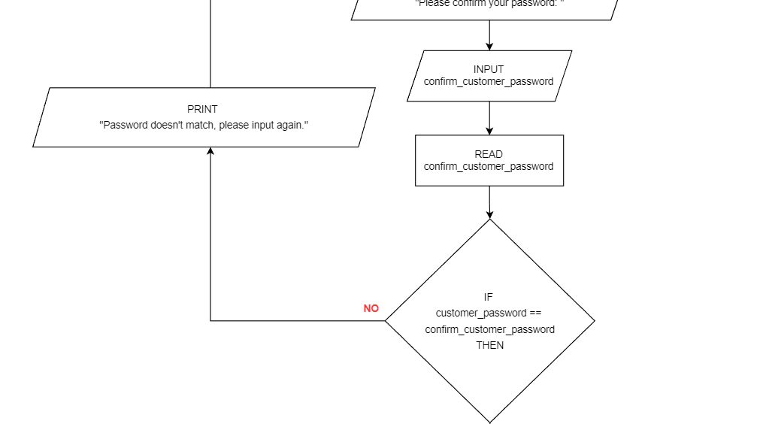

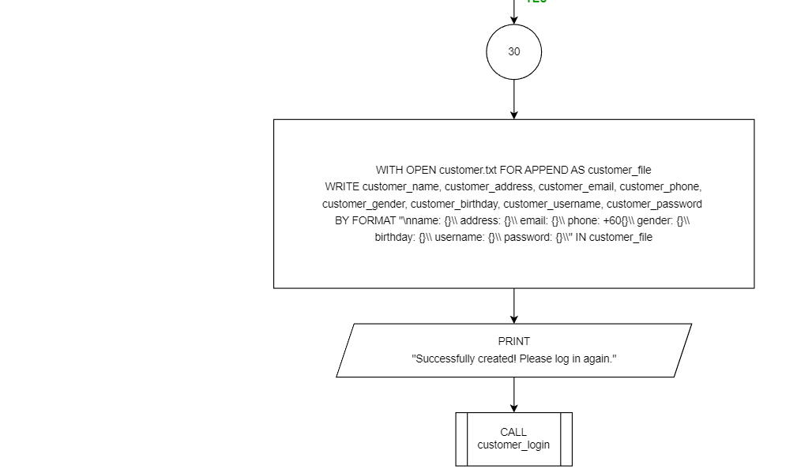

**customer_login function**

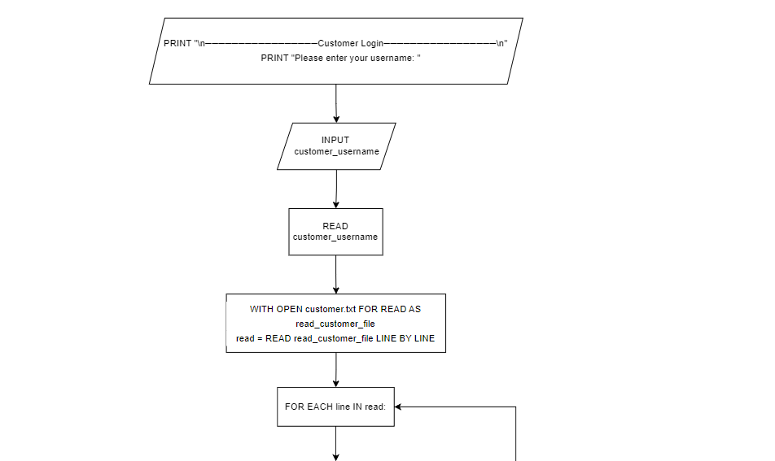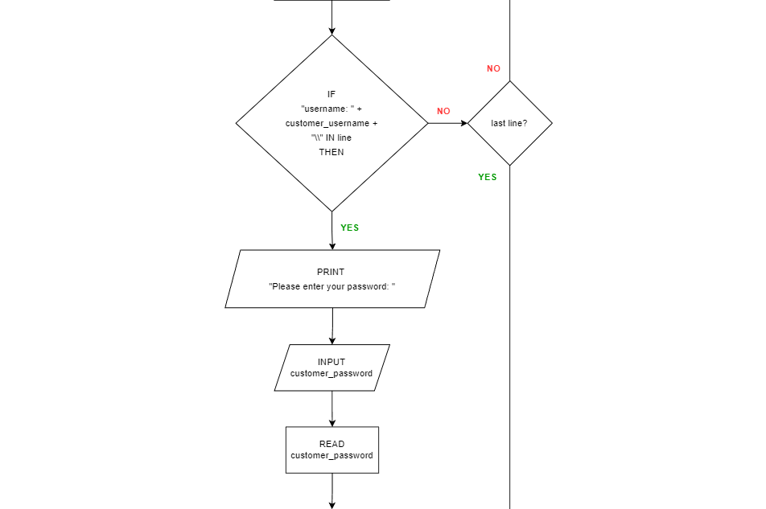

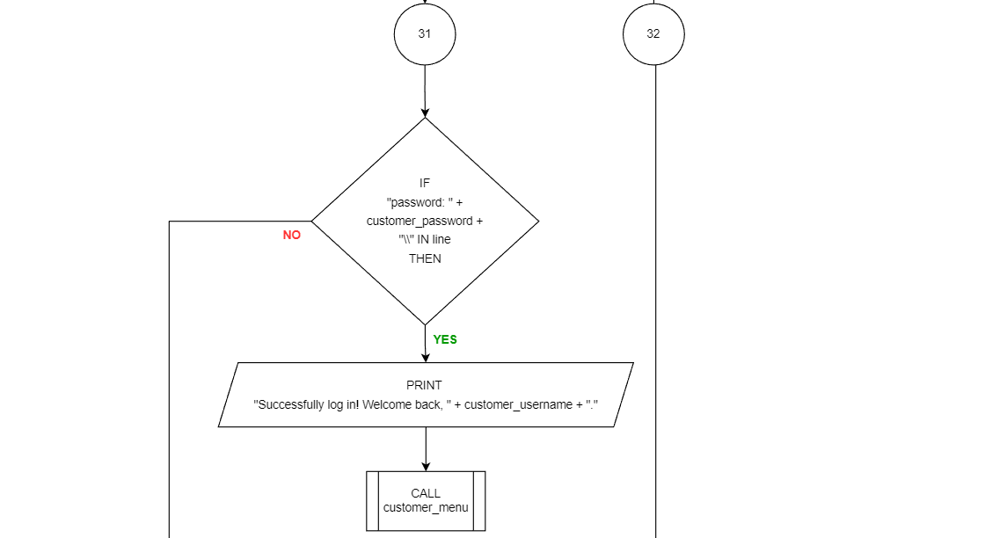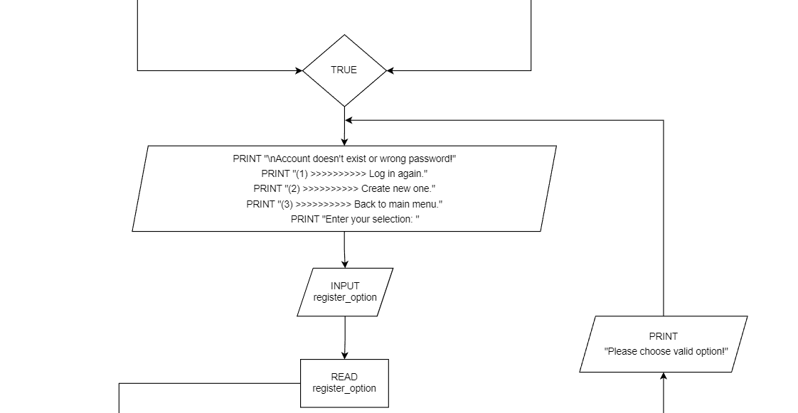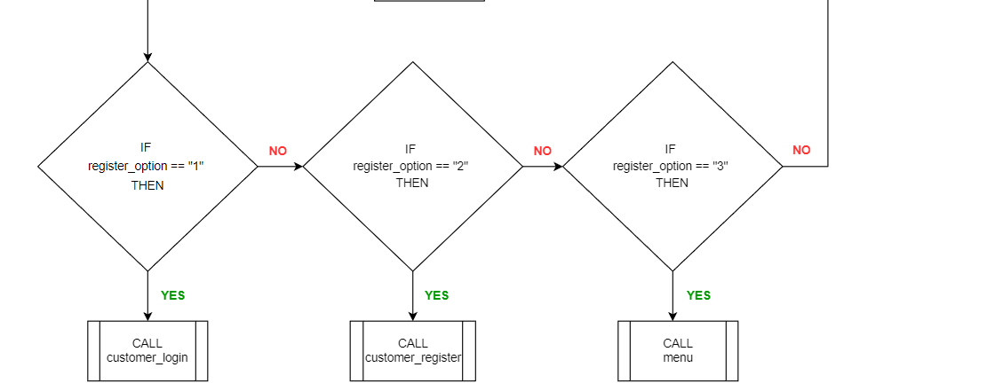

**customer_menu function**

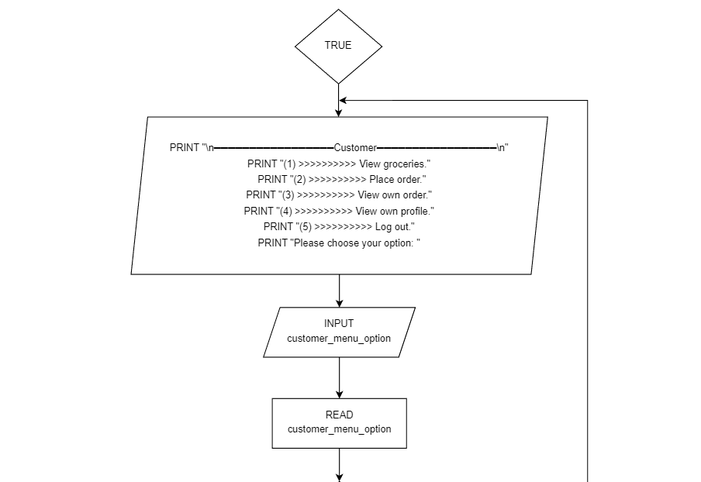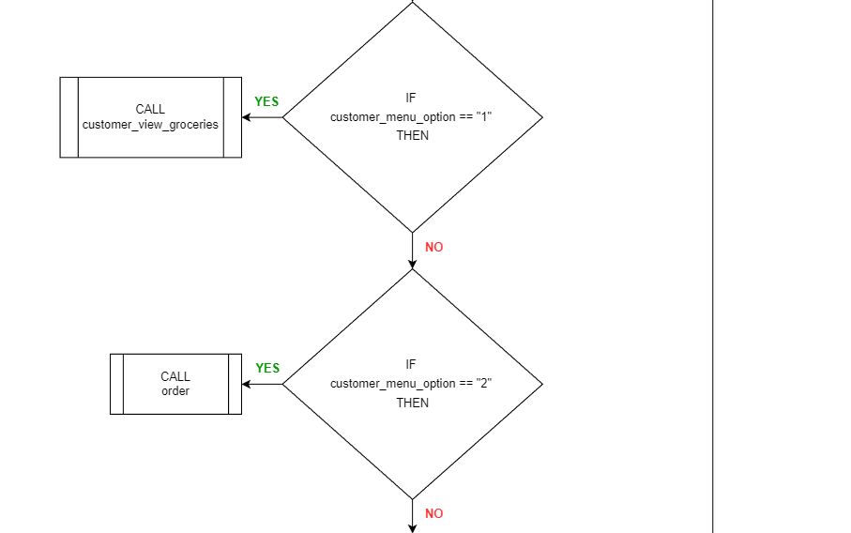

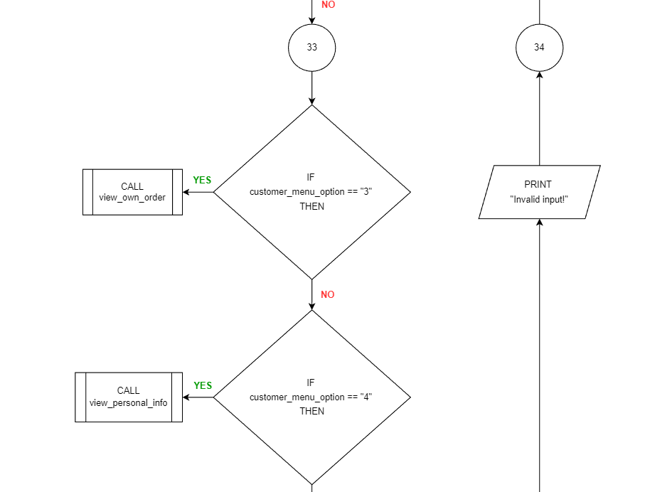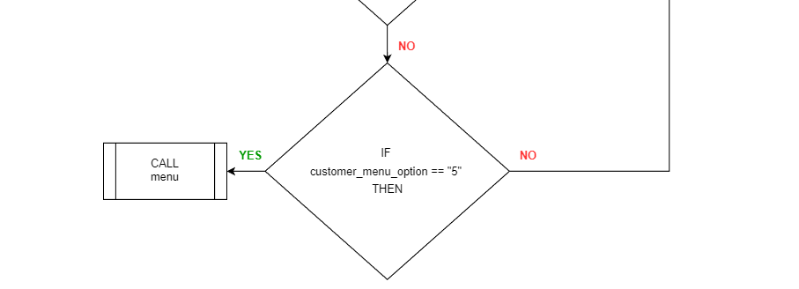

**customer_view_groceries function**

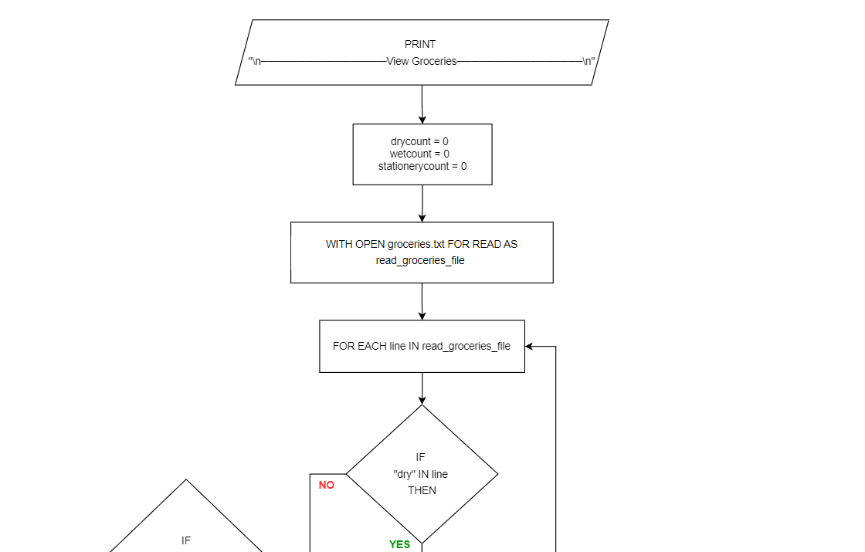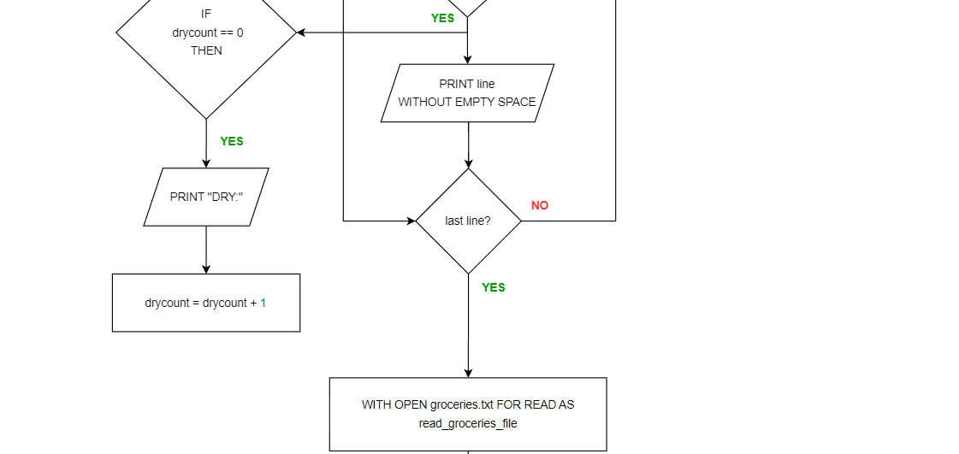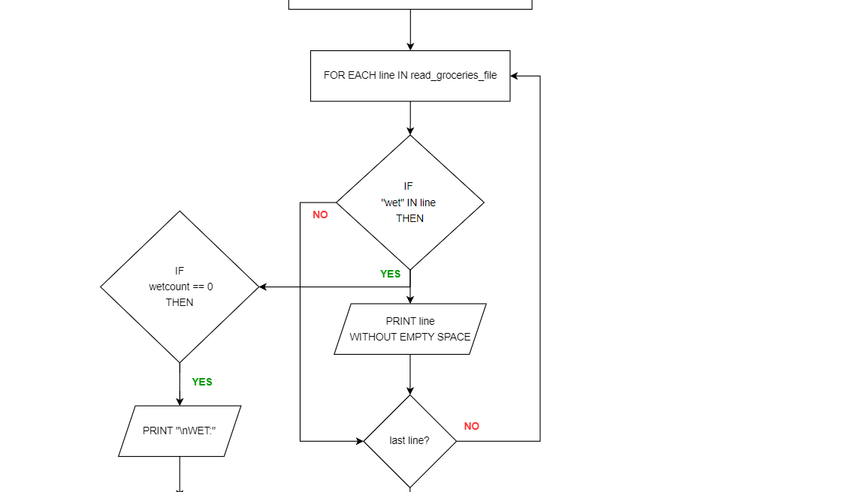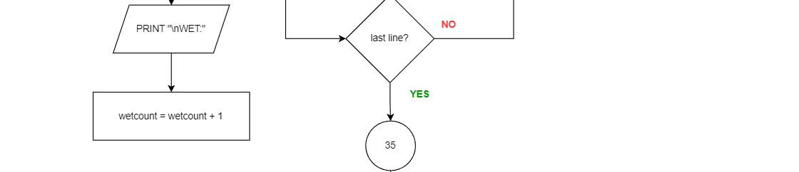

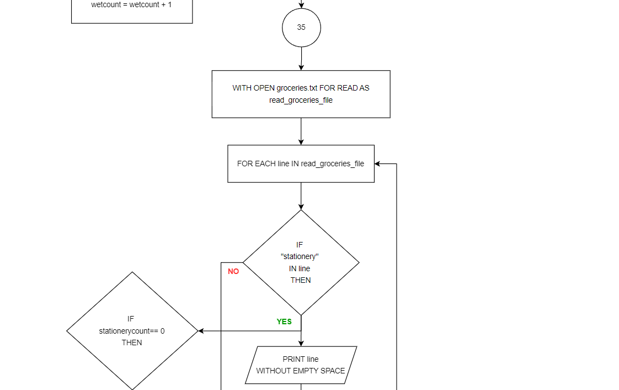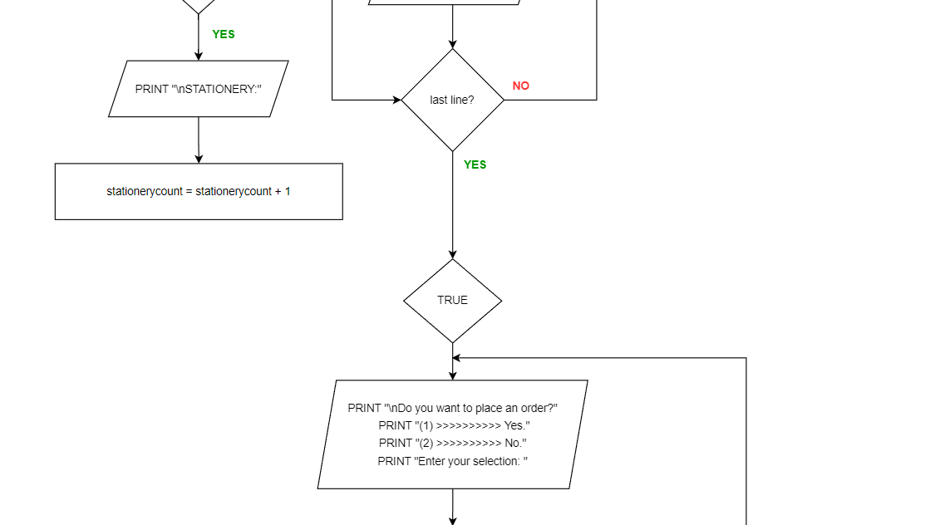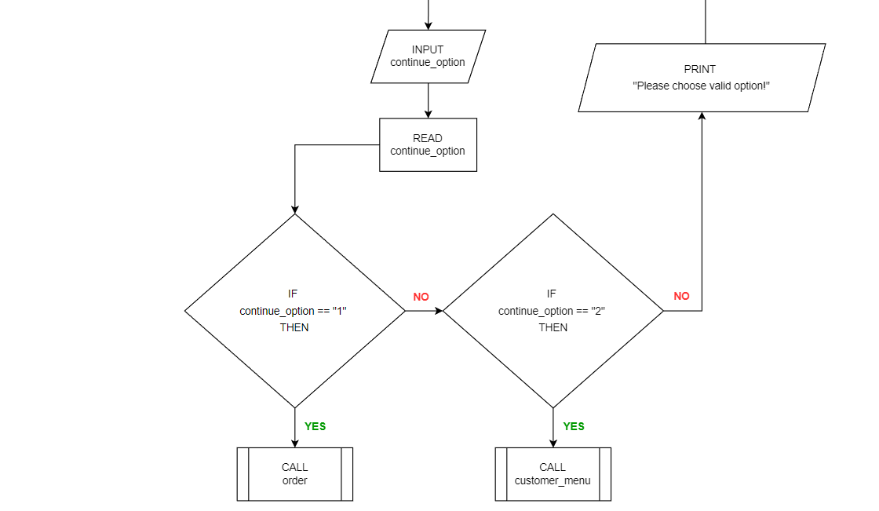

**order function**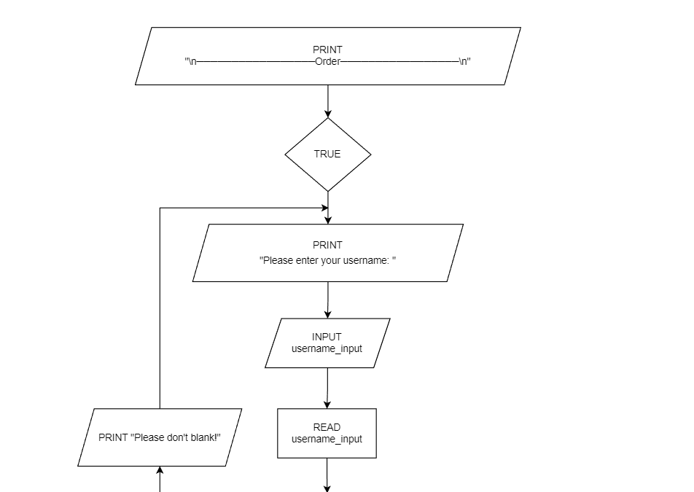

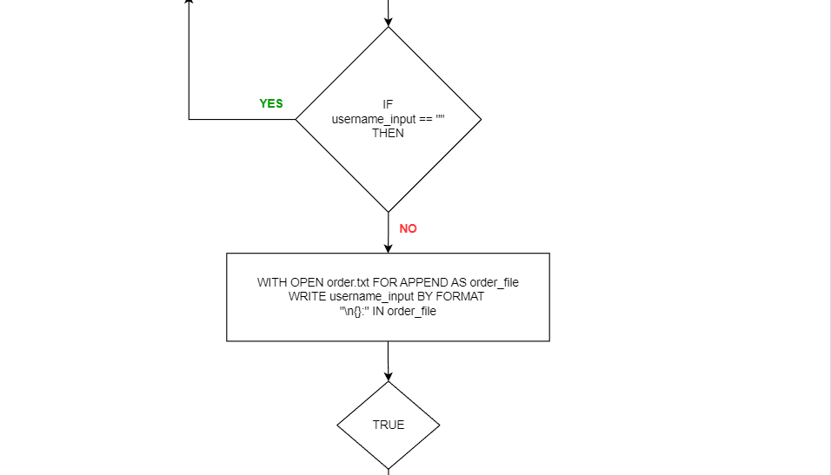

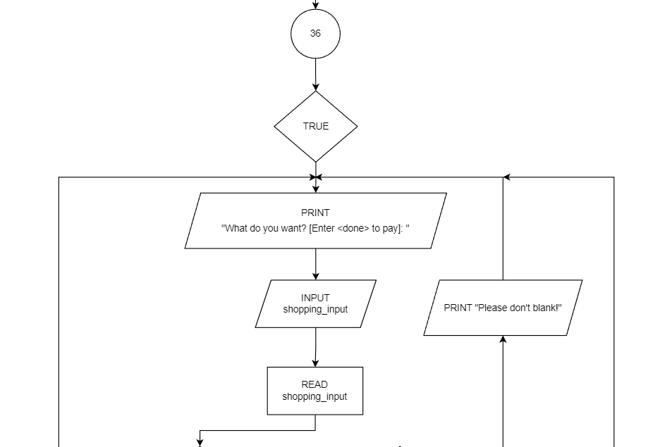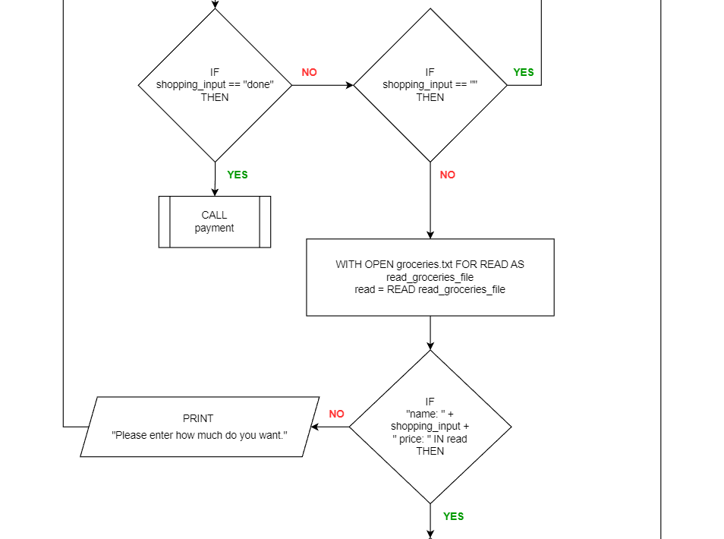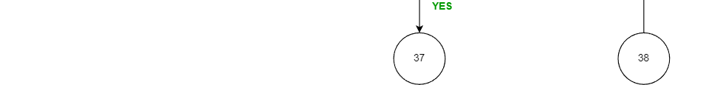

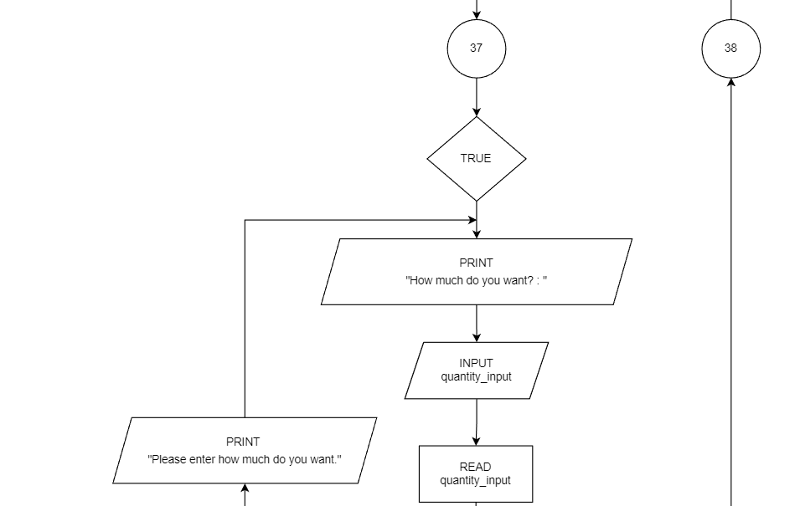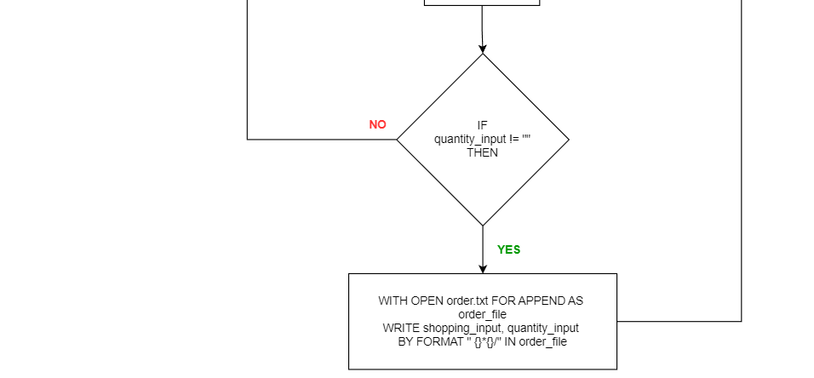

**payment function**

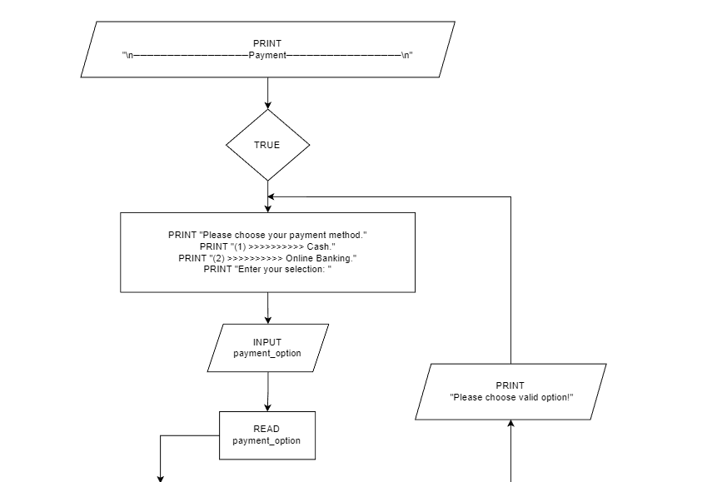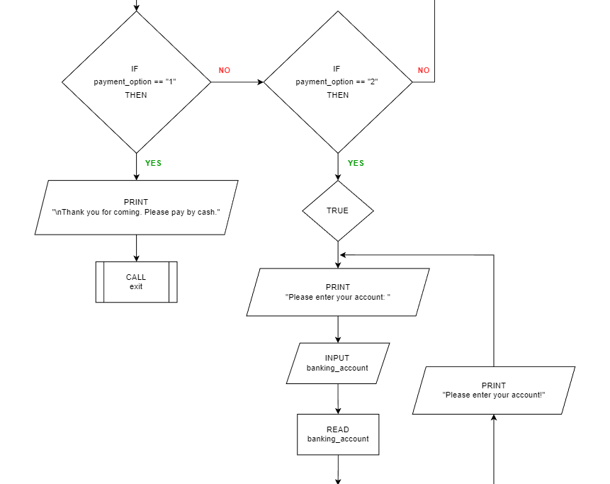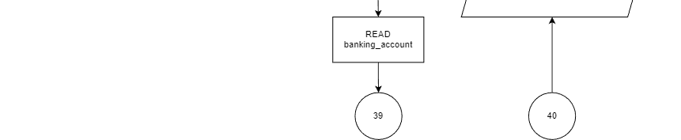

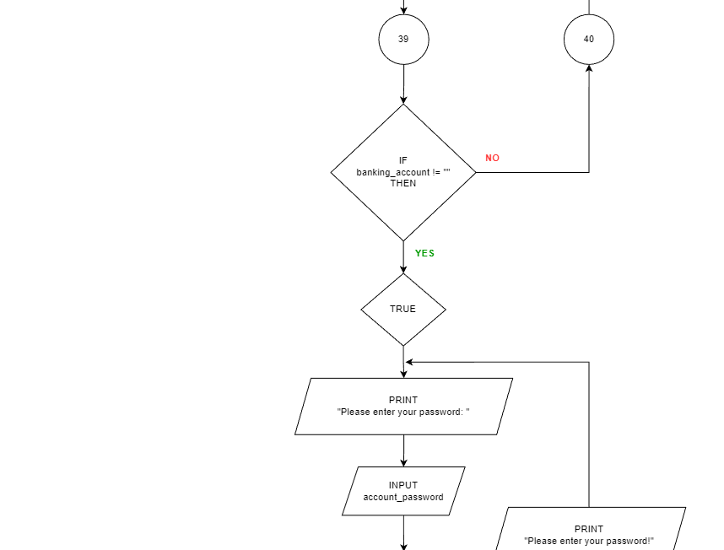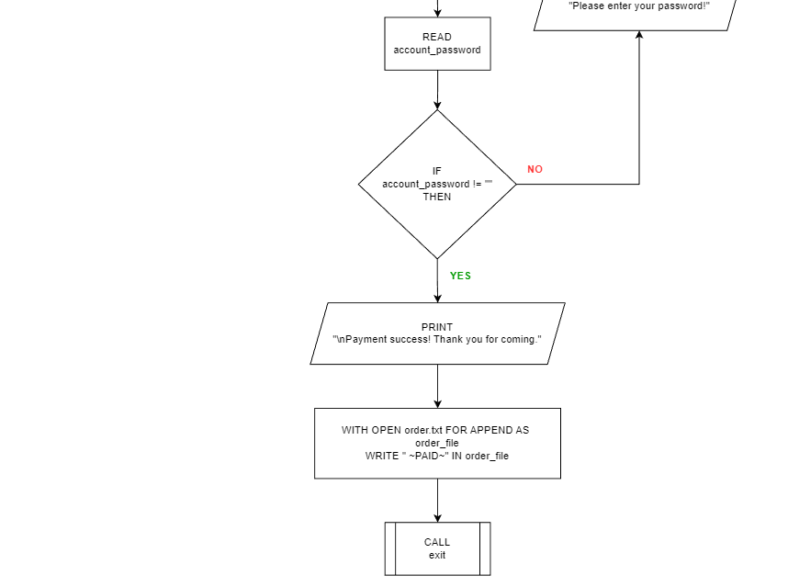

**view_own_order function**

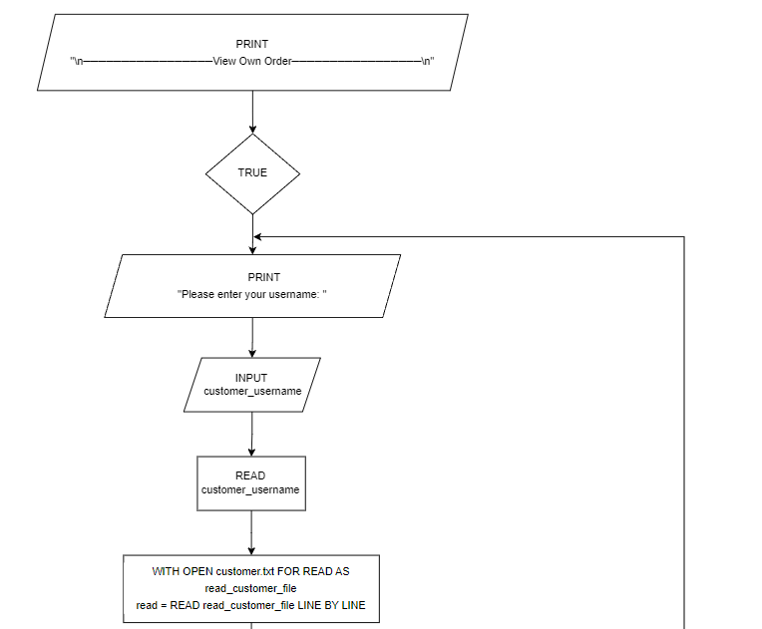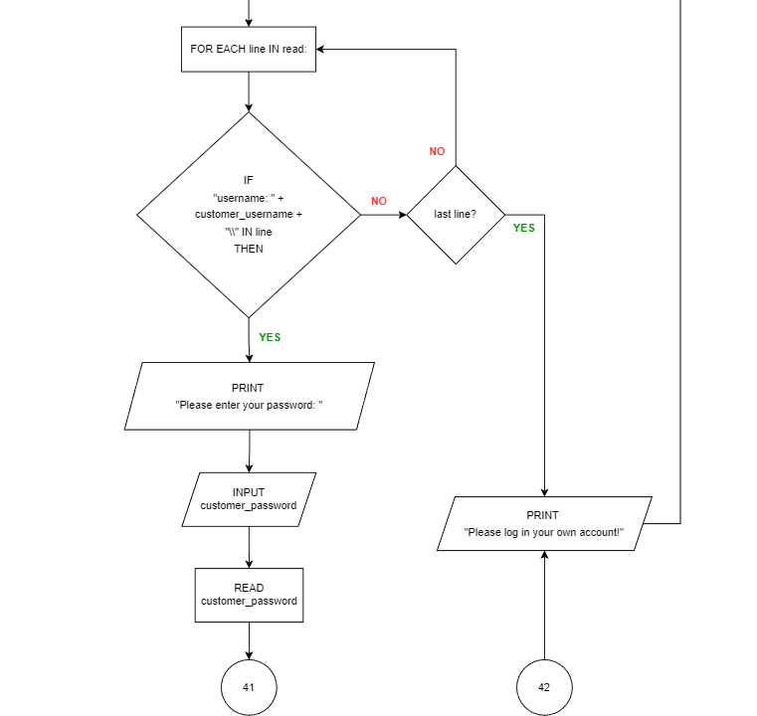

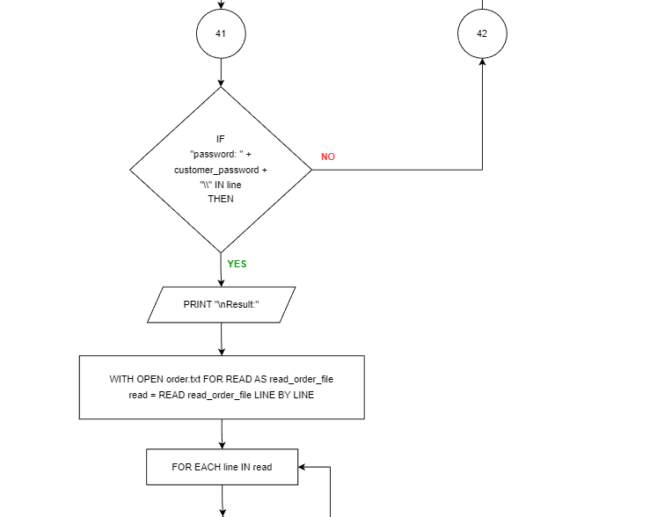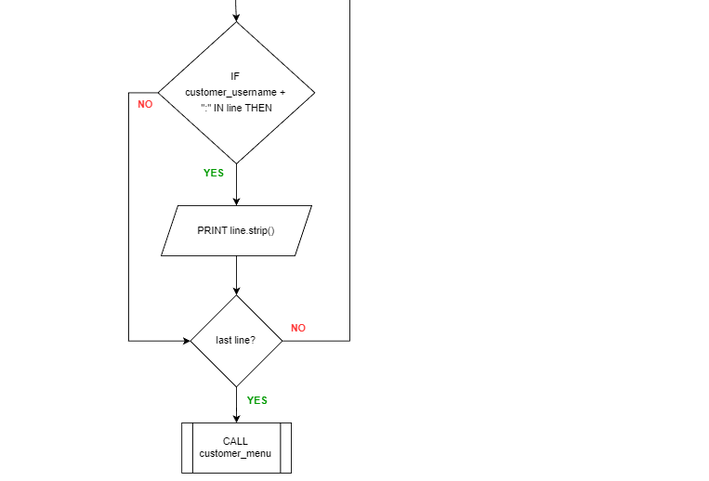

**view_personal_info function**

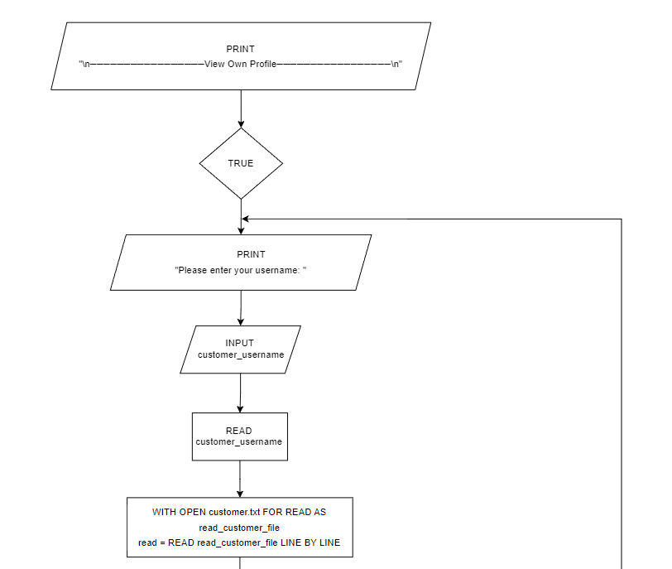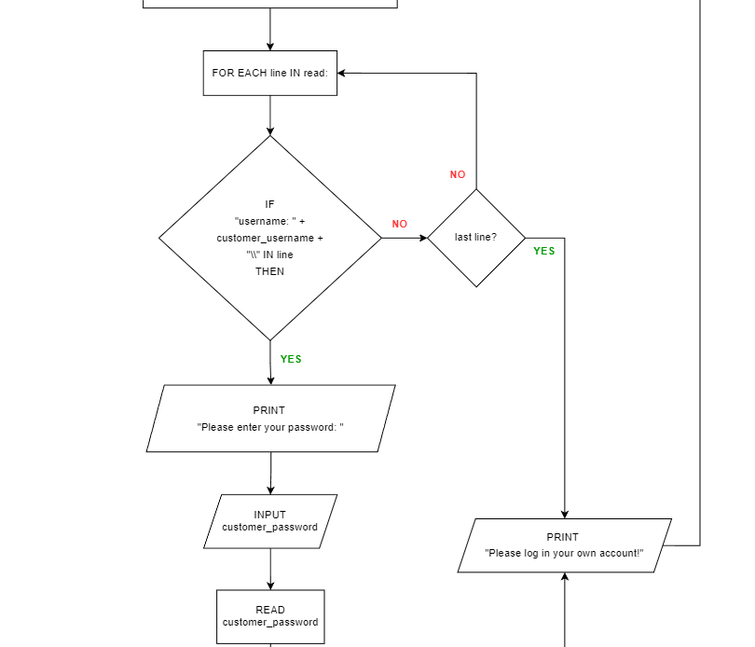

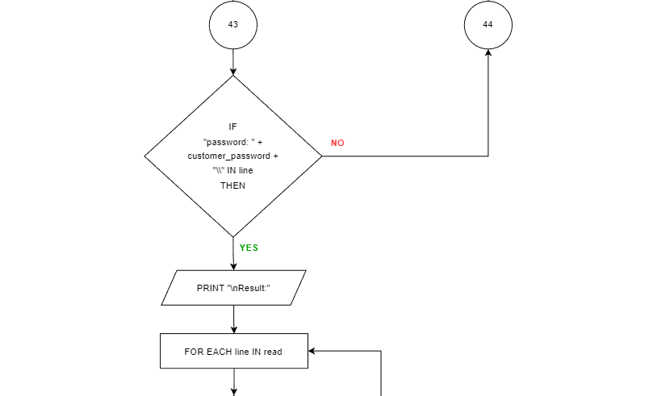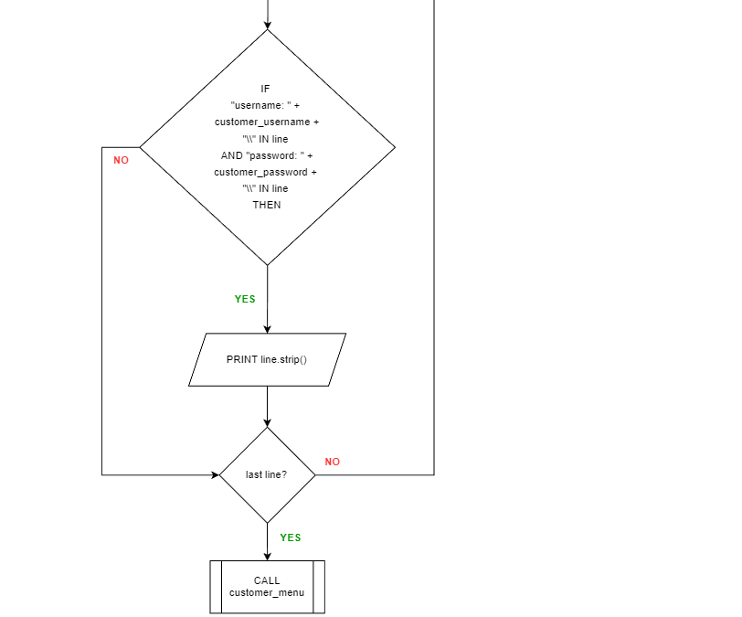

**call overall program**

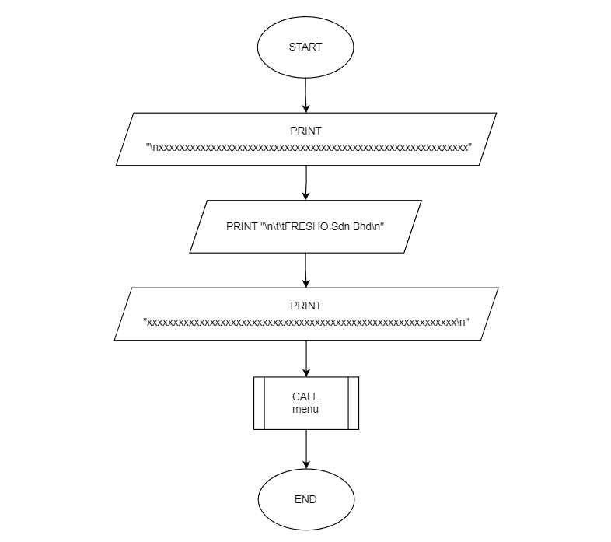

# **4.0 Program Source Code and Explanations**

**menu function**

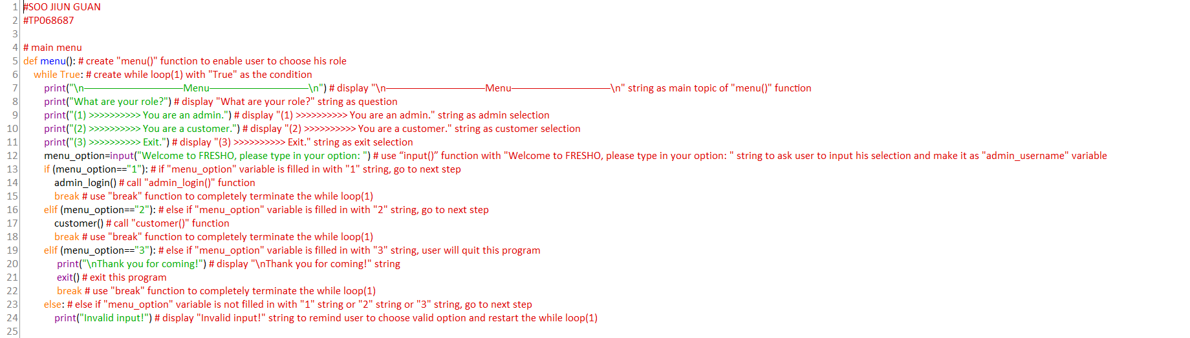

**admin_login function**

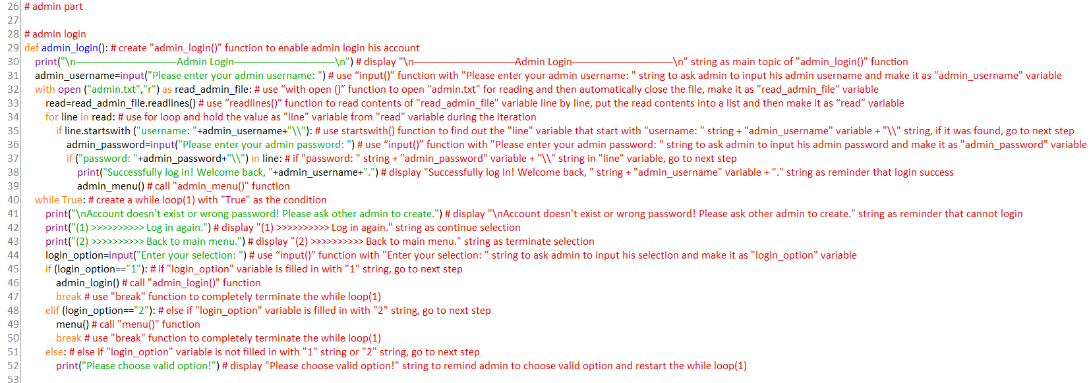

**admin_menu function**

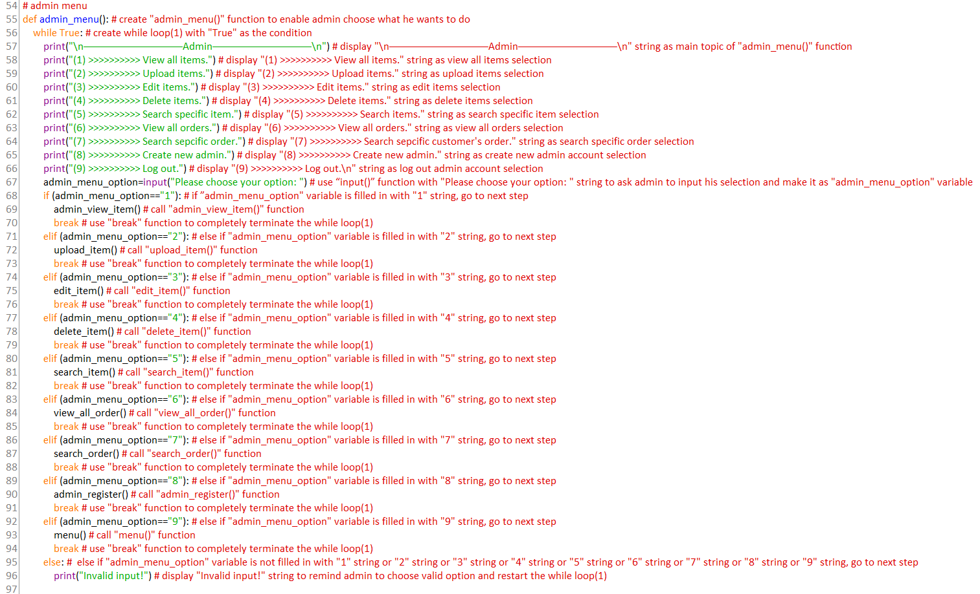

**admin_view_item function**

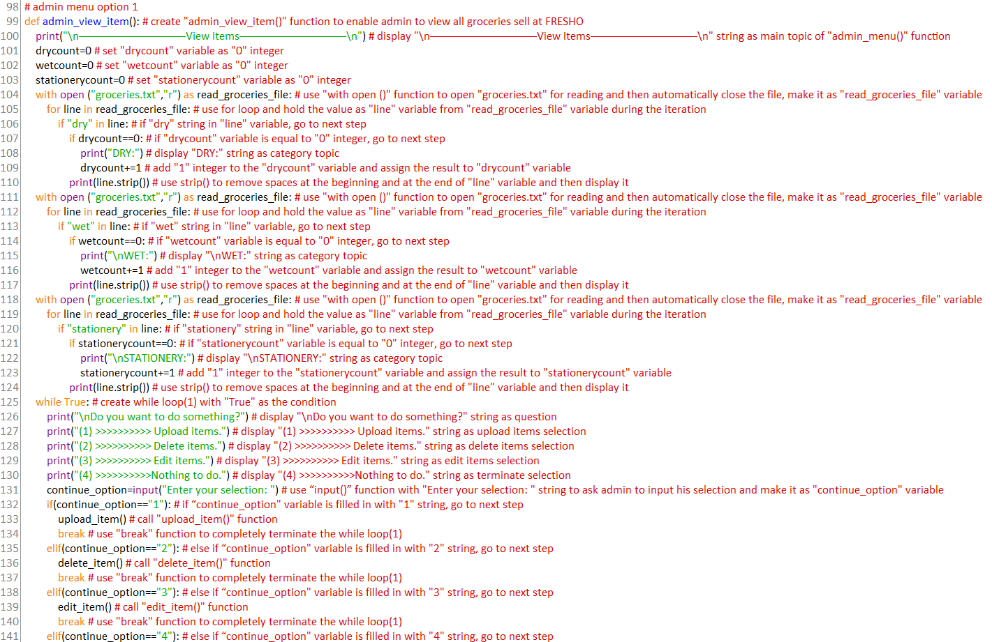

**upload_item function**

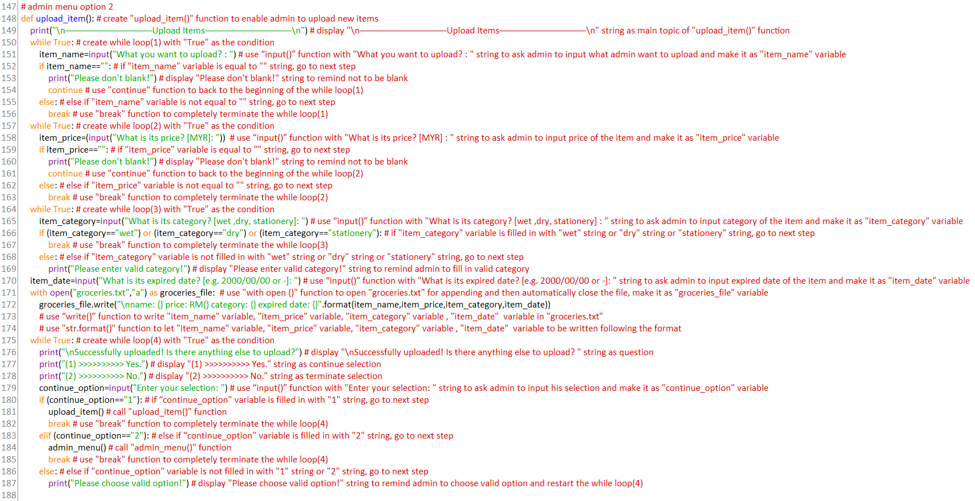

**edit_item function**

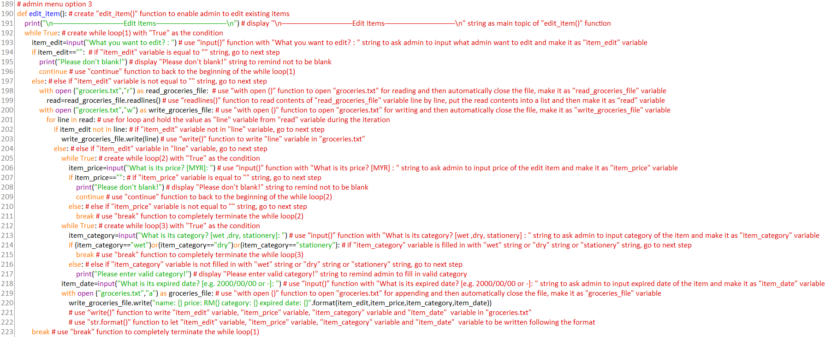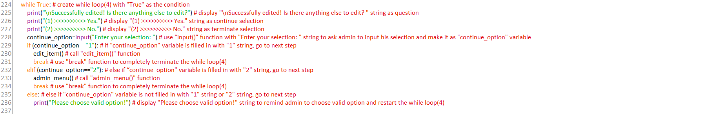

**delete_item function**

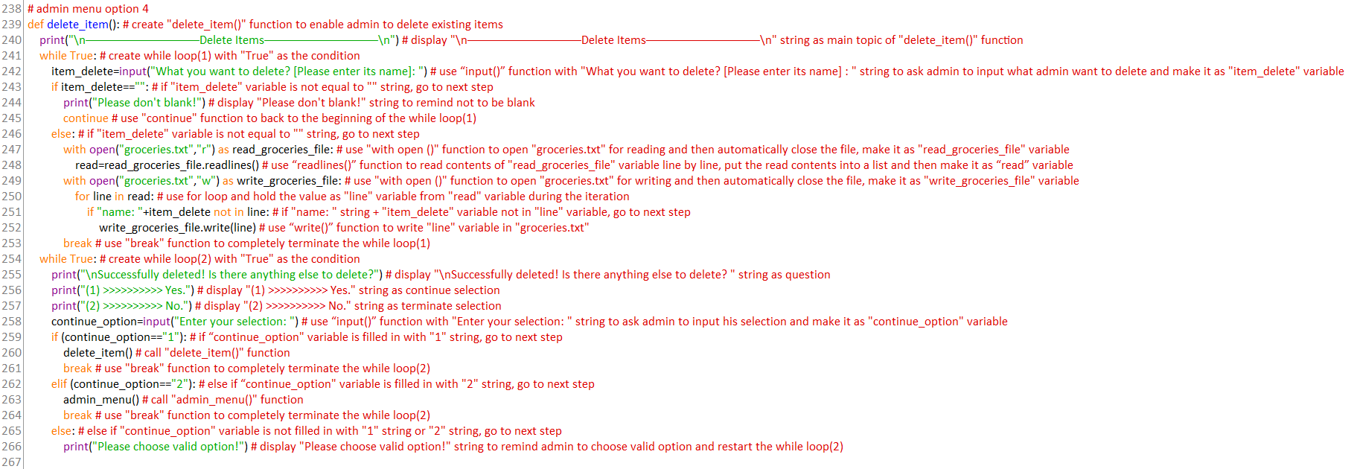

**search_item function**

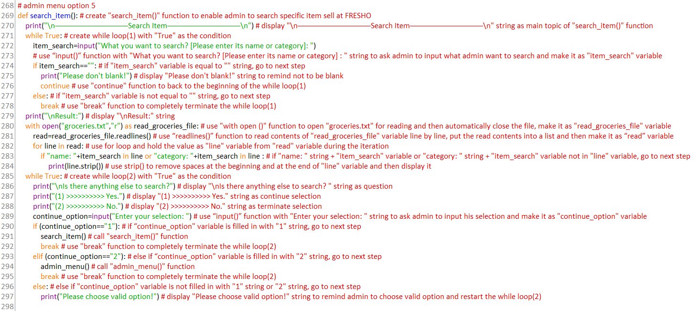

**view_all_order function**

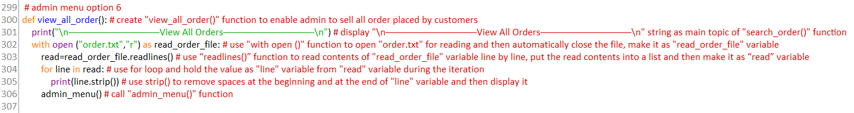

**search_order function**

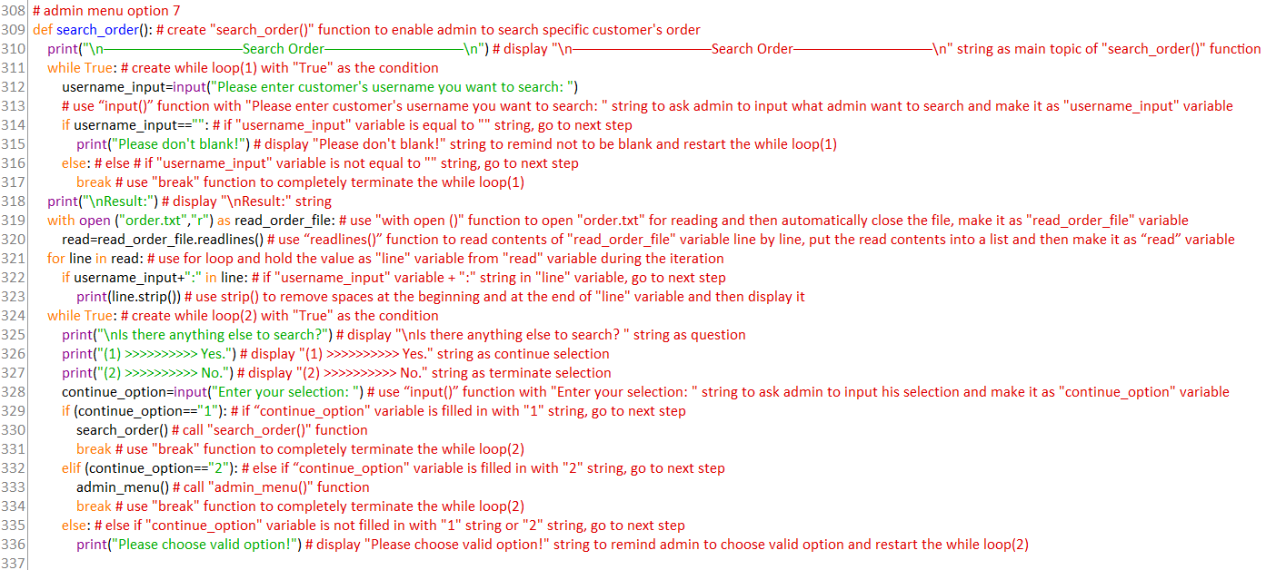

**admin_register function**

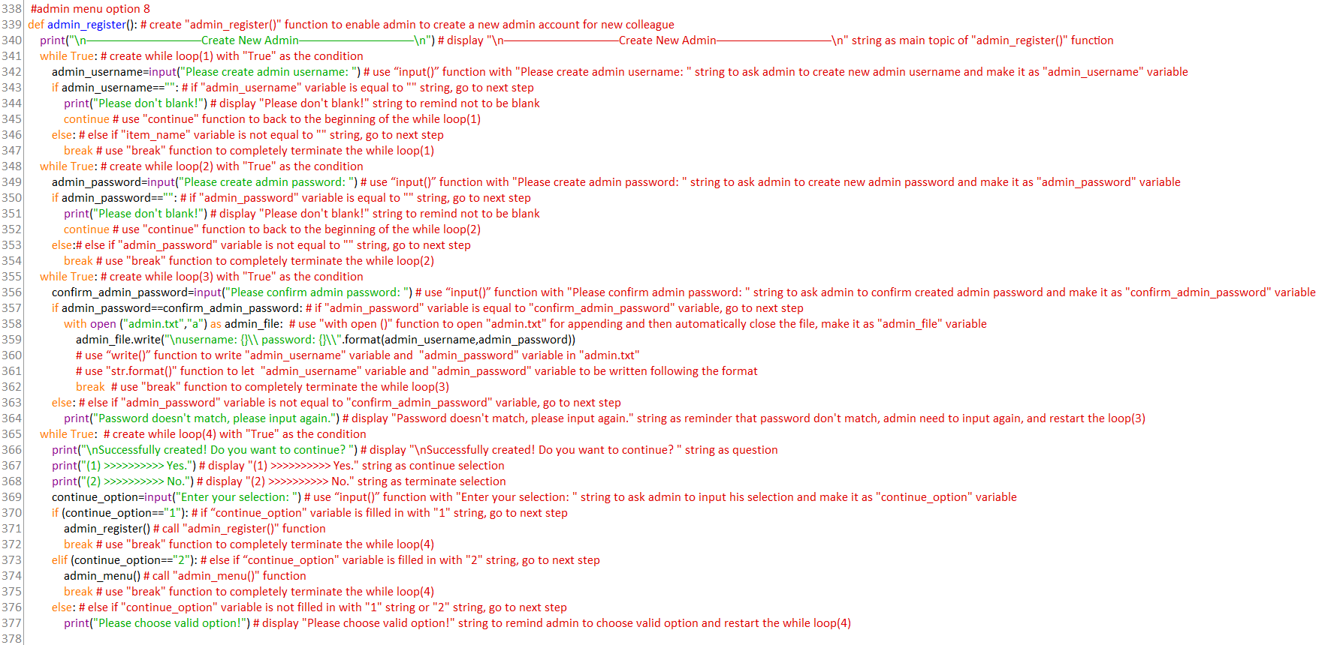

**customer function**

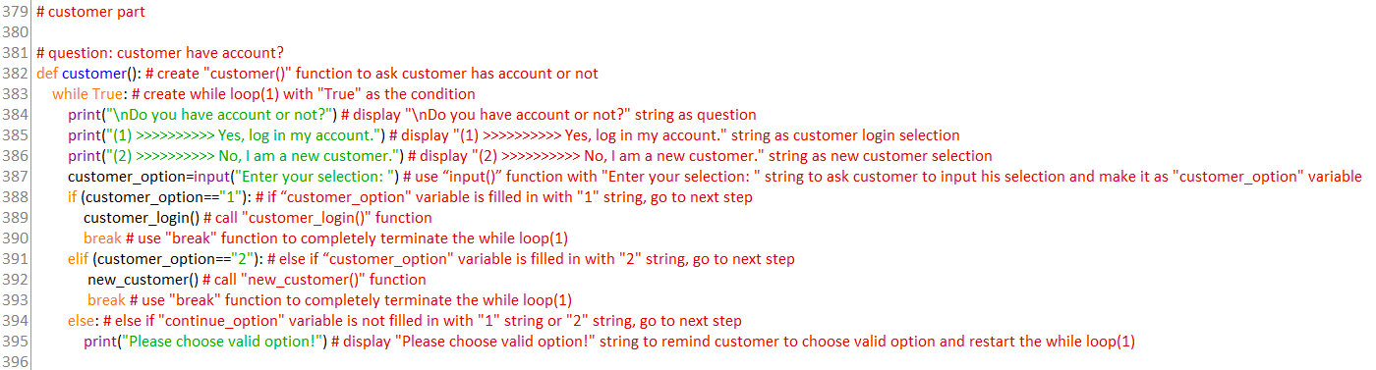

**new_customer function**

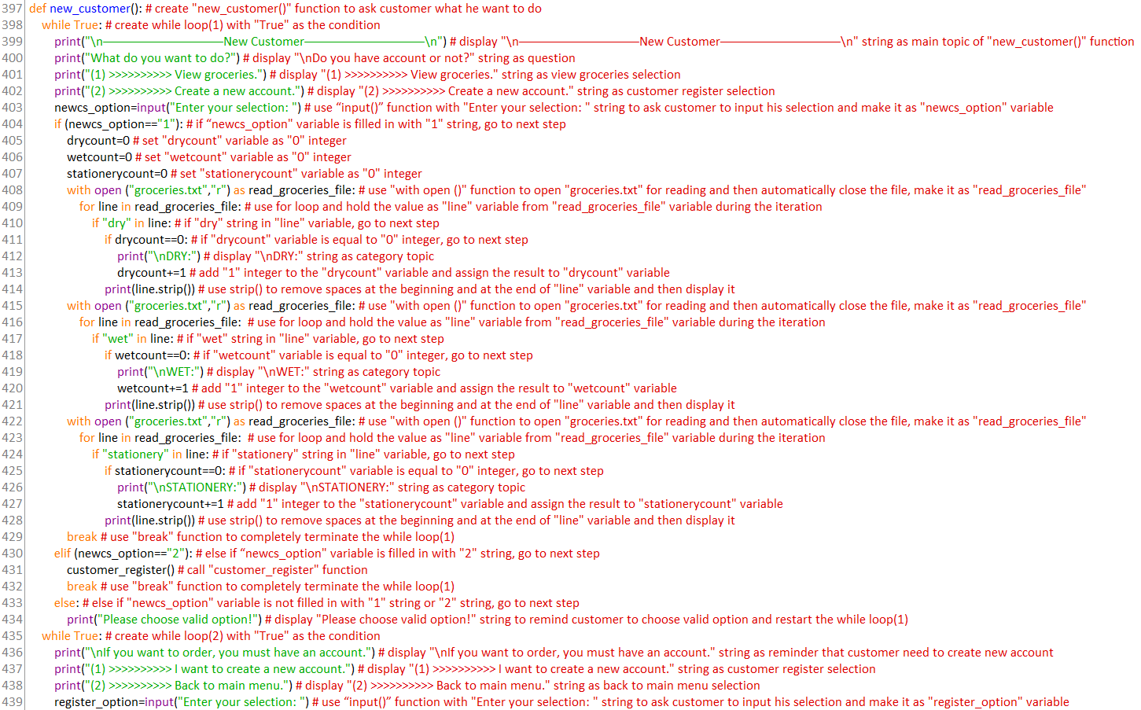 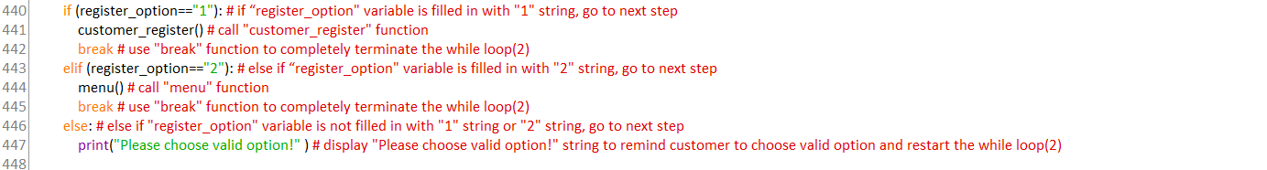

**customer_register function**

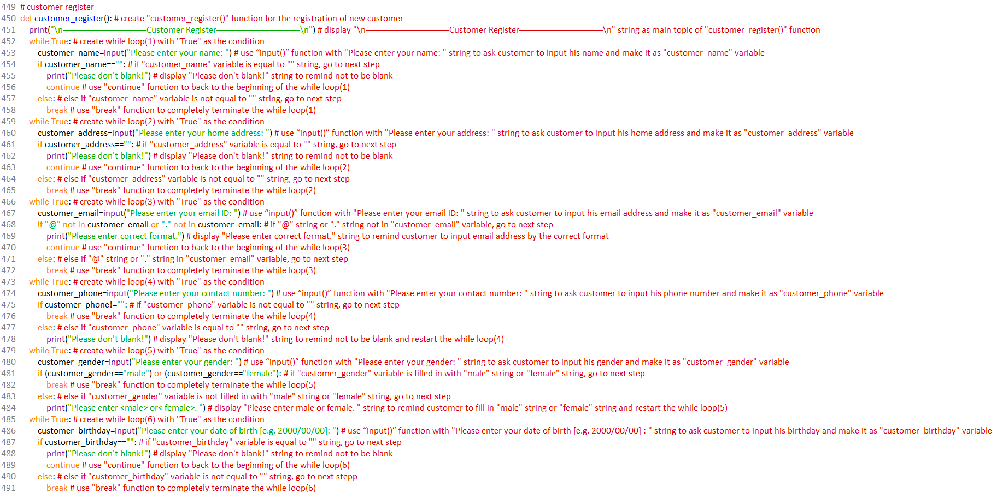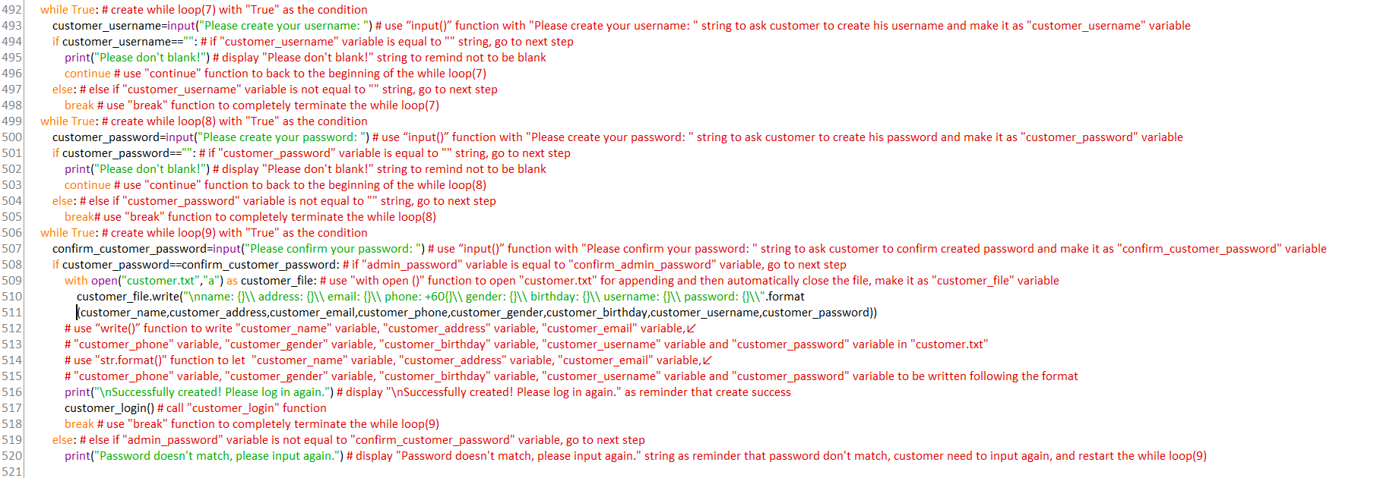



**customer_login function**

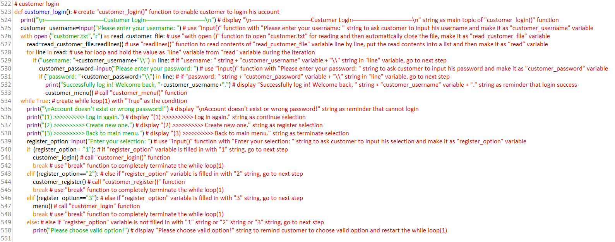

**customer_menu function**

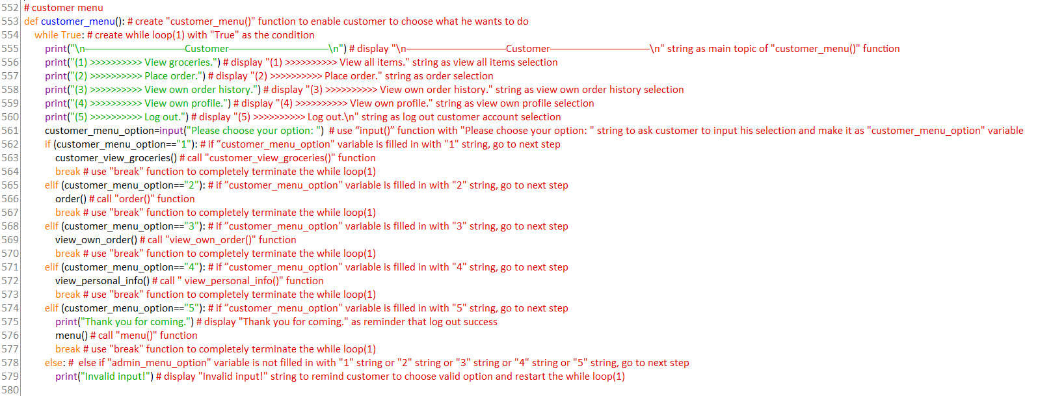

**customer_view_groceries function**

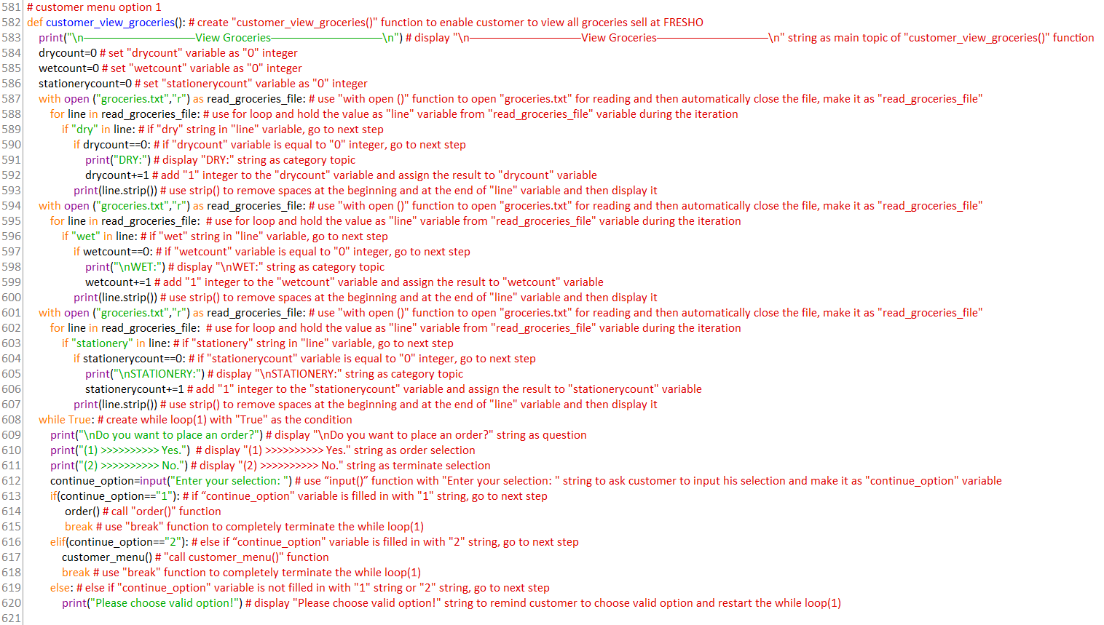

**order function**

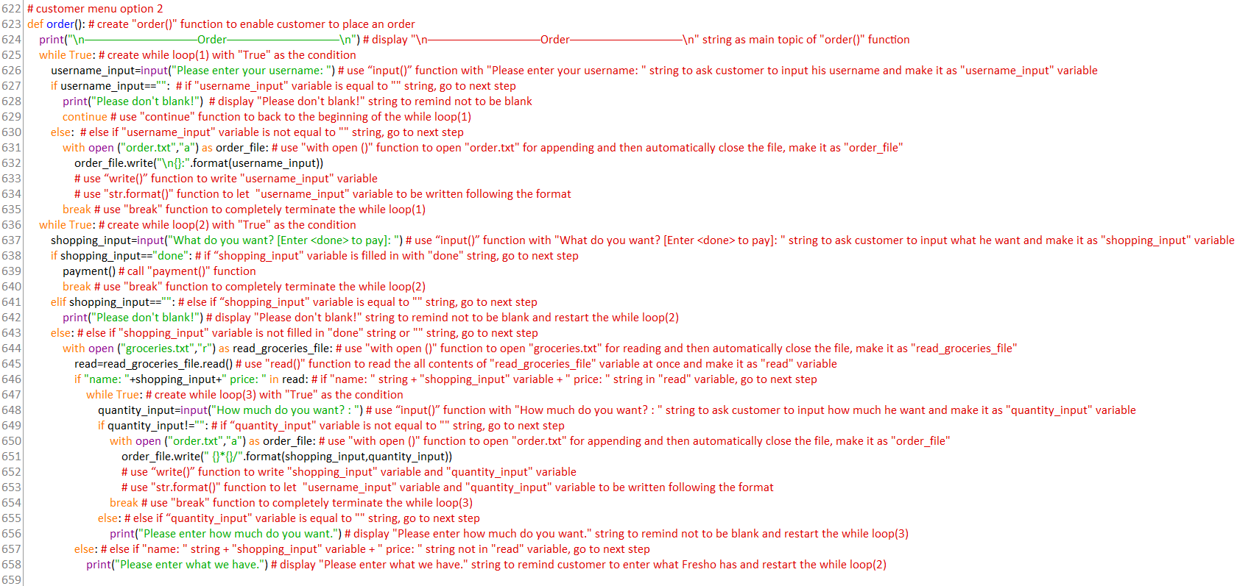

**payment function**

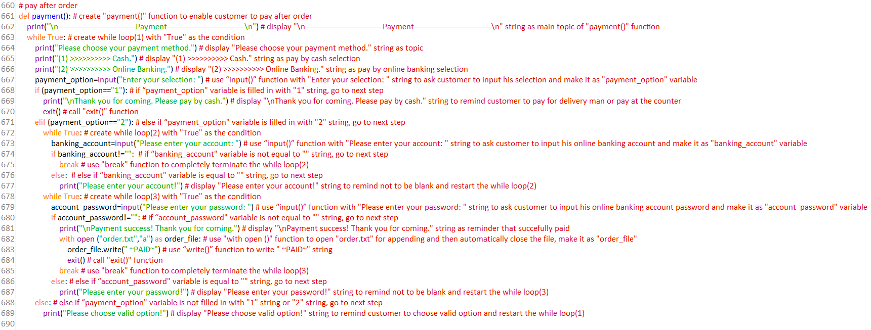

**view_own_order function**

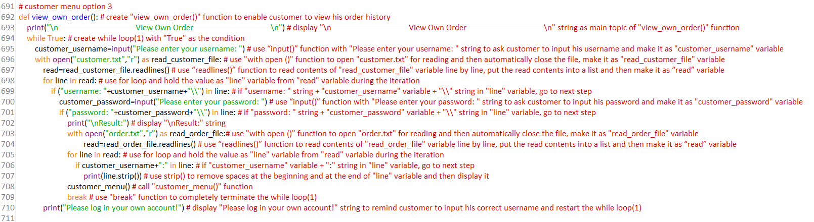

**view_personal_info function**

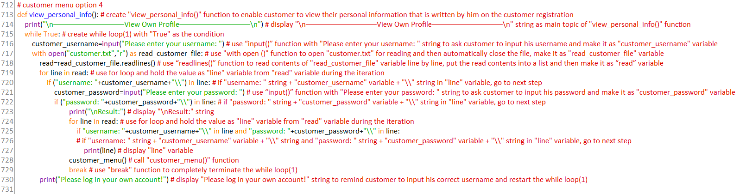

**call overall program**

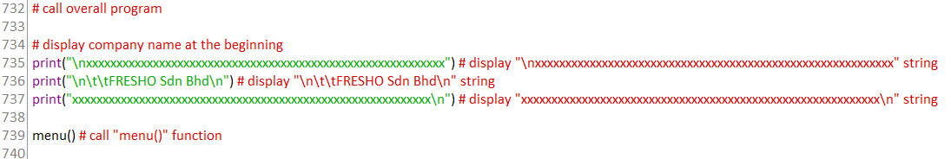

# **5.0 Sample Input/Output and Explanations**

Note: On this whole program, if user chooses invalid option, it will reprint again.

## **5.1 Main Menu**

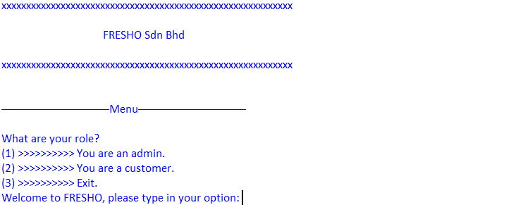*Figure 5.1.1 main menu*

At the beginning, user can see name of the company and there is a menu that let user chooses his role.

## **5.2 Exit**

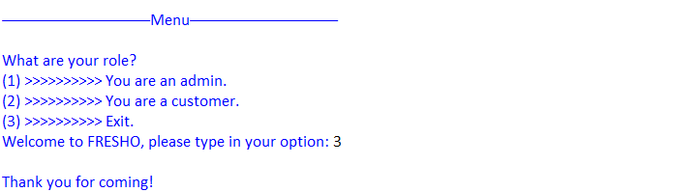

*Figure 5.2.1 exit the program*

If user fills in “3” on main menu page, it will end the entire program.

## **5.3 Admin**

**admin login and admin menu**

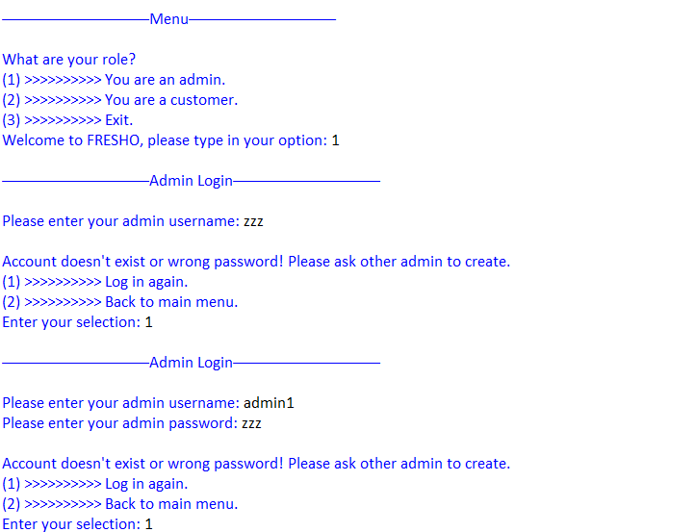

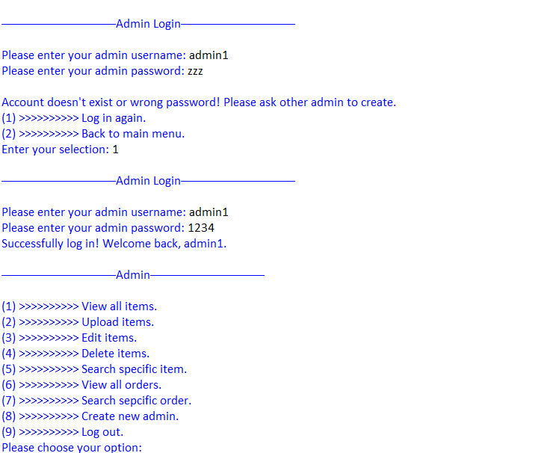

*Figure 5.3.1 admin login and admin menu*

If user fills in “1” on main menu page, it will go to admin login page. If admin enters wrong username or password, it will display a menu that has login again selection and go back to main menu selection. Otherwise, if admin inputs correct username and password, it will go to admin menu page.

**admin menu 1st option: view all items**

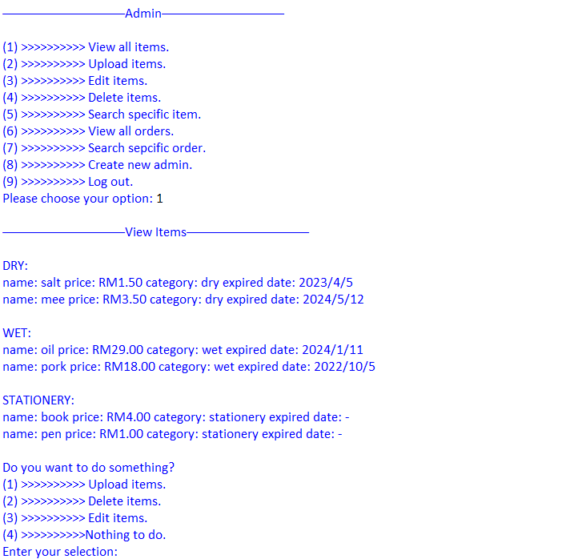

*Figure 5.3.2 view all groceries sell at FRESHO*

If admin selects first option on admin menu page, it will show all groceries sell at FRESHO following the categories. After that, it will display a menu that has upload, delete, edit, and back to admin menu selections. Admin can choose by their needs, and it will go to specific page. If admin chooses “nothing to do.”, it will go back to the admin menu page.

**admin menu 2nd option: upload items**

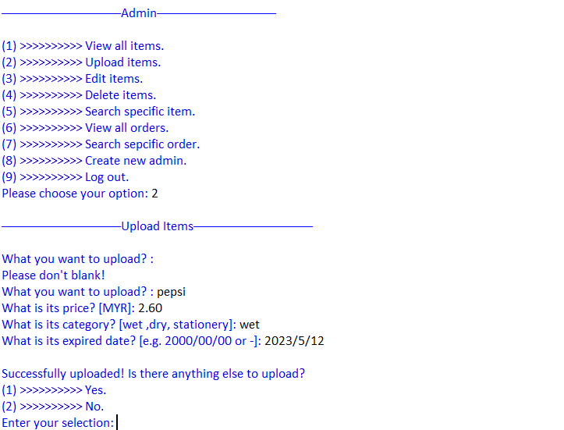*Figure 5.3.3 upload new items*

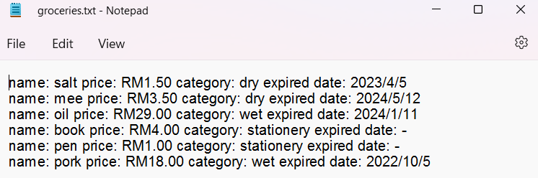

*Figure 5.3.4 groceries.txt before upload*

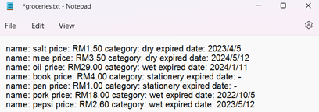

*Figure 5.3.5 groceries.txt after uploaded*

If admin selects second option on admin menu page, it will go to upload items page. The name, price, and category of the upload item cannot be blank, if it is blank, it will require admin to fill in again. After admin uploaded, it will ask admin wants to continue or not. If admin chooses “yes”, it will return to the upload items page, otherwise it will go back to the admin menu page. Admin can check the uploaded item in groceries.txt. The item has been added in groceries.txt.

**admin menu 3rd option: edit items**

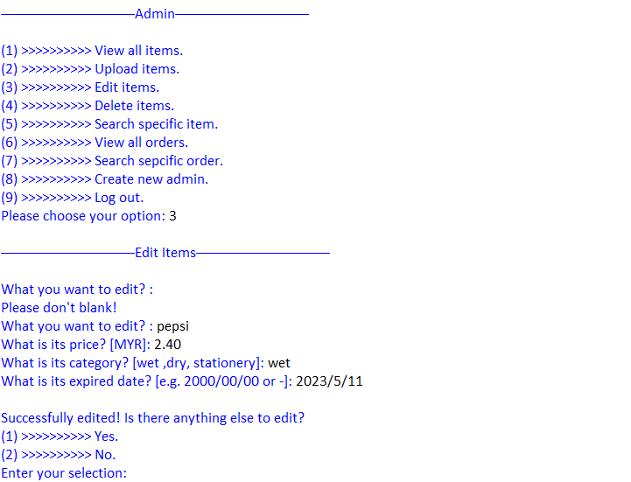

*Figure 5.3.6 edit items*



*Figure 5.3.7 groceries.txt before edit*

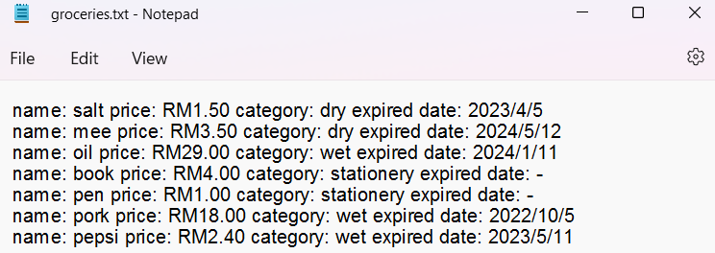

*Figure 5.3.8 groceries.txt after edited*

If admin selects third option on admin menu page, it will go to edit items page. The name, price, and category of the edit item cannot be blank, if it is blank, it will require admin to fill in again. After admin edited, it will ask admin wants to continue or not. If admin chooses “yes”, it will return to the edit items page, otherwise it will go back to the admin menu page. Admin can check the edited item in groceries.txt.

**admin menu 4th option: delete items**

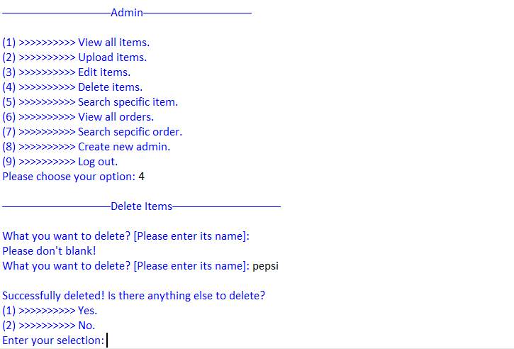

*Figure 5.3.9 delete items*



*Figure 5.3.10 groceries.txt before delete*

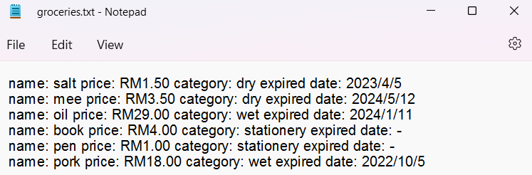

*Figure 5.3.11 groceries.txt after deleted*

If admin selects fourth option on admin menu page, it will go to delete items page. The name of the delete item cannot be blank, if it is blank, it will require admin to fill in again. After admin deleted, it will ask admin wants to continue or not. If admin chooses “yes”, it will return to the delete items page, otherwise it will go back to the admin menu page. Admin can check in groceries.txt. The item has been removed from groceries.txt.

**admin menu 5th option: search specific item**

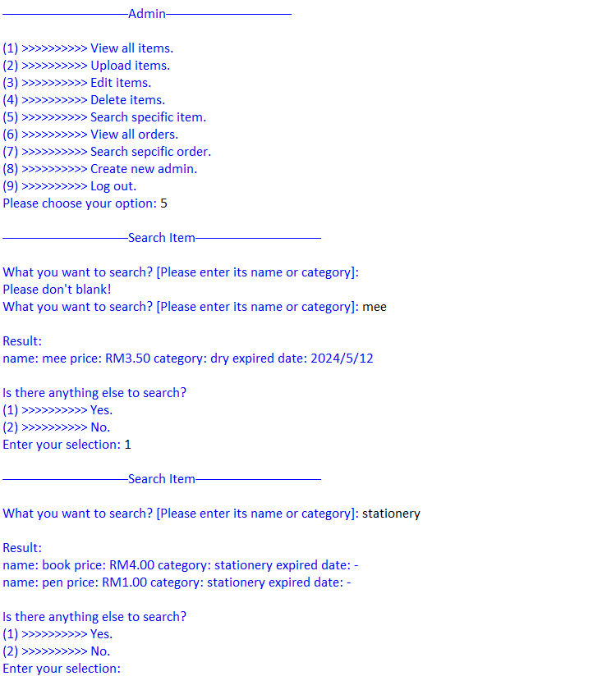

*Figure 5.3.12 search specific item*

If admin selects fifth option on admin menu page, it will go to search item page. On this page, admin can enter name or category to search the specific item, but it cannot be blank. If it is blank, it will require admin to fill in again. After admin searched, it will ask admin wants to continue or not. If admin chooses “yes”, it will return to the search item page, otherwise it will go back to the admin menu page.

**admin menu 6th option: view all orders**

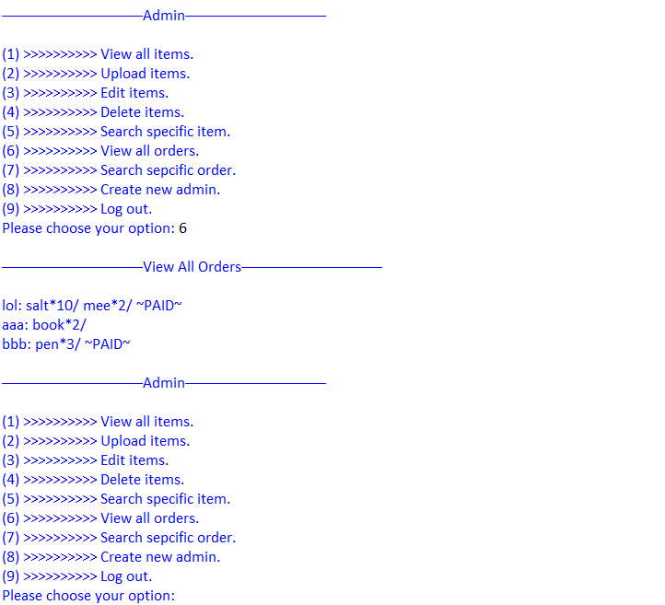*Figure 5.3.13 view all orders*

If admin selects sixth option on admin menu page, it will go to view all orders page. It will show the orders placed by customers. After that, it will go back to the admin menu.

**admin menu 7th option: search specific order**

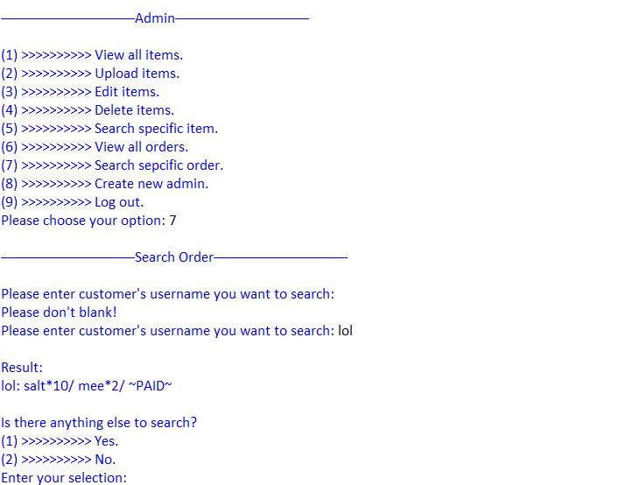

*Figure 5.3.14 search specific customer’s order*

If admin selects seventh option on admin menu page, it will go to search order page. The username of customer cannot be blank, if it is blank, it will require admin to fill in again. After admin searched, it will ask admin wants to continue or not. If admin chooses “yes”, it will return to the search order page, otherwise it will go back to the admin menu page.

**admin menu 8th option: create new admin**

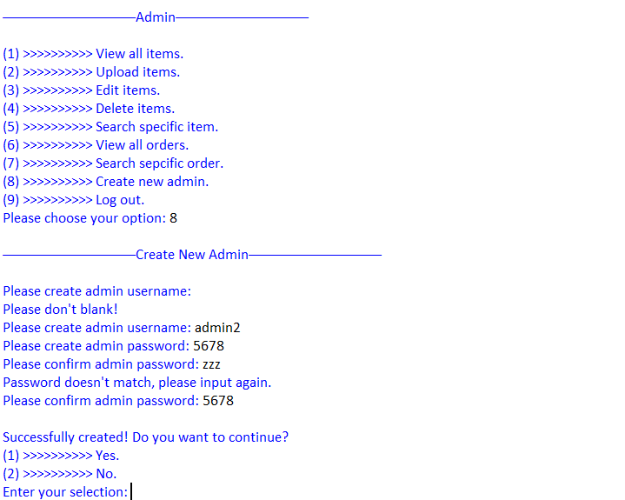

*Figure 5.3.15 create new admin*

If admin selects eighth option on admin menu page, it will go to create new admin page. The admin username and admin password cannot be blank, if it is blank, it will require admin to fill in again. If confirm admin password is not same as the created password, it will also require admin to input the confirm admin password again. After admin created, it will ask admin wants to continue or not. If admin chooses “yes”, it will return to the create new admin page, otherwise it will go back to the admin menu page.

**admin menu 9th option: log out**

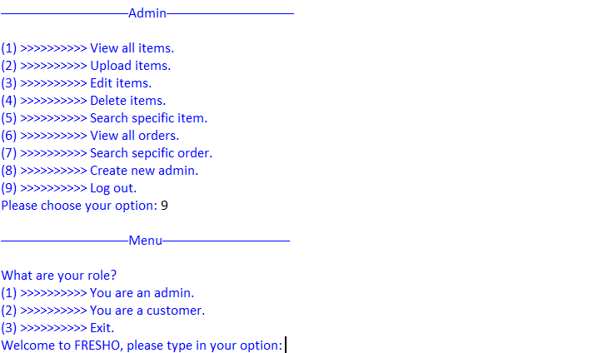

*Figure 5.3.16 log out admin account*

If admin selects ninth option on admin menu page, it will go back to the main menu.

## **5.4 Customer**

**customer login and customer menu**

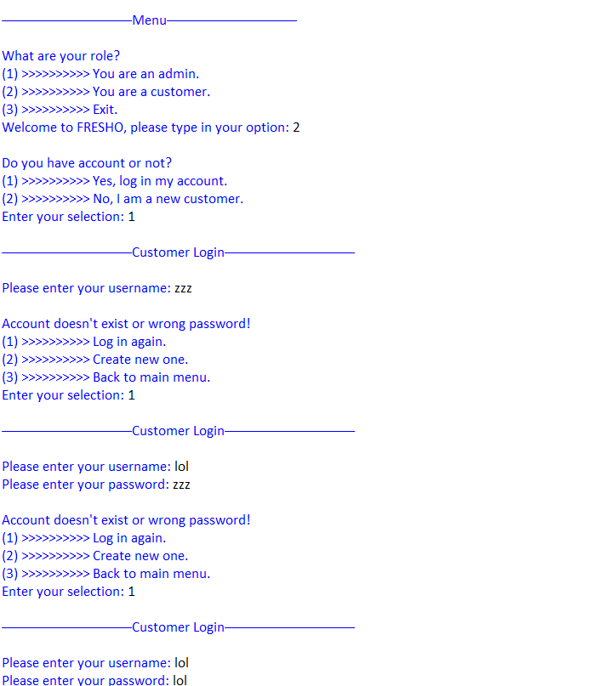 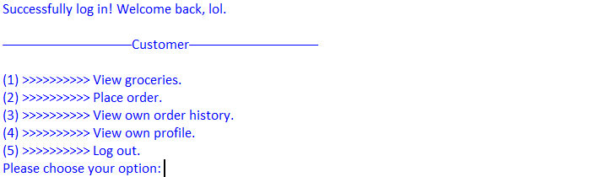

*Figure 5.4.1 registered customer login and customer menu*

If user fills in “2” on main menu page, it will go to customer page. It will display a menu that has old customer selection and new customer selection. On this menu, if customer chooses old customer selection, it will go to customer login page. If customer enters wrong username or password, it will display a menu that has login again selection, register selection, and go back to main menu selection. Otherwise, if customer inputs correct username and password, he will go to customer menu page.

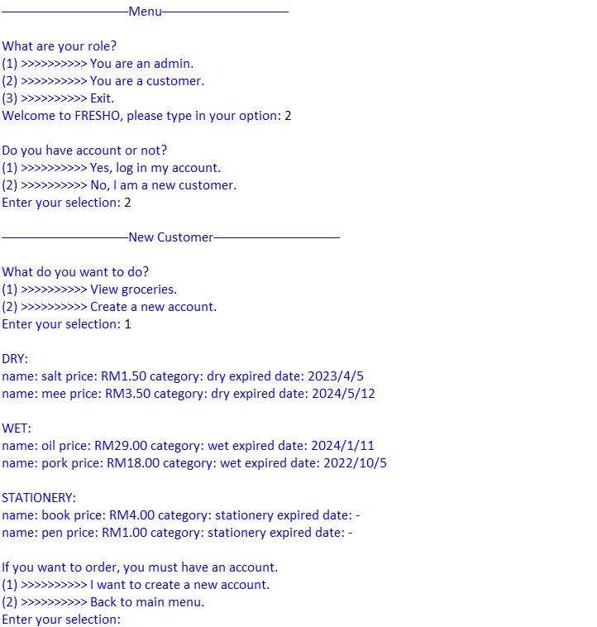

*Figure 5.4.2 new customer login*

Otherwise, if customer chooses new customer selection, it will go to new customer page. It will display a menu that has view groceries selection and create new account selection. If customer choose view groceries selection, it will display all groceries sell at FRESHO and then ask customer want to create new account to order or go back to the main menu. If customer chooses create new account selection, it will go to customer register page.

**new customer registration**

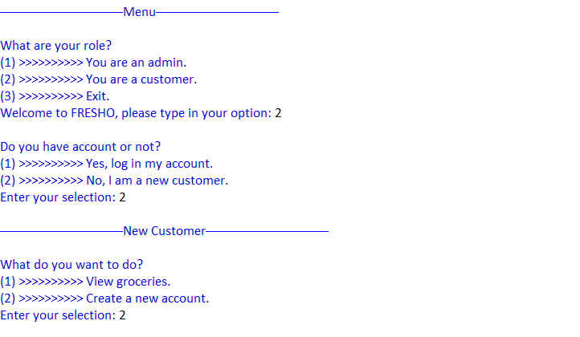

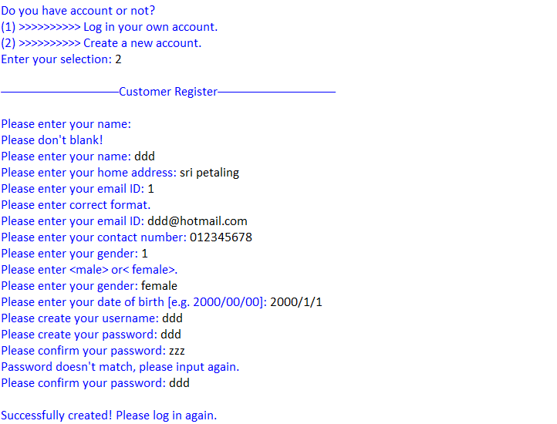

**

*Figure 5.4.3 new customer registration*

If customer chooses to create a new account, it will go to customer register page. On this page, customer needs to provide their personal information, but it cannot be blank. After customer created, it will go to customer login page.

**customer menu 1st option: view groceries**

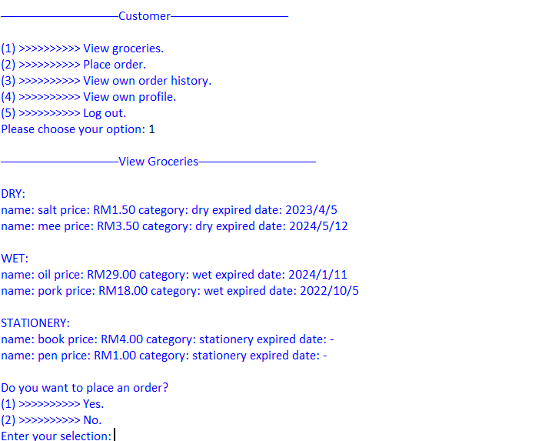

*Figure 5.4.4 view all groceries sell at FRESHO*

If customer selects first option on customer menu page, it will show all groceries sell at FRESHO following the categories. After that, it will display a menu that customer wants to place an order or not. If customer chooses “yes”, it will go to order page, otherwise it will go back to the customer menu page.

**customer menu 2nd option: place an order**

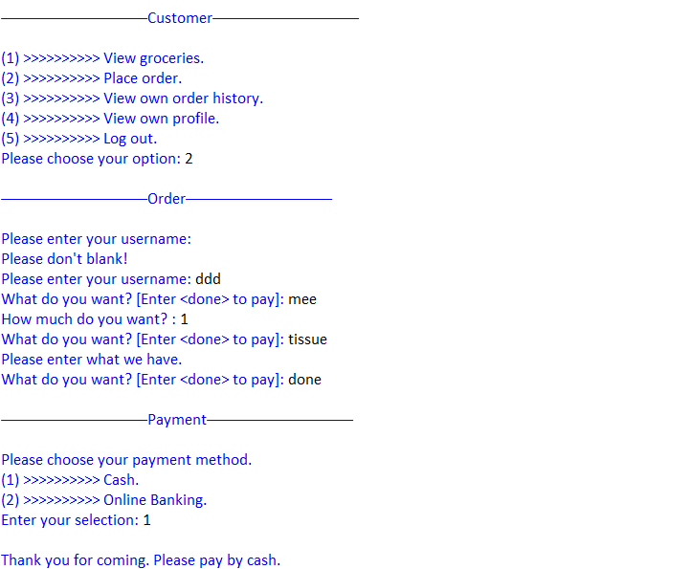

*Figure 5.4.5 place an order and pay by cash*

If customer selects second option on customer menu page, it will go to order page. The username cannot be blank, if it is blank, it will require customer to fill in again. After that, customer can order what and how much they want. It is worth mentioning that customer only can order those groceries can be available at FRESHO. If customer enter what FRESHO doesn’t have, it will remind customer. Customer can input “done” anytime to finish his order. After customer input “done”, it will go to payment page. If customer pays by cash, it will remind customer to pay cash for the delivery man or pay cash at the counter and then end the entire program.

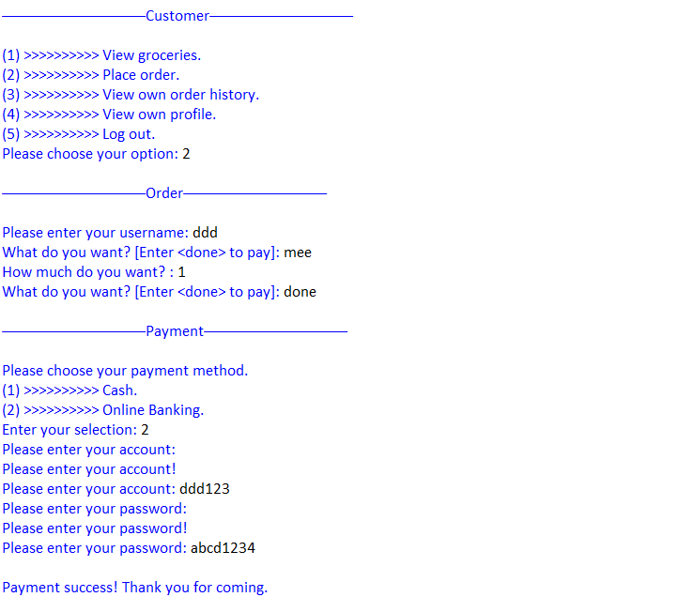

*Figure 5.4.6 place an order and pay by online banking*

Otherwise, if customer pays by online banking, it will require customer to enter his account and password, but it cannot be blank. If it is blank, it will require customer to fill in again. After that, it will end the entire program.

**customer menu 3rd option: view own order history**

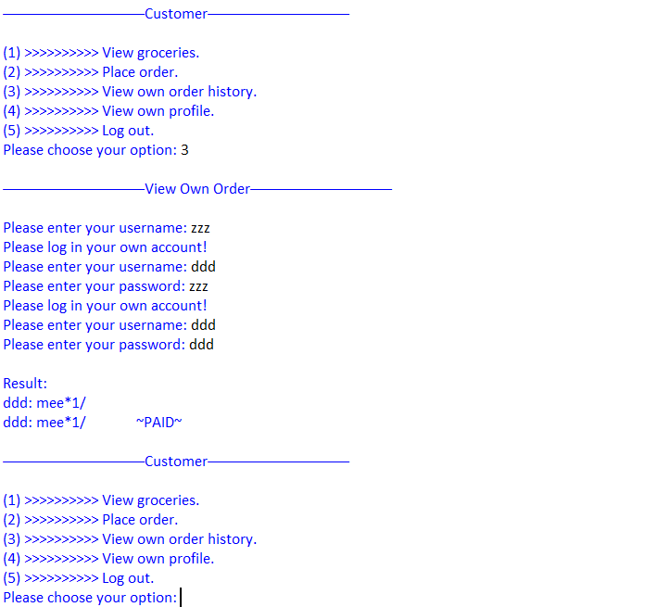

*Figure 5.4.7 view own order history*

If customer selects third option on customer menu page, it will go to view own order page. If customer enters wrong username or password, it will require customer to fill in again. Otherwise, if customer inputs correct username and password, it will show history of customer ordered. After that, it will go back to the customer menu page.

**customer menu 4th option: view own profile**

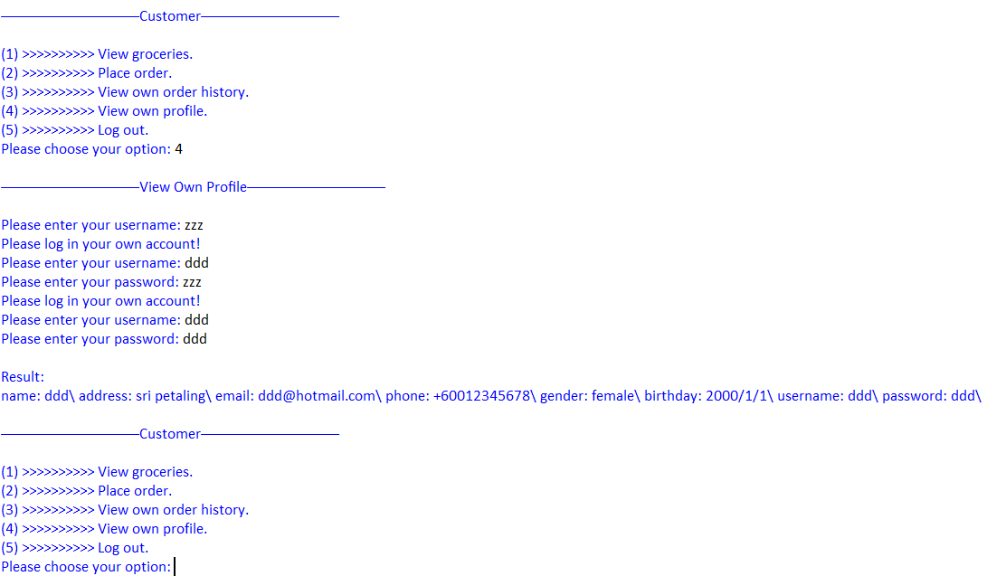

*Figure 5.4.8 view own profile*

If customer selects fourth option on customer menu page, it will go to view own profile page. If customer enters wrong username or password, it will require customer to fill in again. Otherwise, if customer inputs correct username and password, it will show customer’s personal information. After that, it will go back to the customer menu page.

**customer menu 5th option: log out**

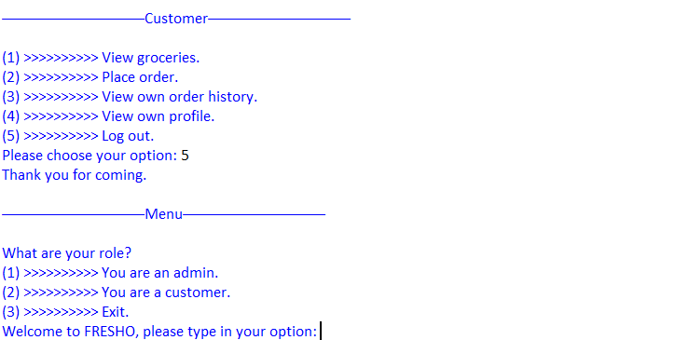

*Figure 5.4.9 log out customer account*

If customer selects fifth option on customer menu page, it will go back to the main menu.

# **6.0 Conclusion**

In this task, I use python as a programming language to complete the design of the groceries management system. There are many functions I used in this task to make this system more effective and attractive. In the modern retail business era, I hope that this menu-driven and user-friendly groceries management system can be used in various grocery stores or shopping malls in near future to relieve merchants’ workload and costs because it can automatically process the order and then list to admins. In addition, it also can give customers a chance to buy goods online and then pay by multiple payment methods like credit card, gift voucher, cash, etc.

# **7.0 References**

www.w3schools.com. (n.d.). *Python While Loops*. [online] Available at: <https://www.w3schools.com/python/python_while_loops.asp>.

‌W3Schools (2019). *Python For Loops*. [online] W3schools.com. Available at: <https://www.w3schools.com/python/python_for_loops.asp>.

‌W3schools.com. (2019). *Python Functions*. [online] Available at: <https://www.w3schools.com/python/python_functions.asp>.